List Payment yang sudah bisa di implementasi :

1. Paypal (https://paypal.com/)
2. Authrize.net (https://www.authorize.net/)
3. Stripe (https://stripe.com/hk)

Requirement Untuk

1. Paypal

Contoh Cara Upgrade ke Account Business

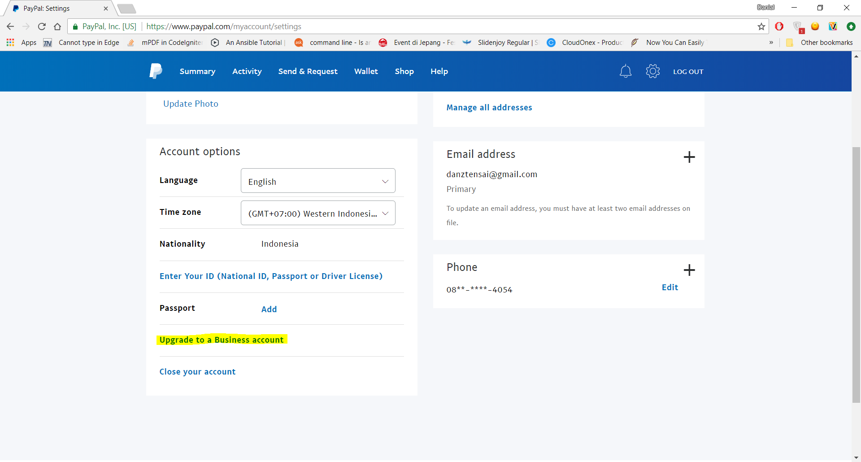

2. Requirement Untuk Stripe

<https://stripe.com/hk/payments>

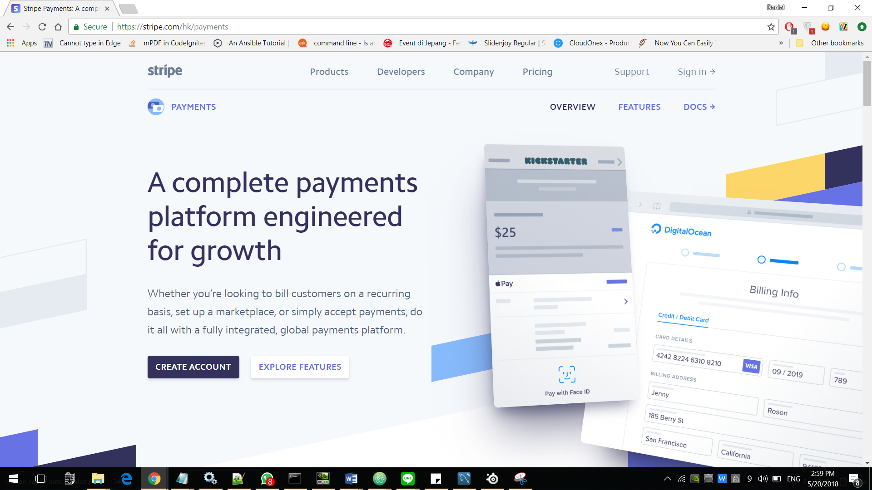

3. Authorize.net

<https://www.authorize.net/solutions/merchantsolutions/pricing/>

