Description
Title of Invention : Sample application with charts
- This is a sample document. Charts and graphs are not supported by the converter.
- If found in the description, the chart will be ignored during conversion with a warning:
- The following chart will be ignored during conversion:

”
- If the chart is in the Drawings section, the document will be rejected with a red error.
- If you need to insert a chart, please save it as an image first and then insert it in the document.
- The following chart has previously been saved as an image and will be converted:
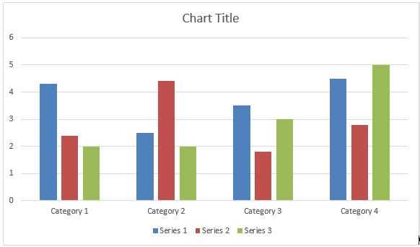
- [fig.1] is the image of a chart that will be converted.
- This is the last paragraph of the description.

Claims
- This is a sample Claim. First Claim.
- This is a sample Claim. The claim or claims must “define the matter for which protection is sought.” Claims must be clear and concise

Abstract
This is a sample text. The abstract must consist of a summary of the disclosure as contained in the description, the claims and any drawings. Where applicable, it must also contain the most characteristic chemical formula. The abstract must be as concise as the disclosure permits (preferably 50 to 150 words if it is in English or when translated into English).

[Fig. 1]

