Description
Title of Invention : Sample with a table designed in the drawings section
- This is a sample document.
- This sample is to demonstrate that a table created directly in the Drawings section with the text editor is not supported and will be rejected by the converter.
- Only images are accepted in the drawings section, so if you need to add a table as a figure of the drawings, it will only be accepted as an image.
- If you create the table with the text editor directly in the Drawings section, the document will be rejected with a red error:
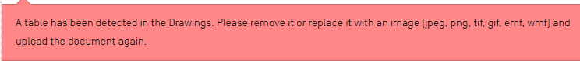
- In the Description, tables insert as image or created with the text editor are supported and they will be converted.

Claims
- This is a sample Claim. First Claim.
- This is a sample Claim. The claim or claims must “define the matter for which protection is sought.” Claims must be clear and concise.

Abstract
This is a sample text. The abstract must consist of a summary of the disclosure as contained in the description, the claims and any drawings. Where applicable, it must also contain the most characteristic chemical formula. The abstract must be as concise as the disclosure permits (preferably 50 to 150 words if it is in English or when translated into English).

[Fig. 1]
 |  | ABC
NFkB mutation |  | CD79A | CD79B | CD79B | TAK1 | A20 | CARD11
Target | Compound | OCI-Ly10 | HBL1 | TMD8 | U2392 | Su-DHL2 | OCI-Ly3
PKCb | AEB071 | 1.3 | 0.50.2 |  | 5 | >20 | >2015>200.412
PKCb | Compound D | ND 0.5 | 0.2 | 0.2 | 3 | >20 | >2015>200.412
PKCb | Compound B | ND 0.5 | 0.5 | 0.2 0.2 | 10 | 15 | >2015>200.412
IKKb | Compound A | 0.3 | 2.5 | 0.2 0.2 | 2.5 | 15 | >2015>200.412
IKKb | MLN120B | 10 | 10 | 10 | 10 | 10 | >2015>200.412

