Description
Title of Invention : Sample Application with an empty table in a table
- This is a sample document. A Table inserted inside another table (also called nested table) is not supported by the converter. If the table in the table is empty and has no content, the table in the table will be ignored with a warning.
- Example of an empty table in a table:
- Table 1
 | Cell 1 | Cell 2
Cell 3 | Cell 4 | Cell 5
”
- This is a another example:
- The following table includes an empty table:
 |  | ABC
NFkB mutation |  | CD79A | CD79B | CD79B | TAK1 | A20 | CARD11
Target | Compound | OCI-Ly10 | HBL1 | TMD8 | U2392 | Su-DHL2 | OCI-Ly3
PKCb | AEB071 | 1.3 | 0.50.2 |  | 5 | >20 | >2015>200.412
PKCb | Compound D | ND 0.5 | 0.2 | 0.2 | 3 | >20 | >2015>200.412
PKCb | Compound B | ND 0.5 | 0.5 | 0.2 0.2 | 10 | 15 | >2015>200.412
IKKb | Compound A | 0.3 | 2.5 | 0.2 0.2 | 2.5 | 15 | >2015>200.412

- If you need to insert a table in a table, please insert it as an image, as in the following example:
- Table 2
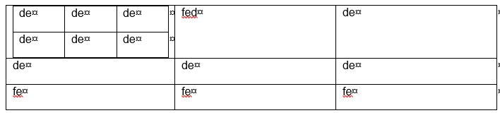
As tables can be designed in the text editor or added as images, this table will be processed an image of a table and will be converted.
- In the Drawings section, only images are supported, so please insert an image of a table or the document will be rejected by the converter.
- [fig.1] is the image of a table in a table.

Claims
- This is a sample Claim. First Claim.
- This is a sample Claim. The claim or claims must “define the matter for which protection is sought.” Claims must be clear and concise.

Abstract
This is a sample text. The abstract must consist of a summary of the disclosure as contained in the description, the claims and any drawings. Where applicable, it must also contain the most characteristic chemical formula. The abstract must be as concise as the disclosure permits (preferably 50 to 150 words if it is in English or when translated into English).

[Fig. 1]

