Description
Title of Invention : Sample Application with grouped images in the drawings
- Grouped or overlapped images are not supported and should not be inserted in docx application as the document will be rejected with a red error:
- If you need to insert this type of images, please save them as one image and then insert them in the document.
- Example of two grouped images:
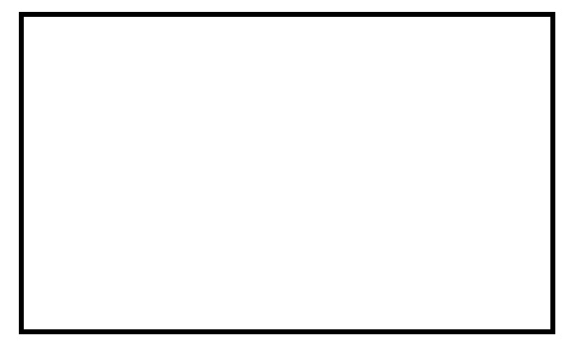
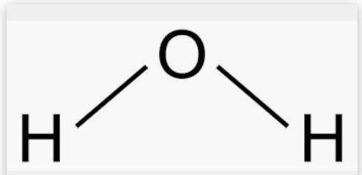

Claims
- This is a sample Claim. First Claim.
- This is a sample Claim. The claim or claims must “define

- Fig. 1 of the drawings are two grouped images that will make the document fail conversion.

CLAIMS
- This is a sample Claim.For the purposes of those designated States where that different manner of claiming is not permitted, the applicant must decide which drafting style to adopt. If that different manner of claiming is used, amendments may need to be made to the claims during the national phase in those States which do not permit it. Moreover, the national Offices of such States, when they act as International Searching Authorities, may indicate under Article 17(2)(b) that a meaningful search could not be carried out if that different manner of claiming is used (see paragraph 280).

Abstract
This is a sample text. The abstract must consist of a summary of the disclosure as contained in the description, the claims and any drawings. Where applicable, it must also contain the most characteristic chemical formula. The abstract must be as concise as the disclosure permits (preferably 50 to 150 words if it is in English or when translated into English).

[Fig. 1]

[Fig. 2]

