Description
Title of Invention : Sample with image effects applied in the text editor
- Image effects applied to an image directly in the docx document are not supported and will be ignored during conversion with a warning. These effects should be applied before saving the image.
- Example of an image with border and recolor applied after inserting the image in the document:
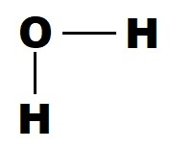
- Example of an image with effect ‘3D’ added after the image insertion:
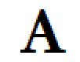
- The following image has been saved with the rotate effect and then inserted in the document:
- 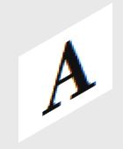
- The description must disclose the invention in a manner sufficiently clear and complete for it to be carried out by a person skilled in the art. It must start with the title of the invention as appearing in Box No. I of the request. Rule 5 contains detailed requirements as to the “manner and order” of the sdescription, which, generally, should be in six parts. Those parts should have the following headings:
- [fig.1] picture effect ‘recolor’ has been applied in the document and this effect will be ignored during conversion with a warning.
- [fig.2] picture effect ‘bevel’ has been applied in the document and this effect will be ignored during conversion with a warning.

Claims
- This is a sample Claim. First Claim.
- This is a sample Claim. The claim or claims must “define the matter for which protection is sought.” Claims must be clear and concise.

Abstract
This is a sample text. The abstract must consist of a summary of the disclosure as contained in the description, the claims and any drawings. Where applicable, it must also contain the most characteristic chemical formula. The abstract must be as concise as the disclosure permits (preferably 50 to 150 words if it is in English or when translated into English).

[Fig. 1]
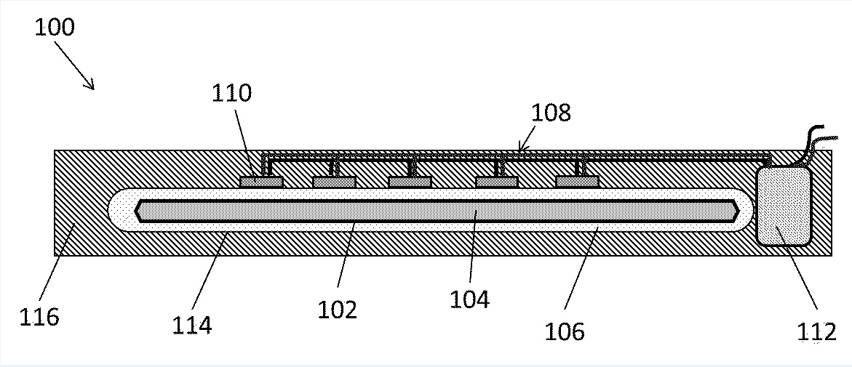
[Fig. 2]
