Description
Title of Invention: Sample-with Embedded OLE object
- Embedded OLE objects are not supported by the converter and will be ignored during conversion with a warning..
- The object below is an embedded OLE object that is not supported by the converter and will be ignored during conversion with a warning in the validation report:

- The following paragraph includes another embedded OLE object:
- .
- This object will be removed during conversion with a warning.
- If the object is in Drawings section, conversion will fail with a red error as only images are accepted in that section.

Claims
- Dummy Claims with non-supported embedded object:
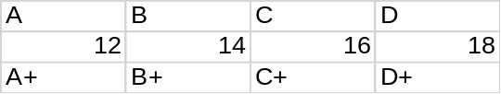

Abstract
Dummy Abstract including a non-supported embedded OLE object. The following image in an embedded OLE object that will be ignored during conversion with a warning in the validation report:

This is the end of the abstract.

