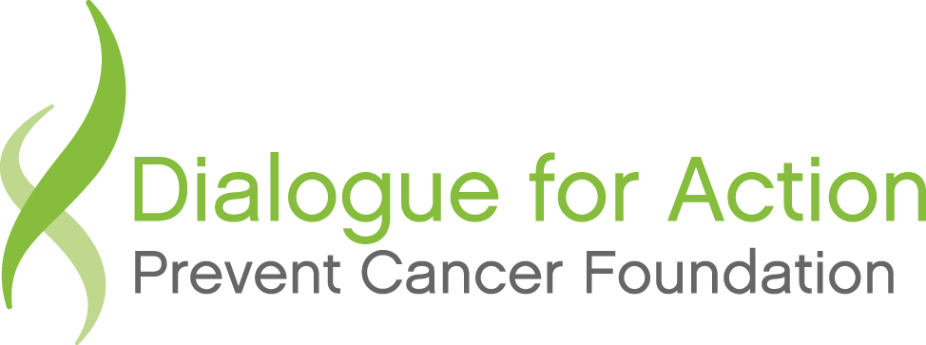

2012 Updates from American Indian/Alaska Native Dialogue for Action Project Teams

Between 2006 and 2008 the Prevent Cancer Foundation worked with 11 teams from tribal and urban Indian health organizations, including a state-level team from Minnesota, to increase colorectal cancer screening and awareness in their respective communities through the Dialogue for Action program:
- Aberdeen Area Tribal Chairman’s Health Board
- Alaska Native Tribal Health Consortium (ANTHC)
- Black Hills Center for American Indian Health
- Cherokee Nation
- Ho-Chunk Nation
- Intertribal Council of Michigan (ITCMI)
- Kaw Nation
- Mashantucket Pequot Tribal Nation
- Minnesota Intertribal Project (State-level Dialogue project)
- Texas Gulf Coast American Indian/Alaska Native Community
- Urban Indian Health Institute

The tribes and urban Indian health organizations which made up the 2006-2008 AI/AN Dialogue teams reach across many states and influence the health of many American Indians and Alaska Natives. Action plans were developed by each team and many tangible outcomes were achieved in 2008 (See 2009 AI-AN Chart and Minnesota Dialogue digest). The chart below provides updated information from six of the teams.

Team | 2012 Update
Alaska Native Tribal Health Consortium | The Dialogue helped the Alaska Native Tribal Health Consortium focus on colorectal cancer (CRC) throughout the tribal system. “It was part of a turning point for elevating CRC to a priority issue.” Since then three tribal organizations received CDC CRC funding which has resulted in the expansion of activities, publications and partnerships (See ANTHC Attachment).
Cherokee Nation | Cherokee Nation has recently updated their Comprehensive Cancer Control Plan, which includes updating the goals and objectives for colorectal cancer prevention. A culturally appropriate treatment brochure is currently in the works. The Hastings Indian Hospital clinical staff have contracted with Tahlequah City Hospital to use their surgical unit in order to increase the screening rates and for the past few years surgical staff have worked vigorously to decrease patients on the waiting list for colonoscopies; cutting the waiting list in half. In the next couple of years the wait-list time for a colonoscopy is anticipated to decrease to six months. A program has been implemented at the bi-annual summits where clinical staff are recognized with awards for those who have increased screening rates the most and the CCC staff will be working with clinical staff soon to develop a CD that will educate patients on flushing out their colon and preparing for a colonoscopy. This will save valuable time in the surgery units and increase screening rates.
Ho-Chunk Nation | The Ho-Chunk Nation is still continuing with their pursuit of cancer education. While the birthday card reminder program for check-ups and screening has been discontinued, the group still meets on a monthly basis to discuss cancer issues and current projects. There are monthly cancer support group meetings and efforts are underway to start support groups in other Ho-Chunk Communities. The clinic is working on developing a contract with an oncologist to begin treating and seeing cancer patients at the clinic. Cancer education is provided at health fairs and community events including encouragement to get screenings and practice healthy life habits.
Minnesota Intertribal Project | Waiting receipt.
Intertribal Council of Michigan | The Intertribal Council of Michigan received additional funds from the Michigan Department of Community Health via CDC to emphasize colon cancer screening among four tribal communities. Each site has 1) instituted patient and provider reminder systems; 2) held community education events – including the Giant Colon; 3) are reviewing screening rates within the clinics on a routine basis. The group also received funds from the American Cancer Society to focus on family health history (some young colon cases have been seen, suggesting a genetic concern in some families). 1)Posters and brochures were developed with input from the communities encouraging the gathering of family health history; 2) trainings were held with providers to help better assess those with a genetic risk factor and project follow up and correspondence continues with providers and community health staff.
Urban Indian Health Institute | Urban Indian C.A.R.E.S. has developed screening promotion and other communication materials, including screening awareness posters and postcards. A new website has also been developed to house Urban Indian C.A.R.E.S. materials (www.uihi.org/projects/urban-indian-cares/). Monthly conference call meetings are held with participants of Urban Indian C.A.R.E.S., and are facilitated by the Urban Indian Health Institute.  Urban Indian C.A.R.E.S. continues to meet on a monthly basis. The group is seeking additional funding opportunities to support in-person meeting and strategic planning efforts, as well as continued documentation and dissemination of resources and promising practices among urban Indian health organizations.

