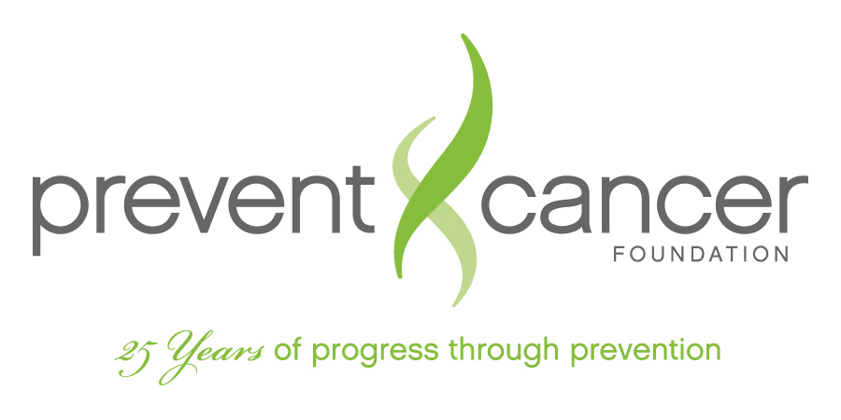

June 23, 2011

The Honorable Carolyn Maloney
2332 Rayburn House Office Building
Washington, DC 20515

The Honorable Charlie Dent
1009 Longworth House Office Building
Washington, DC 20515

Dear Representatives,
The Prevent Cancer Foundation is a national, nonprofit organization with the mission of cancer prevention through research, education and advocacy.
We would like to convey our support for H.R. 1676, the Tanning Bed Cancer Control Act of 2011. We strongly support the goal of this legislation, to expand federal regulation regarding tanning beds in what we consider a positive and proactive manner that could potentially help reduce the incidence of skin cancer.
The Tanning Bed Cancer Control Act of 2011 addresses the need to limit the amount of radiation that an ultraviolet tanning lamp could emit and limit the approved amount of time that a person could be exposed to UV radiation at that level. The performance standards, such as the strength of the UV rays emitted and the recommended amount of time a consumer should remain in the bed, have not been updated since about 1985. Given that the link between skin cancer and indoor tanning is undeniable, it is crucial that we protect Americans from harmful UV rays. We believe that we cannot afford to stand by and watch people suffer as a result of misinformation and poor regulation.
More importantly, H.R. 1676 initiates an effort to charge the Commissioner of the FDA to change the classification of ultraviolet tanning lamps to show that they are a known carcinogen. Currently, tanning beds are classified in the lowest risk category, Class I, like Band Aids, tongue depressors and cotton balls; items that pose no risk to consumers. In comparison, the United States Department of Health and Human Services and the World Health Organization's International Agency for Research on Cancer have classified indoor tanning beds as a known carcinogen, the same category as tobacco smoke, asbestos and uranium. The Prevent Cancer Foundation agrees that tanning beds are not appropriately classified in accordance with the risks of their use.
The most common serious form of skin cancer is melanoma, which is expected to be diagnosed in about 68,000 persons each year. Melanoma incidence rates have been increasing for at least 30 years and in the most recent time period, rapid increases have occurred among young white women at 3% per year since 1992 in those aged 15 to 39 years. A survey by the American Academy of Dermatology confirmed that 32% of Caucasian teen girls and young women admitted using tanning beds in the past year and, of those respondents, 25 % used a tanning bed at least weekly, on average. It is time to take action and make sure that people know the risks posed by indoor tanning and that we take steps to protect them.
The Prevent Cancer Foundation supports legislation that will empower the Food and Drug Administration to determine whether the current performance standards and regulations placed on tanning beds accurately reflect their safety and effectiveness.
We look forward to working with you towards the passage of the Tanning Bed Cancer Control Act of 2011.
Sincerely,

Lisa Hughes
Director, Policy and Advocacy
The Prevent Cancer Foundation

