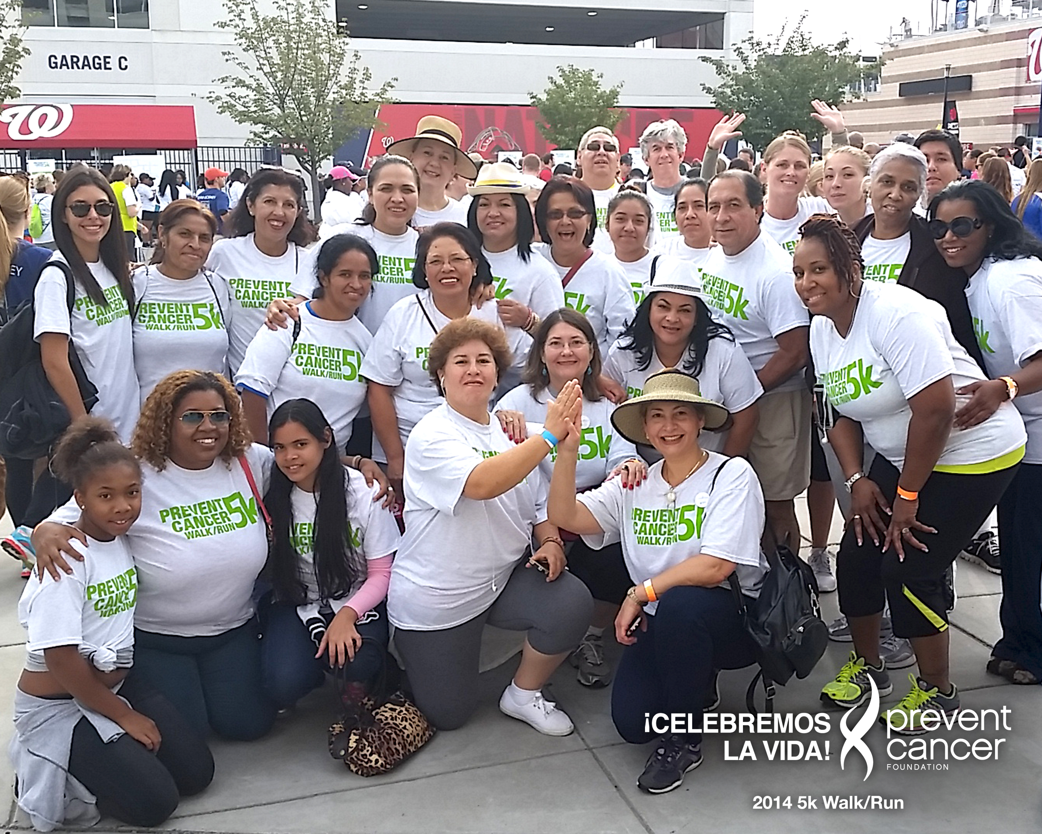
Since 1994, the Prevent Cancer Foundation has partnered with Spanish Catholic Center in Washington, DC, to implement ¡Celebremos la Vida! (Let’s Celebrate Life!), a program which provides breast and cervical cancer education and screening to medically underserved Hispanic women over 40 years of age in the Washington, DC, area. In 1996, Celebremos also launched at Georgetown University. In 2004, the program expanded to Family Health Partnership Clinic in McHenry County, IL, and, four years later, Spanish Catholic Center extended Celebremos to its clinic in Langley Park, MD, which later relocated to the Cardinal McCarrick Center in Silver Spring, MD.
¡Celebremos la Vida! ensures that participants receive free/low-cost comprehensive education and screening in a setting that is culturally appropriate and nurturing. This environment encourages women to return for yearly check-ups, take care of their health and promote the message of early detection to other women in their families and communities. Scheduling follow-up appointments for abnormal tests and patient navigation is provided by each site’s bilingual and bicultural coordinator. If breast or cervical cancer is detected, the coordinator works with collaborating medical centers to ensure medical follow-up and treatment, regardless of ability to pay.
- Since its inception, the Celebremos program has provided over 10,300 screening and diagnostic mammograms and nearly 9,000 Pap tests.
- Over 13,100 Celebremos participants and accompanying friends and family members have received health education.
- To date, 42 women have been diagnosed with cancer, and all have received treatment.
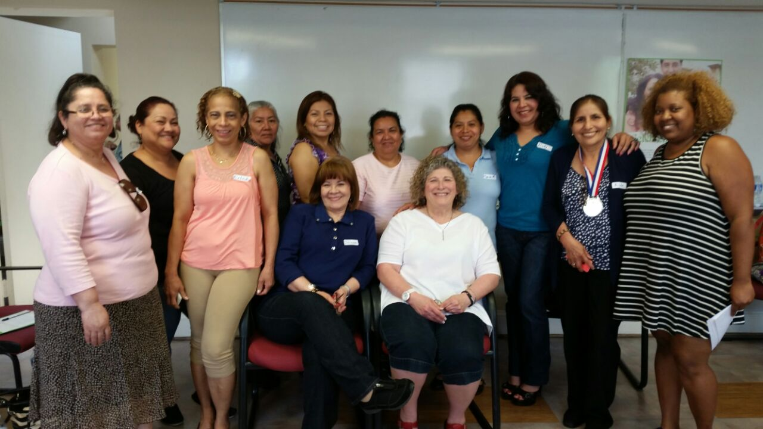
Campeonas contra el cáncer del seno (Champions Against Breast Cancer) is a new project developed through ¡Celebremos la Vida! in which women who have received breast cancer screenings are trained to encourage family and friends to get screened as well. For more information and to see the materials visit: www.campeonas.org.
The Foundation would like to express its appreciation to Susan G. Komen® and ONYX Pharmaceuticals, Inc. for their generous support of ¡Celebremos la Vida!

