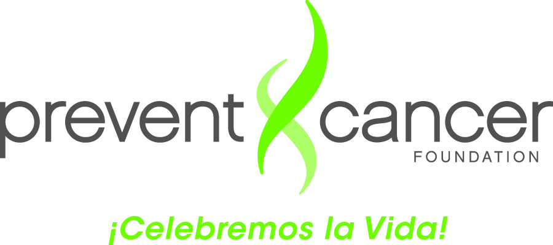

**Guide for Completing the *Campeonas* Log**

***Purpose of the Contact Log****:* To assist *Campeonas* with collecting and tracking information

about their conversationswith the women they contacted

The Log has two (2) sections:

***Section I*:** Provides information about you and the place where you were trained:

1. ***Campeona’s* name:** First and last name
2. **City:** Name of the city where you live
3. **State:** Name of the state where you live
4. **Training Location and name of the organization:** City and State where you were trained and name of the organization providing the training

***Section II:*** Provides information from the women you talked to:

1. **Date of the conversation:** Month, day and the year (e.g., 01/01/12)
2. **Name of the woman you talked to:** Only first name is required
3. **Age:** For example, 40 years old
4. **Country of Origin:** Country where the woman you talked to was born (e.g., El Salvador)
5. **Relationship:** Your relationship with the other person (e.g., mother, sister, *comadre*, daughter, grandmother, friend, church member, or other)
6. **Materials from the folder**: *Novela* and the list programs with free mammography. (Indicate with a check mark (✓) if they were provided to the woman when you spoke to her.)
7. **Willing to have a mammogram?:** Mark Yes or No
8. **Comments:** Brief comments regarding your conversation if you think are needed