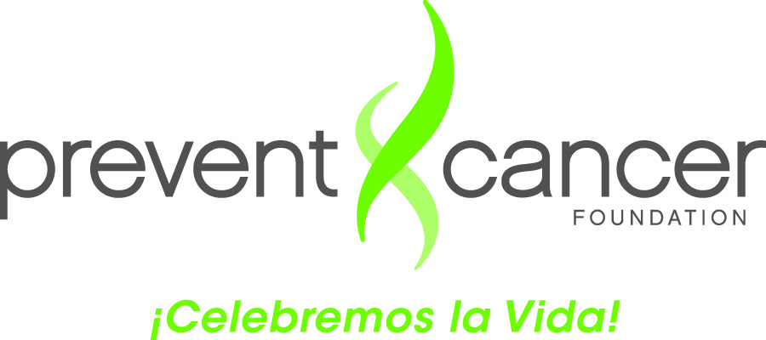

**Evaluation Form**

**Date: __________________________________**

**Location: ____________________________**

**Instructors: _______________________________**

Please complete this evaluation form. For each of the following questions, mark (X) the column that best represents your opinion. A rating of 1 means that you strongly disagree with the statement. A rating of 5 means that you strongly agree. THIS FORM IS CONFIDENTIAL; YOU DO NOT NEED TO WRITE DOWN YOUR NAME.

|  |  |  |  |  |  |  |
| --- | --- | --- | --- | --- | --- | --- |
|  | **As a result of this training, I am able to:** | **Strongly Disagree** | | **Agree** | **Strongly Agree** | |
| 1 | 2 | 3 | 4 | 5 |
| 1. | Describe the role of a *Campeona* |  |  |  |  |  |
| 2. | Name three common myths about breast cancer and breast cancer screening—and why they are myths |  |  |  |  |  |
| 3. | Understand “The 3 Es” (escuchar, entender and empoderar) and why they’re important for *Campeonas* |  |  |  |  |  |
| 4. | Understand the “five easy steps” of a *Campeonas* conversation |  |  |  |  |  |
| 5. | Start a conversation with female friends and family members about having a mammogram |  |  |  |  |  |
|  | **Please continue answering overall course questions:** | **Strongly Disagree** | | **Agree** | **Strongly Agree** | |
| 1 | 2 | 3 | 4 | 5 |
| 6. | I intend to use information gained from this training with my female friends and family members. |  |  |  |  |  |
| 7. | The presentation was clear and to the point. |  |  |  |  |  |
| 8. | The length of training was adequate for learning. |  |  |  |  |  |
| 9. | The activities and role plays increased my familiarity with the topic. |  |  |  |  |  |
| 10. | The workshop materials and handouts were helpful. |  |  |  |  |  |