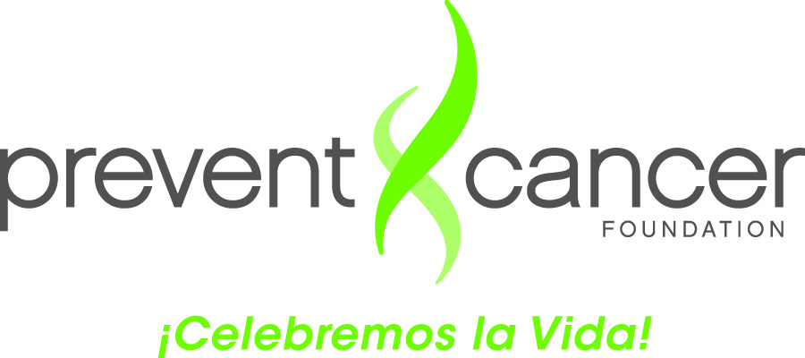

**BILINGUAL PROGRAMS WITH FREE MAMMOGRAPHY**

**IN THE WASHINGTON DC METROPOLITAN AREA**

(This information is subject to change, as organizations may change their schedules, availability or requirements.)

**Arlington Clinic**  
Arlington Free Clinic provides low income, uninsured adult residents of Arlington County access to comprehensive medical care.   
2921 11th Street South, Arlington, VA 22204  
**Phone:** [(703) 979-1400](tel:%28703%29%20979-1400)  
[www.arlingtonfreeclinic.org](http://www.arlingtonfreeclinic.org/)

**Capital Breast Care Center**

Low income with or without insurance

Ages 40-64 DC residents

Ages 50-64 Virginia residents

Requirments: Picture ID needed for individuals with insurance; Picture ID and proof of address is needed for those without insurance.

Phone: (202) 784-2700

**Community Healthcare Network**

CHCN was formed to provide primary health services for low income, uninsured residents of Fairfax County and the cities of Fairfax and Falls Church, who cannot afford primary medical care services for themselves and their families.South County Location: 8350 Richmond Highway, Suite 301, Alexandria, VA 22309  
Telephone: (703) 704-5333

**DC Project Wish Program**

Low income, uninsured residents of DC, Maryland and Virginia are eligible for mammograms if within the age of 40 and 64 years of age and pap smears if you are with the ages of 21 and 64

Requirements: has to below 200% federal poverty level, have a valid ID and proof of address.

Phone: (202) 442-5900

**Every Woman’s Life**

Through the VA Department of Health

Requirements: Must be 18-64 year old, resident of Virginia, have no health insurance or unable to afford insurance deductible or insurance does not cover screening exams, income requirements. Limited Spanish available.

Main Office: 109 Governor Street, 8th Floor, Richmond, VA 23219

Call to find an office/clinic near you.

Telephone: (866) 395-4968

email: [free_screens@vdh.virginia.gov](mailto:free_screens@vdh.virginia.gov)

**Family Resource Center**Programs and services are open to everyone of all age groups, nationalities and cultural backgrounds. There is also no residency requirement or income requirements.  Culmore Family Resource Center: 3304B Culmore Court, Falls Church, VA 22041  
Telephone: 703-379-5217  
Springfield/Franconia Family Resource Center: 7224 Commerce Street, Springfield, VA 22150  
Telephone: 703-644-0000

**George Washington Mammovan**

With or without medical insurance

Ages 40 and older

Residents of Virginia, DC, or Maryland

Requirements: photo ID and medical referral

Phone: (202) 741-3252

**La Clínica del Pueblo**

Does not offer mammogram on site however can provide a referral.

2831 15th Street, NW

Washington DC 20009

Phone: (202) 462-4788

**Life with Cancer**

Support groups and classes for families. Can refer out for mammography.

**8411 Pennell Street, Fairfax, VA 22031**

**Telephone: 703.698.2526**

**Services in Spanish**

**Veronica Martinez: 703.698.2539**

**David McGinness: 703.698.2529**

**Mary’s Center**

Do not offer mammograms on site however can provide a referral.

2333 Ontario Rd, NW

Washington DC 20009

Phone: (202) 483-8196

**Nueva Vida**

Nueva Vida’s mission is to support, inform and educate Latino women who have been affected by breast and cervical cancer. As well as to advocate for services for early detection, diagnosis and treatment of cancer. Offer patient navigation and medical referrals at no or little cost.

2000 K Street NW, Suite 200

Washington, DC 20006

Phone: (202) 223-9100

**PG County Program**

For the uninsured and low income population

Prince George’s County residents between the ages of 40-64

Requirements: Proof of address and valid ID income lower than 32k a year

Phone: (301) 883-3541

**Spanish Catholic Center of Catholic Charities (*íCelebremos la Vida!* Program)**

Washington, DC

DC and MD residents with or without medical insurance.

Requires: Photo ID and medical referral

Phone: (202)939-2400 ext. 903

**Spanish Catholic Center – McCarrick Center (*íCelebremos la Vida!* Program)**

Silver Spring, MD

Maryland residents

Low income uninsured

Requires: Photo ID and medical referral

Phone: (301) 434-8985 ext. 953