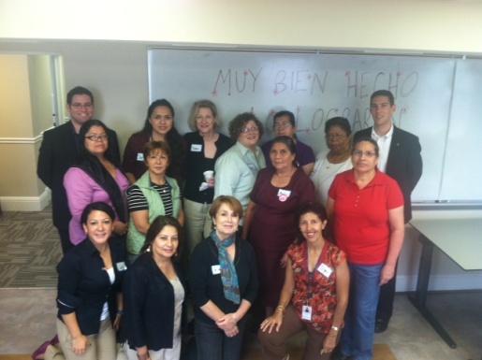***Campeonas contra el cáncer de seno,***

**(Champions against Breast Cancer)**

The *Campeonas* project is an outgrowth of our *¡Celebremos la Vida!* (Let’s Celebrate Life!) program -- a breast and cervical cancer education and early detection program serving medically underserved women in the Hispanic community since 1994.  The *Campeonas* training prepares Latinas, age 40 or older, who have been screened for breast cancer and are committed to advocating for women’s health, to encourage their friends and family (F&F) to be screened.

The project benefits from the combined strengths of a dedicated and very talented team. And all parts of *Campeonas* were created with input from women in the community to ensure cultural appropriateness, interest and usability. The *Campeonas* project allows for comfortable discussion about breast cancer screening. The *Campeonas* program helps to address health disparities: mammography rates in the U.S. are lower for Hispanic women than for non-Hispanic white women. The program offers training for Latinas to share their own breast cancer screening experiences with F&F, to encourage them to be screened.

The *Campeonas* Project Empowers Latina Women

*“I feel self-assured and with courage”*

- Training participant

**Statistics 2012-2015**

|  |
| --- |
| 5 *Campeonas* Trainings Held |
| 57 *Campeonas* Trained |
| Over 100 F&F Reached |
| 3 in-house trainers trained – this will provide sustainability for the program at local sites |

**Want to Implement *Campeonas* in Your Clinic?**

The *Campeonas* program offers free-standing community-level materials: the *novela* entitled *Un encuentro oportuno: conversando sobre el cáncer de seno* (“A Timely Encounter: Talking about Breast Cancer”) uses pictures and conversation between friends to share information about breast cancer screening. The easy-to-use, step-by-step training guide and free-standing community-level materials are now available to download in Spanish or English for FREE to community health organizations on the Foundation’s website [www.campeonas.org](http://www.campeonas.org).

Funding for this project was provided by the Prevent Cancer Foundation and Susan G. Komen®. For more information about *Campeonas contra el cáncer de seno*, contact Prevent Cancer at [campeonas@preventcancer.org](mailto:campeonas@preventcancer.org).