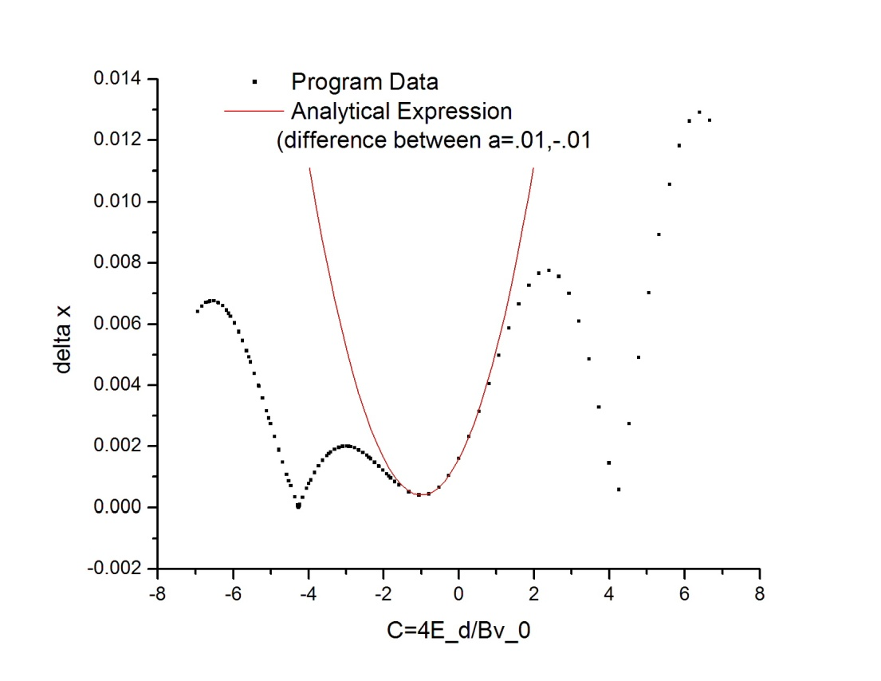

After successfully finding the above analytical expression, I wanted to find the minimum near -4.27 on this graph. Below is a graph of the motion of the electrons through the filter when it is tuned to that minimum. To analytically express this, I determined a way to calculate the angle of deflection.

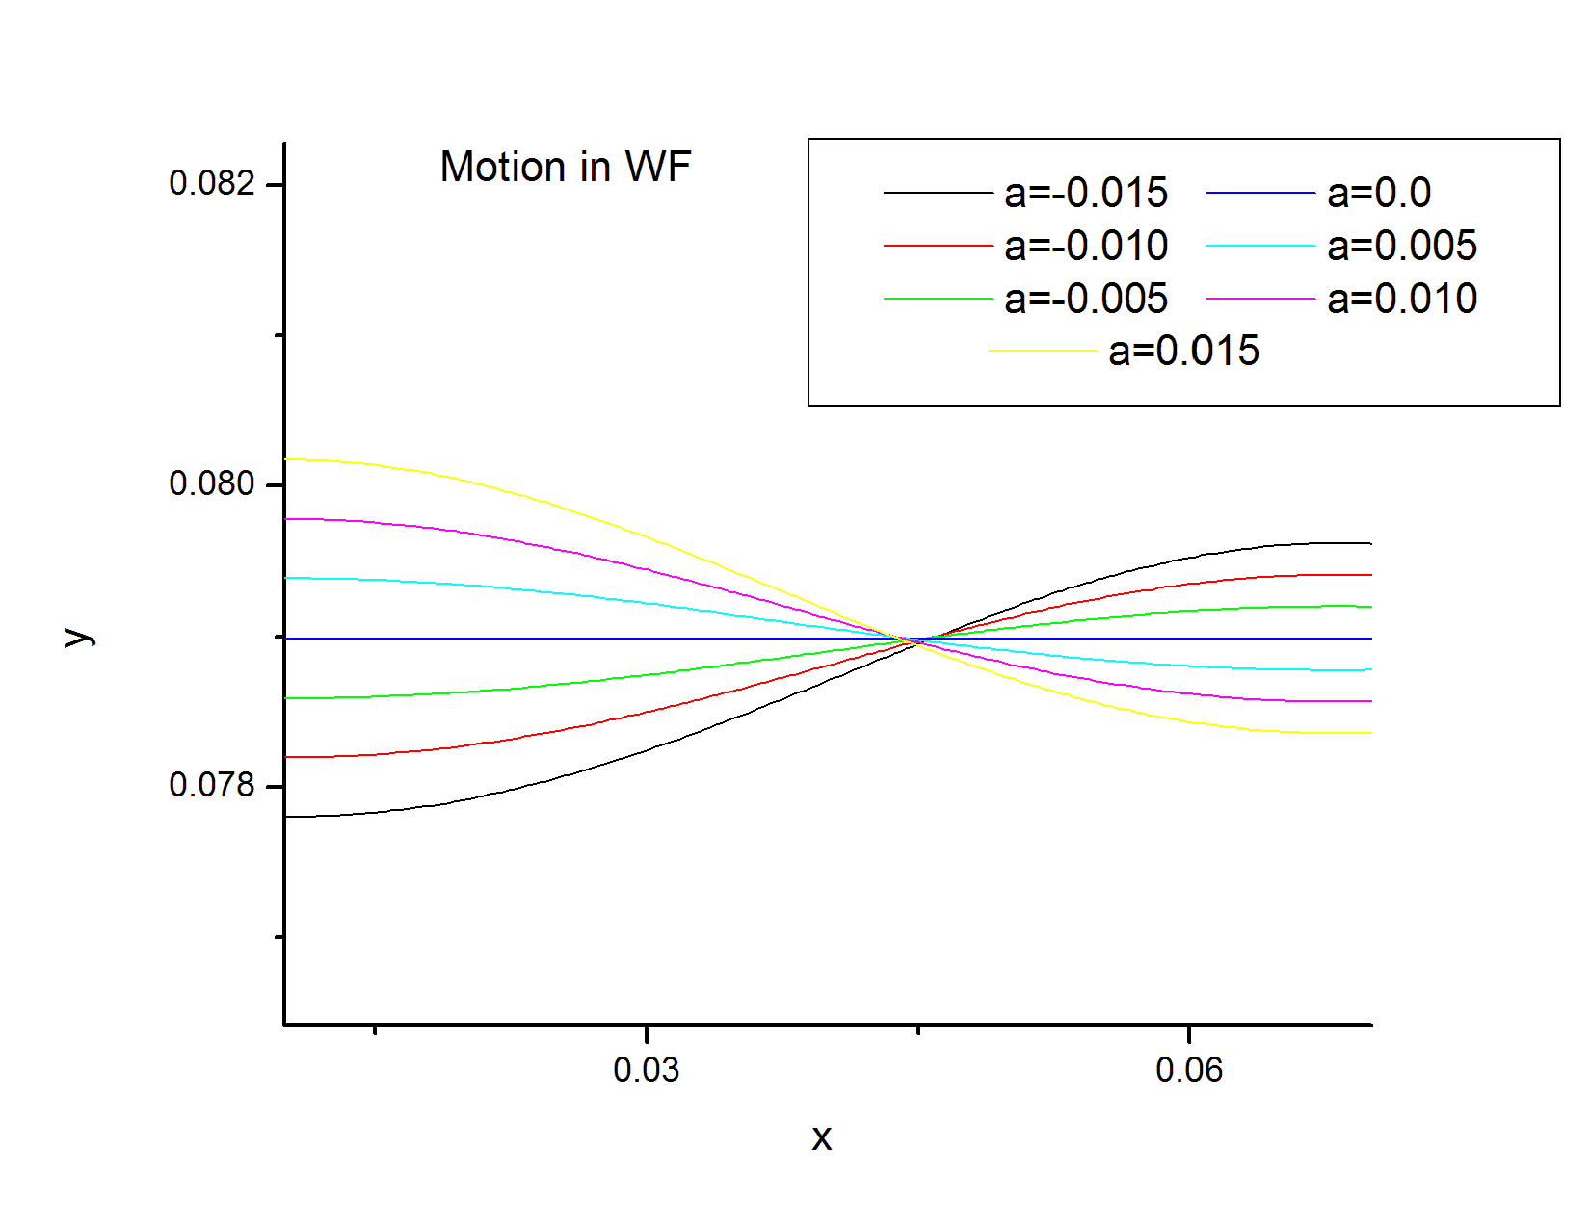

Figure

I noticed that after half a “wavelength” of the oscillating motion, I could use the same approximation for small deflection.

$$\dot{y}=-\frac{\frac{qB}{m}\left(d_{w}+\frac{4πmv_{0}}{qcB}\right)\left(1+c\right)a}{1-a\left(1+c\right)}$$

This is the same expression for $\dot{y}$ but the distance is modified by half a wavelength.

$$\dot{x}=v_{0}\left(1+a\right)$$

Remarkably, the final velocity in the x direction is the same before and after the filter.

$$x_{θ}=4θr=4\frac{\dot{y}}{\dot{x}}\frac{mv_{0}\left(a+1\right)}{Bq}=\frac{4\left(d_{w}+\frac{4πmv_{0}}{Bqc}\right)a\left(c+1\right)}{\left(c+1\right)a-1}$$

Here, the assumptions are that c<0, and that $d_{w}+\frac{πmv_{0}}{qcB}$ is relatively small.



Figure -the program vs the analytical expression for angle

I am very close as well to determining the delay caused by the filter. It is a little trickier than before because the velocity is periodic.

So I ran into a wall. I want to find out how long the electron stays in the wein filter to determine how much behind it gets. but the equation for its x position is as follows

$$d_{w}=\frac{amv_{0}}{Bq} sin(\frac{Bqt}{m}) + v_{0}t$$

The only way I can solve for t is numerically. Any insight?