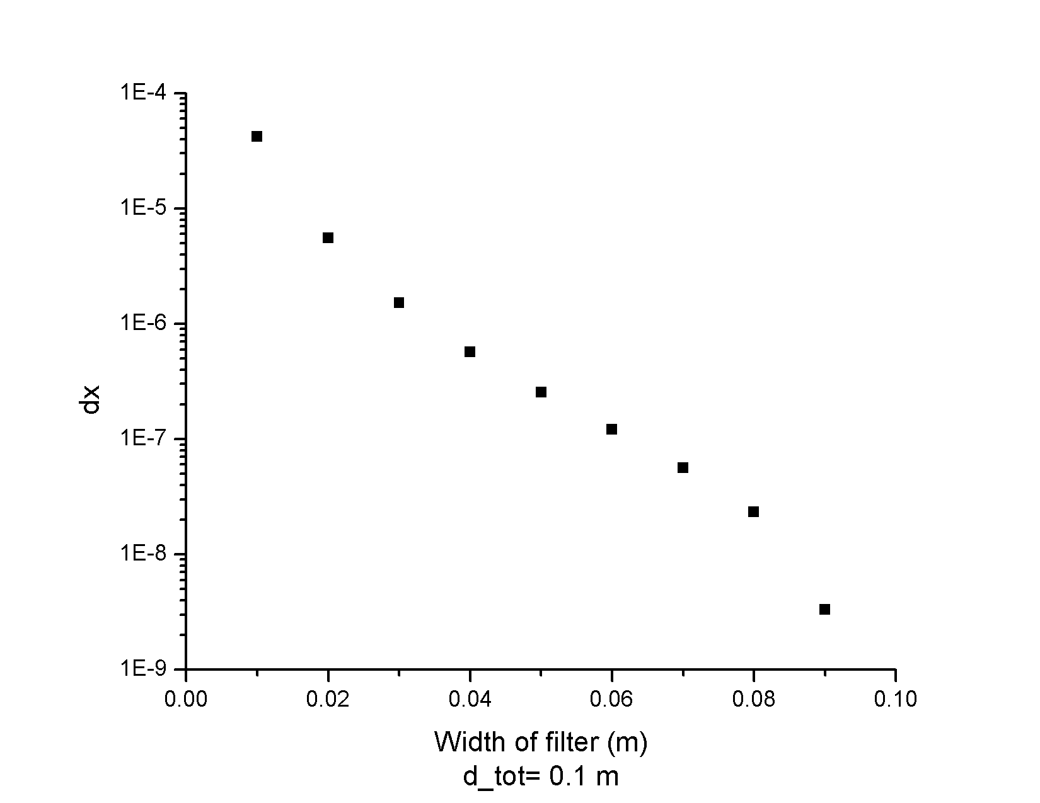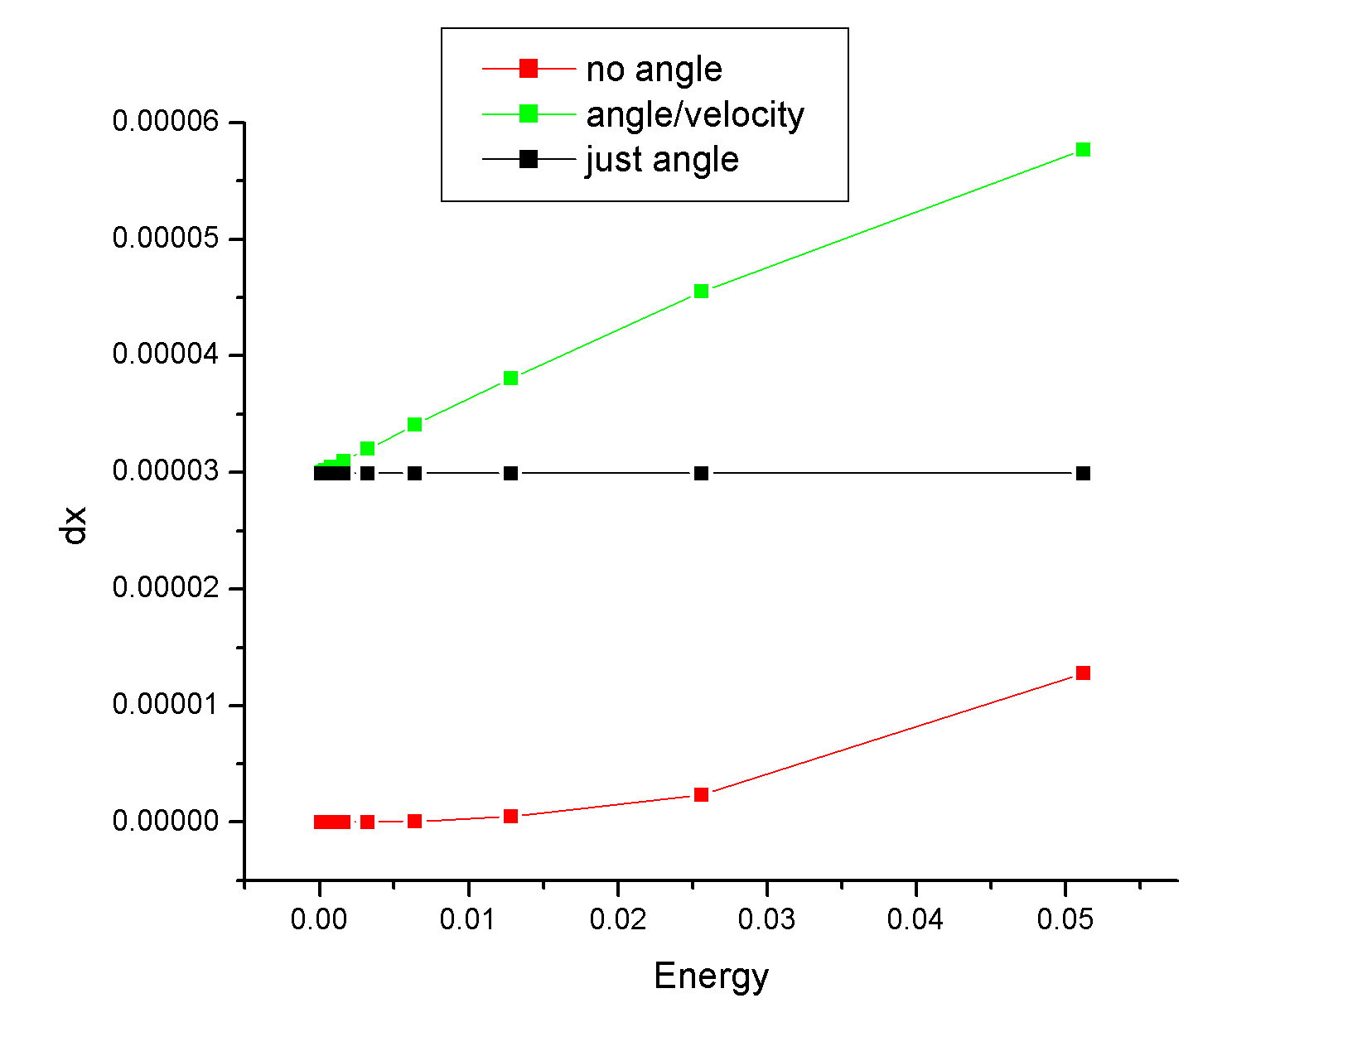

(2-04)

$$ΔY=\frac{4mΔv}{qB} ΔT_{W}=\frac{d_{W}}{v_{0}^{2}}ΔV_{g} ΔV_{g}=\frac{4E}{Bv_{0}}Δv E_{d}=\frac{d_{tot}Bv_{0}}{2d_{w}}$$

$$ΔV_{g}=ΔU\sqrt{\frac{q^2}{8m\left(\frac{1}{2}mv_{0}^{2}\right)}}=ΔU\frac{q}{2mv_{0}}=\frac{qUΔY}{mv_{0}D}=\frac{qΔYE}{mv_{0}}= \frac{q\frac{4mΔv}{qB}E}{mv_{0}}=\frac{4EΔv}{Bv_{0}}$$

$$B_{WF}=\frac{E_{d}}{v_{0}+\left(\frac{qB}{4m}+\frac{qE_{d}}{v_{0}m}\right)ΔY}$$

Enter B-field at angle θ gives longer path $2θr=\frac{2θqB}{mv_{0}}$

Matched B-field BWF allows all particles to move through strait.

Particles going into the filter at an angle wiggle.

