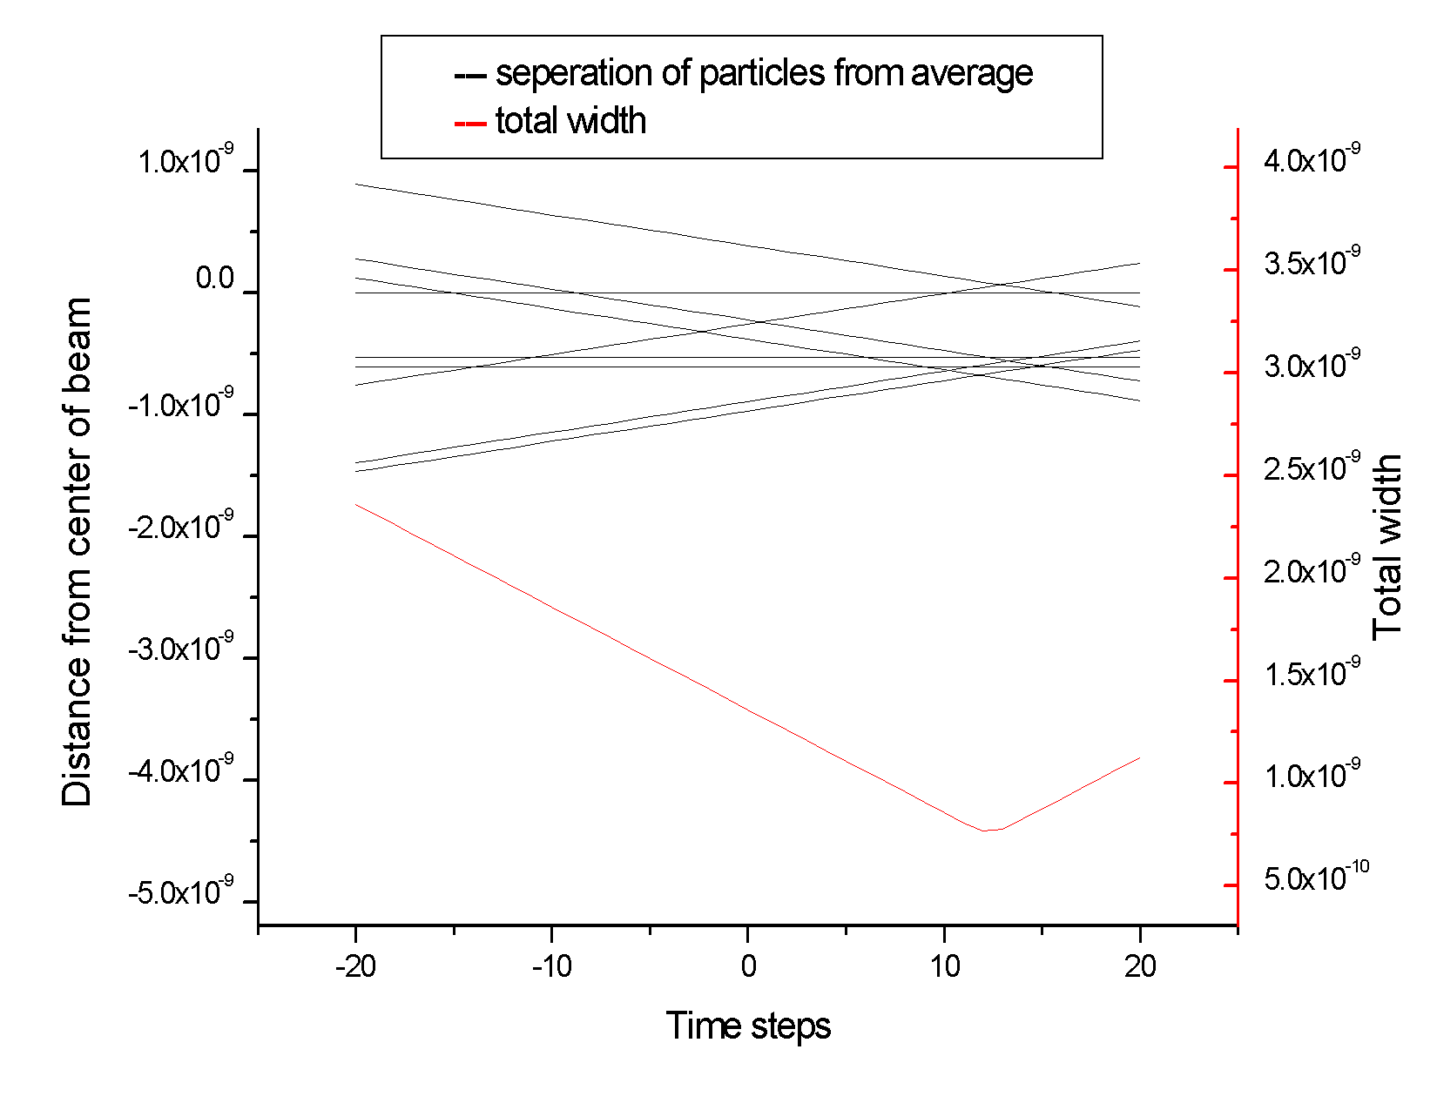4-05-11: This shows that I can now find the actual minimum of the compensator by scanning the last bit of the propagation to determine the minimum width instead of just assuming the minimum was at a certain point.

This goes with commit tag 0405

B=.031D0,dw=.8D-1, pend=1D-1

Δ v=1D-4 vini Δθ = +/- .001 radians