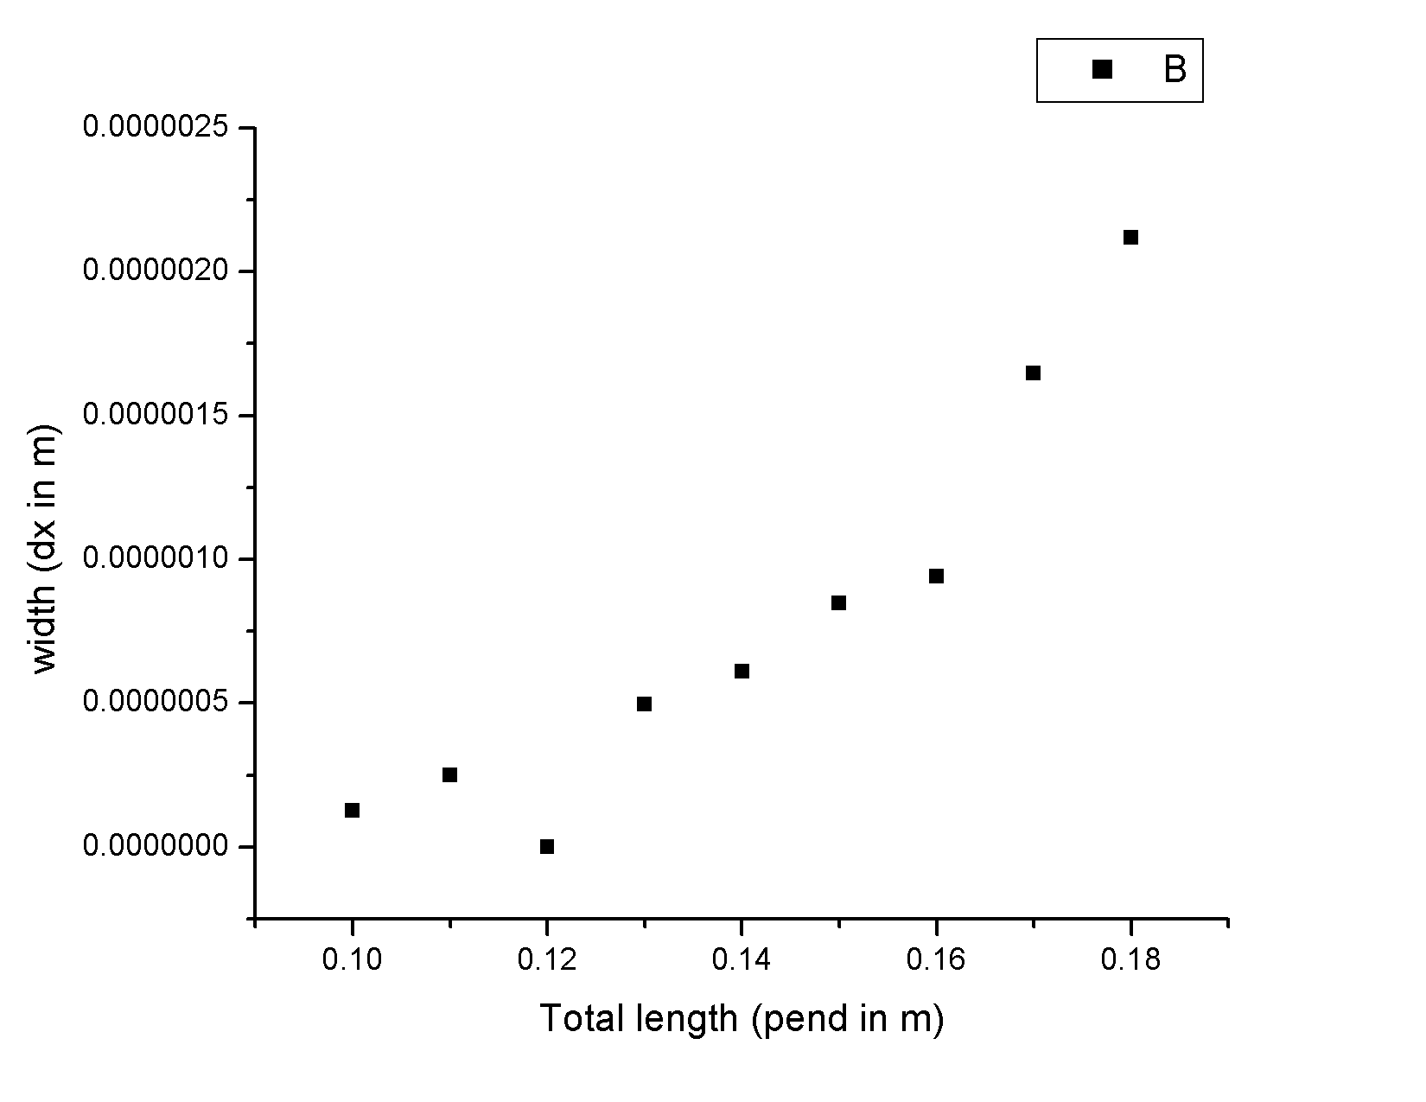This goes with commit 0407

Here I kept the filter width constant and everything else about the system (changing the filter strength to still focus the beam at the desired length) and plotted the final width.

I am using the new method of determining the minimum by scanning the width near the end of the filter.