I found that if you change the E field of the Wien filter and keep the B-Field matched you can change the location of the focus. In the first graph shows that anything lower than 90% focused the pulse inside the last B-field. You can see on the second graph that the focal point is always at 87500 μm which was the end of the B-Field for this run. But by increasing the strength of the WF you push the focal point farther away.

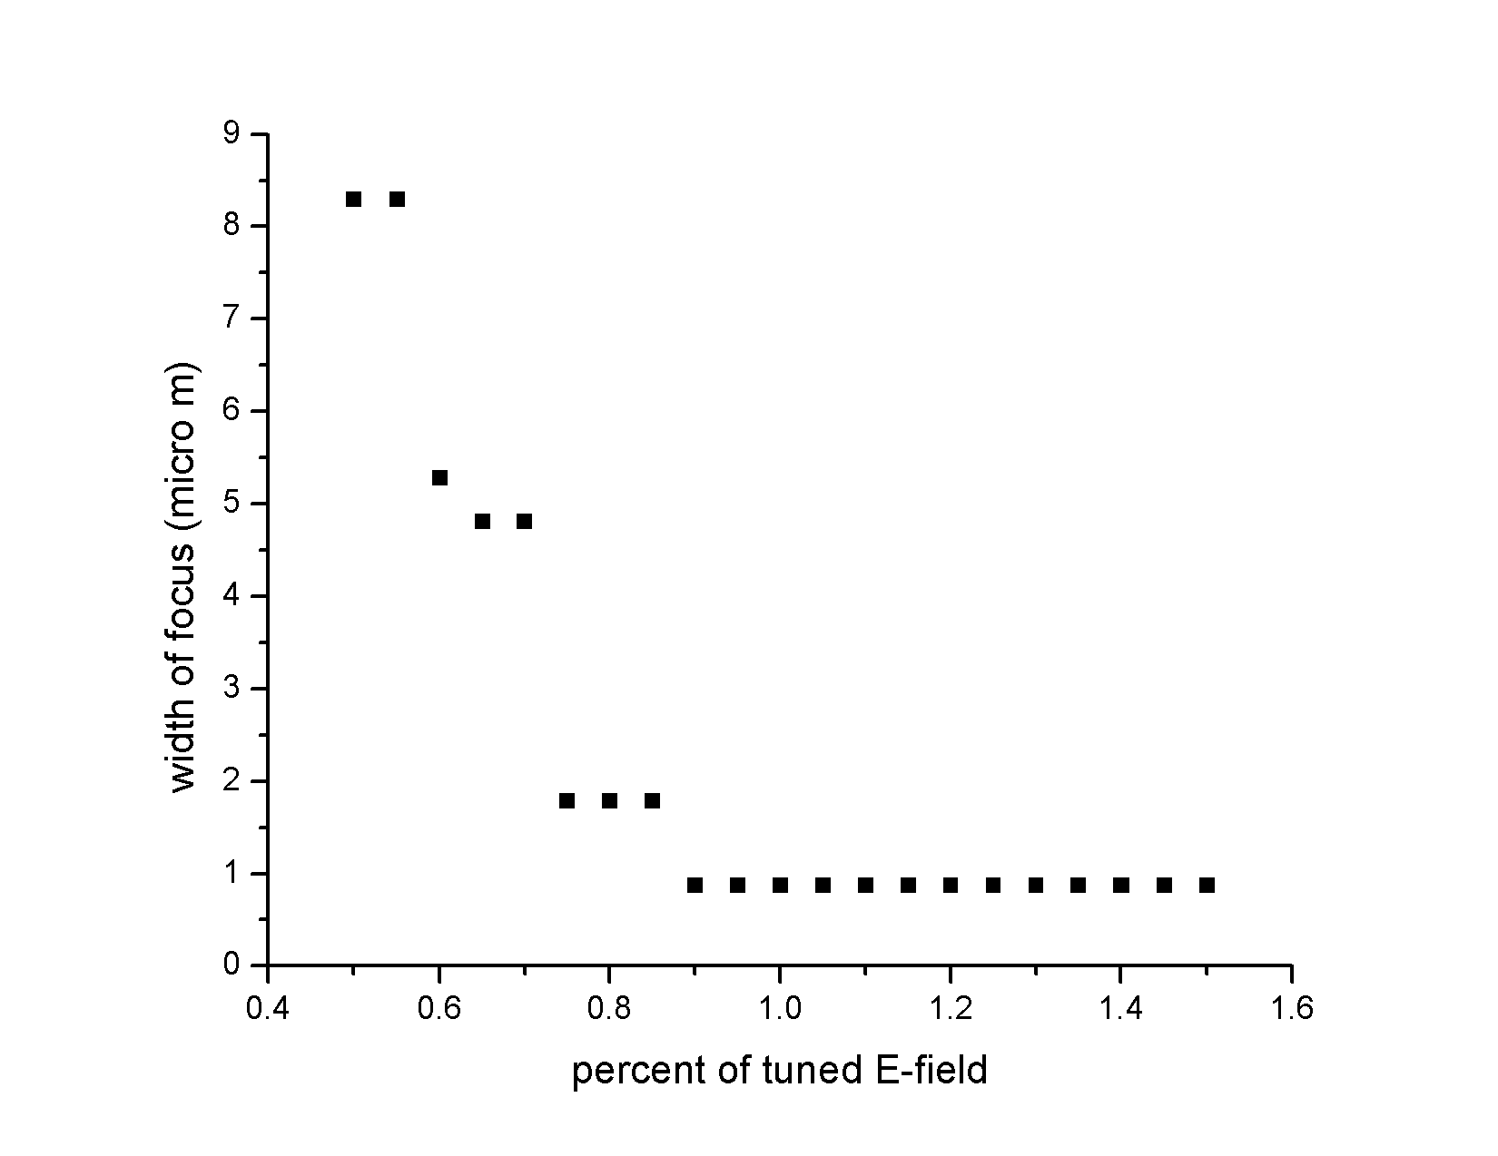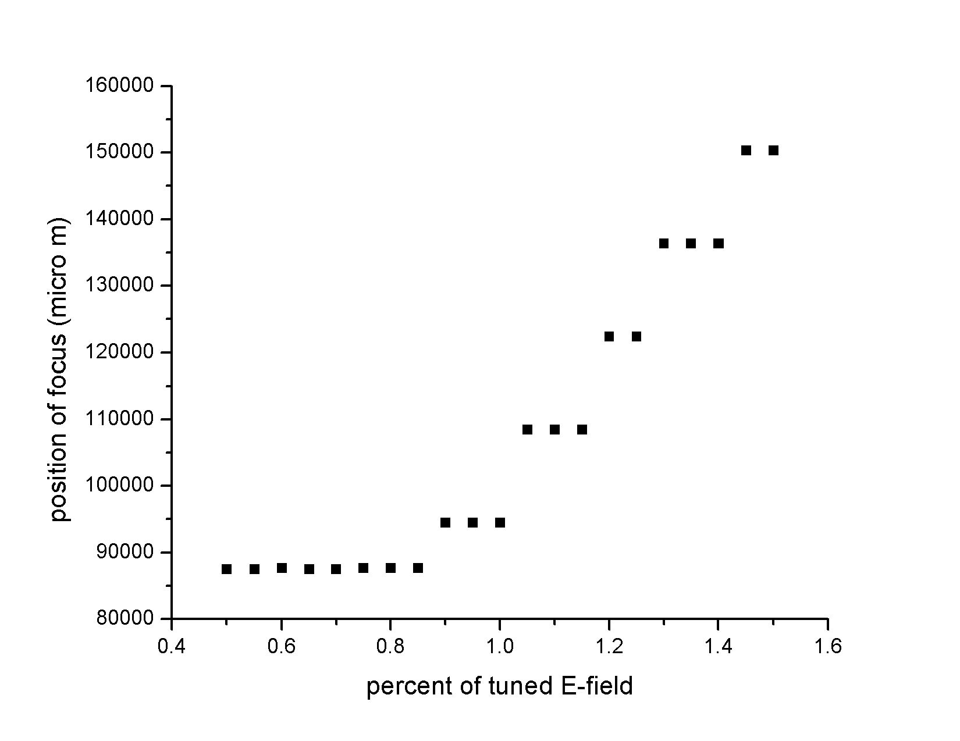

You can see though, how the data still looks discrete. I tried rescaling. On those runs everything was in micrometers and picoseconds. I think the error is within the differentiation package which I don’t quite understand yet exactly how it works. So I will try to learn more. I think it’s because I’m asking it to do too small of steps for the overall run.