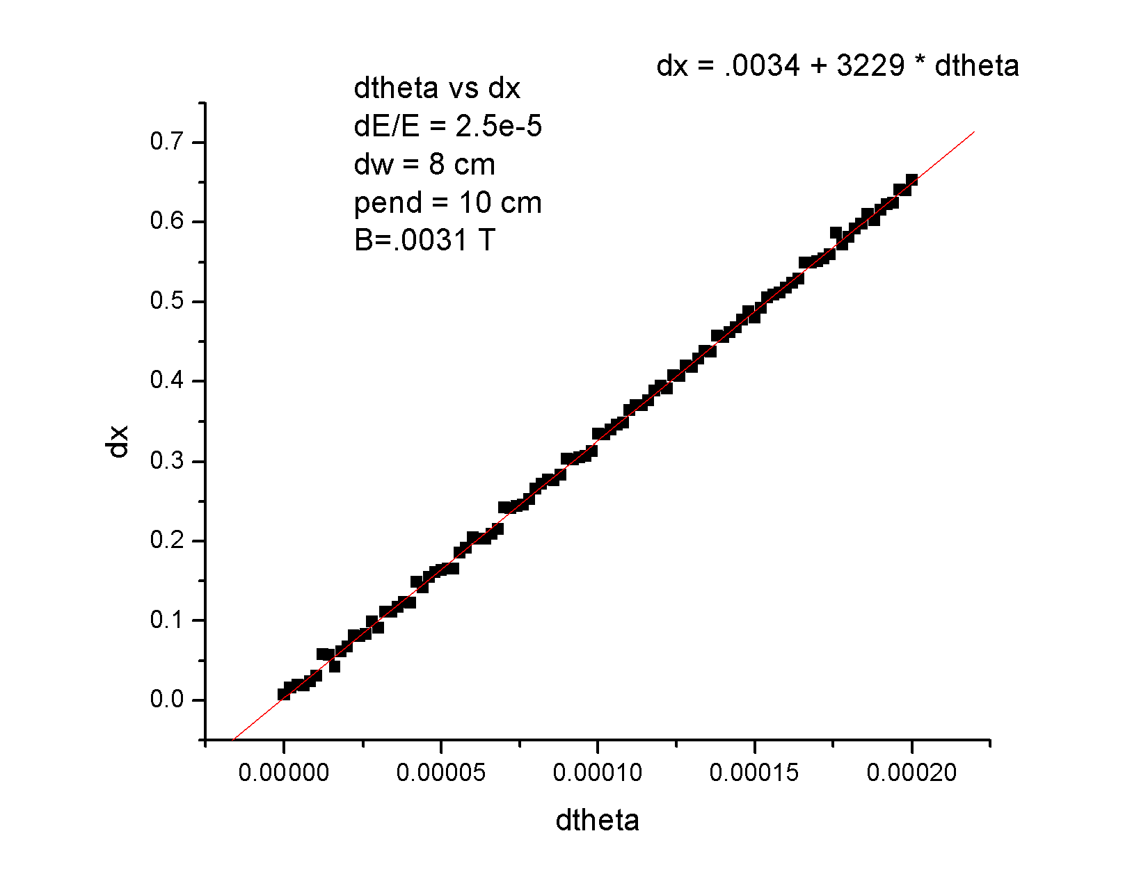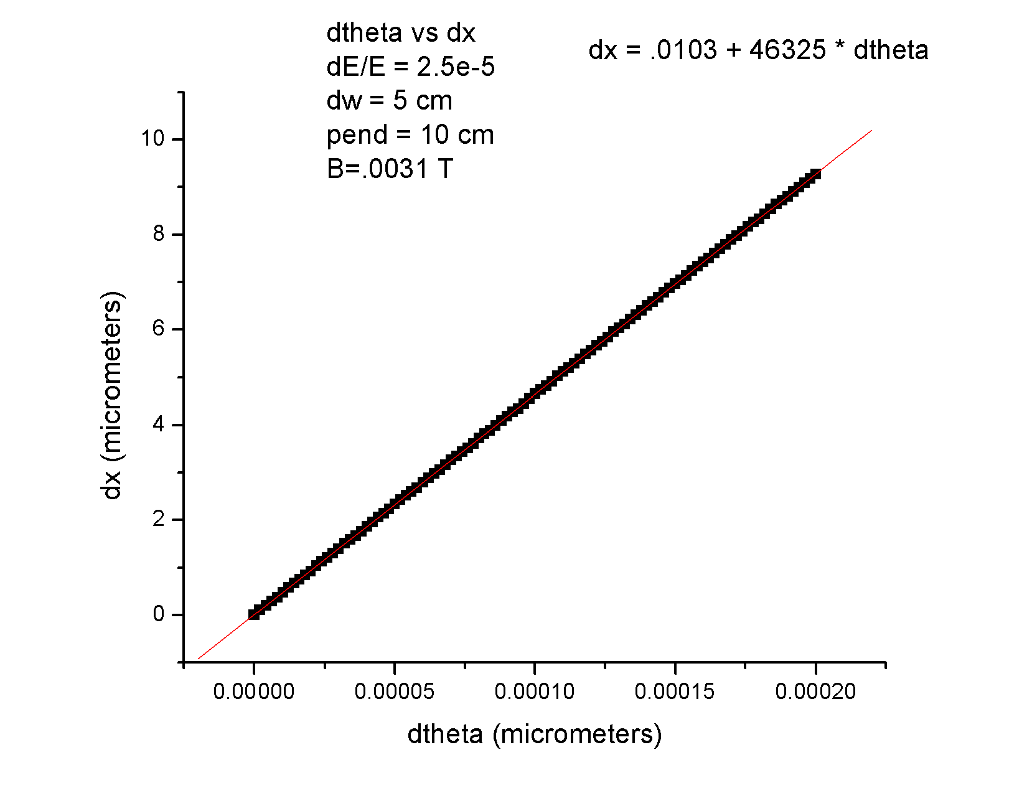

At v_0= 3.23e7 m/s: 1 micrometer is about 30 femtoseconds