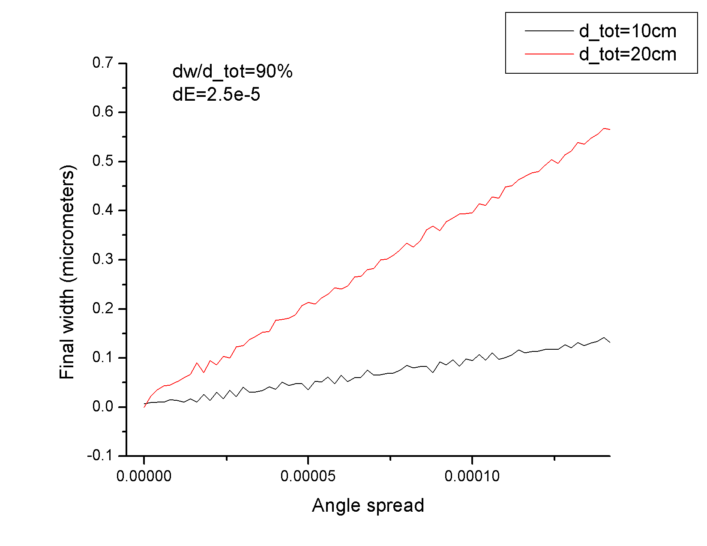

For small angles, the width is linear. It also is worse for longer total lengths

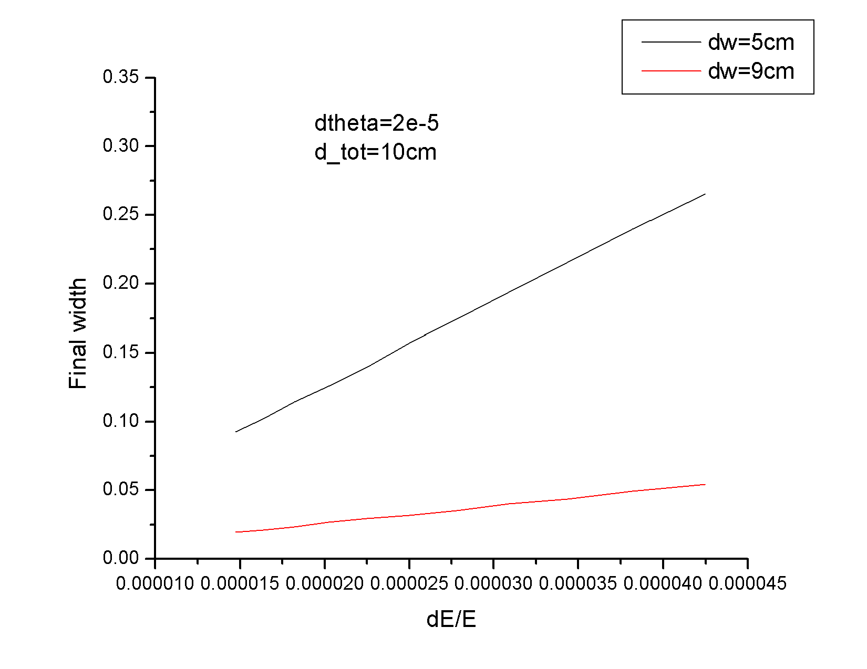

Energy also appears linear with width. This shows the difference between 50% WF and 90% WF. Recall: 10 femtosecond pulse = .3 micrometer width for 3.23e7 m/s. Angles in Radians and Widths in micrometers

I cut the following plot into 3 pieces so you can see what happens at each section. The last plot is the next three end to end.