I found that the sharp increase in width was due to a lucky bad angle. It was corrected by reducing the step size in the turning B-Fields. Here is the previous data with the spike removed and the some new tests showing that the data should be linear through scan.

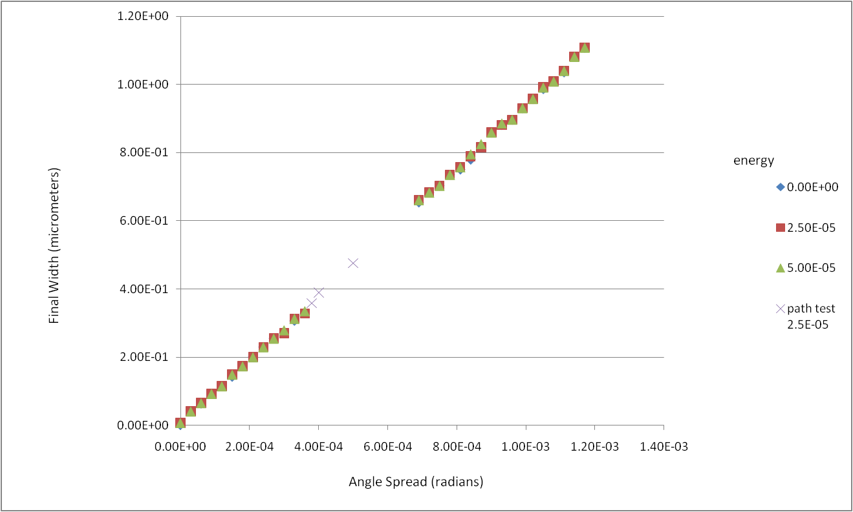

Figure

Figure 2 shows how the final width changes with respect to the energy spread. The relationship appears to be quadratic which agrees with the idea that the particles are spread linearly by velocity but delayed linearly by energy. Figure 3 shows the relationship at low energy spreads. The slope goes to zero which also supports the quadratic fit.

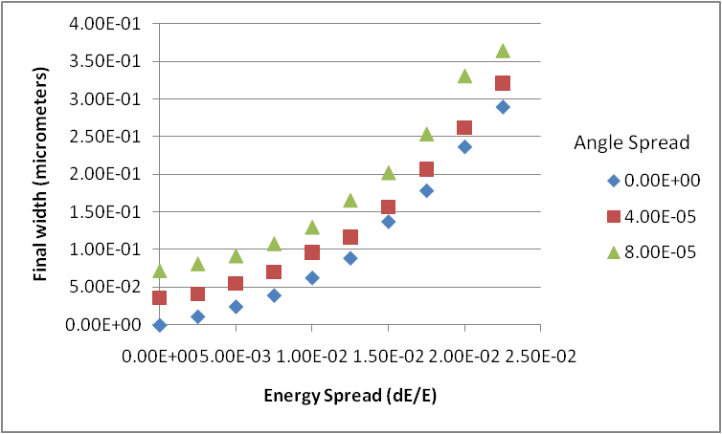

Figure

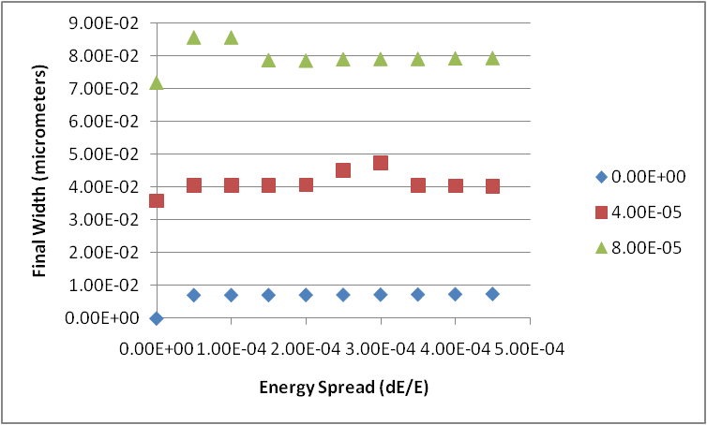

Figure

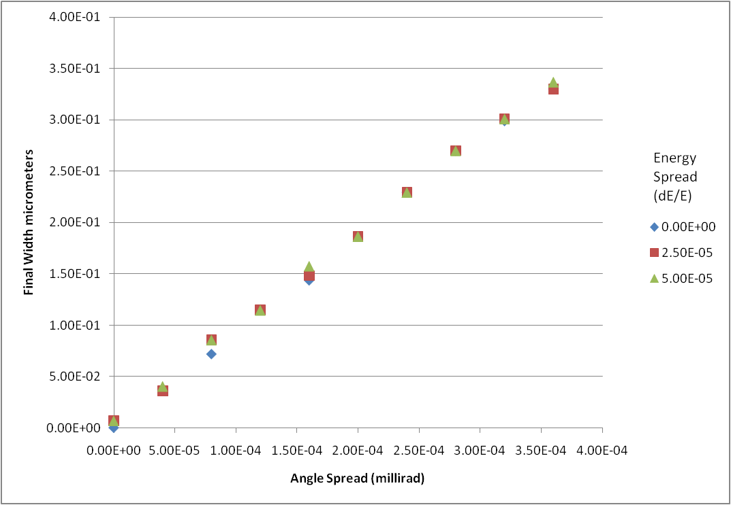

Figure

Figure 4 shows the angle spread vs width but is corrected from the previous graph that had the sharp increases.

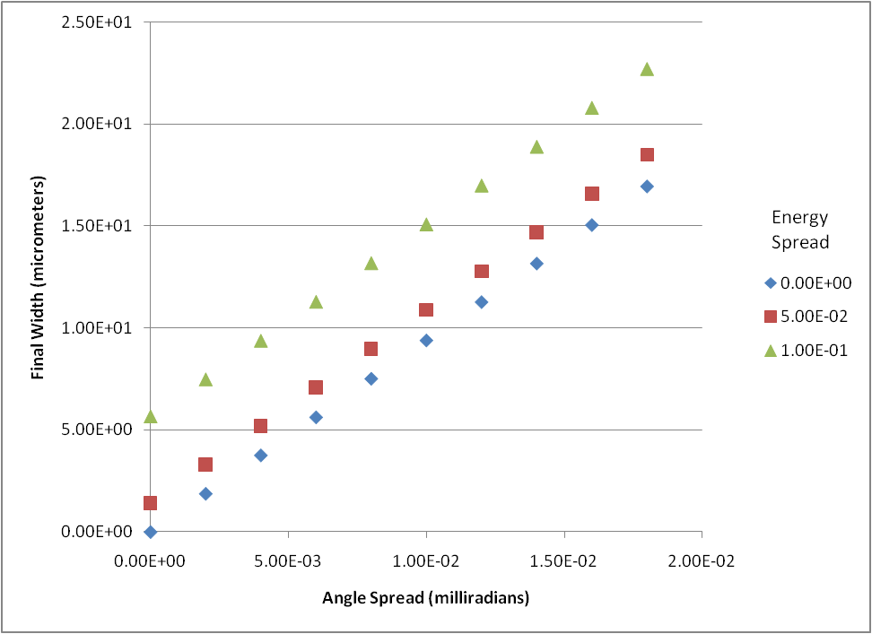

Figure – Plot that also shows angle spread and energy spread