I have done some analytical work for both the delays, one caused by the potential difference and one cause by the angle deflection. This is what I came up with
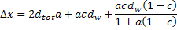
Where and .
To find the angle of the electron I found y’/x’.
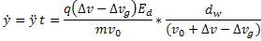
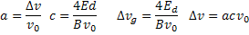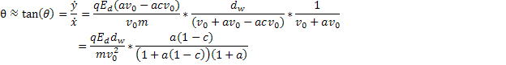
The delay from the angle deflection is
The delay from the potential is given here
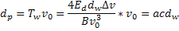
The amount that the electron would be ahead is
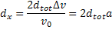
This gives the final equation given above.

Analysis of this equation showed that the pulse width depends on the ratio of d_{tot} to d_{w}, the closer to 2 the better.
Ive done quite a bit of analysis on this equation but will report more later to find out if it correlates with my programs results.

