**Schedule任务管理系统技术文档**

1. **开发环境：**

后台语言：Python 2.7

后台框架：Django

开发IDE：PyCharm

数据库：Sqlite3

后台采用的第三方app：

|  |  |  |
| --- | --- | --- |
| Django | 1.5.5 |  |
| South | 0.8.2 |  |
| antiorm | 1.1.1 |  |
| db | 0.0.15 |  |
| db-sqlite3 | 0.0.1 |  |
| django-filebrowser | 3.5.2 |  |
| django-grappelli | 2.4.8 |  |
| django-mptt | 0.6.0 |  |
| pip | 1.4.1 |  |
| setuptools | 0.9.8 |  |
| PIL | 1.1.7 |  |

前端技术：Jquery+Bootstrap

前端使用第三方app:

|  |  |  |
| --- | --- | --- |
| jquery | 1.10.1 |  |
| bootstrap | 2.3.2 |  |
| jquery.dataTable | 1.9.4 |  |
| TableTools | 2.1.4 |  |
| jquery.jstree | 1.0 |  |
| bootbox | 3.3.0 |  |
| jquery.confirm | 1.2 |  |
| jquery.cookie | 1.4.1 |  |
| jquery.hotkeys | 2.0 |  |
| jquery.modal | 1.0 |  |
| miniyui | 1.6.1 |  |
| perfect-scrollbar | 0.4.10 |  |

服务器：apache 2.2+ mod_wsgi

服务器操作系统：win7、winXP、win2003

推荐浏览器：Firefox/Chrome最新版+Adobe Flash插件

1. **数据库结构：**

使用中的表

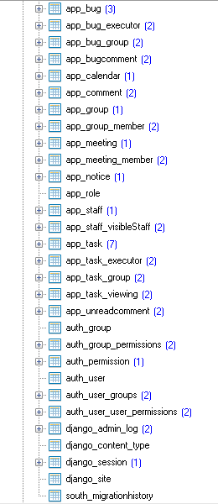

下面对主要的表结构进行介绍，没有介绍关联表。

* auth_user：用于记录与用户登录的相关信息。

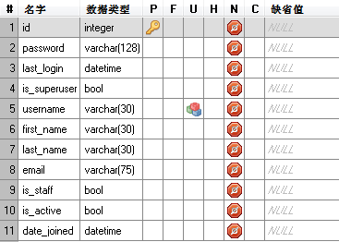

* app_staff:用户表

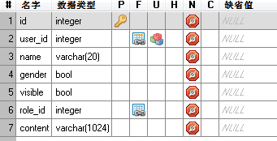

* app_group：小组表

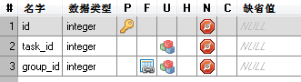

* app_role：角色表（权限表）

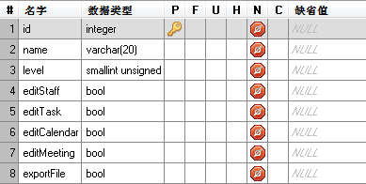

* app_task：任务表

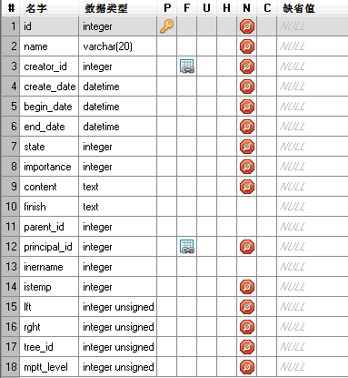

* app_bug：Bug表

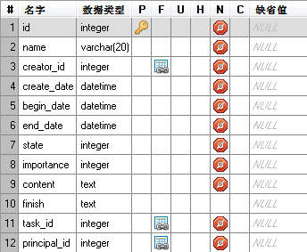

* app_comment：评论反馈表

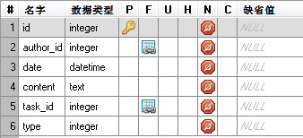

* app_meeting：会议表

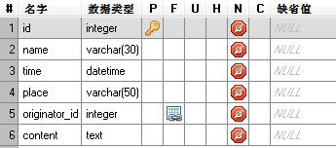

* app_notice：通知表

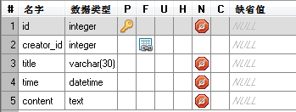

* app_bugcomment：Bug评论反馈表

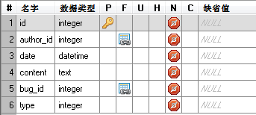

* app_unreadcomment：最新评论表

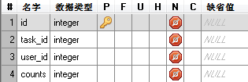

* app_calendar：日程表

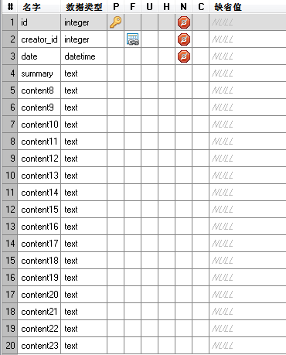

**三、服务器部署**

* 安装Apache2.2，mod_wsgi模块放置到modules文件夹下
* 安装python2.7.x（可能要添加环境变量）（python,Apache,mod_wsgi必须都为32位或64位）
* 配置Apache(httpd.conf),添加一行 `LoadModule wsgi_module modules/mod_wsgi.so`，include自定义VirtualHost,添加`Include conf/extra/my.conf`
* 拷贝代码到服务器硬盘上
* 配置自定义VirtualHost,详见my.conf（根据服务器上代码的的路径修改）
* 修改settings.py中的db位置为实际代码部署的路径
* 更改部署代码的文件夹权限为所有权限（这一步可能不是必须的）
* 解决80端口冲突问题（这一步可能不是必须的）
* windows下防火墙问题
* my.conf文件内容：

#

# Virtual Hosts

#

# If you want to maintain multiple domains/hostnames on your

# machine you can setup VirtualHost containers for them. Most configurations

# use only name-based virtual hosts so the server doesn't need to worry about

# IP addresses. This is indicated by the asterisks in the directives below.

#

# Please see the documentation at

# <URL:http://httpd.apache.org/docs/2.2/vhosts/>

# for further details before you try to setup virtual hosts.

#

# You may use the command line option '-S' to verify your virtual host

# configuration.

#

# Use name-based virtual hosting.

#

#NameVirtualHost *:80

#

# VirtualHost example:

# Almost any Apache directive may go into a VirtualHost container.

# The first VirtualHost section is used for all requests that do not

# match a ServerName or ServerAlias in any <VirtualHost> block.

#

WSGIPythonPath F:\schedule\myapp;F:\schedule\env\Lib\site-packages

Alias /static F:\schedule\myapp\static

AliasMatch ^/([^/]*\.css) F:\schedule\myapp\static\css\$1

<VirtualHost *:80>

ServerName localhost

<Directory />

Options FollowSymLinks

AllowOverride None

Order allow,deny

Allow from all

</Directory>

<Directory F:\schedule\myapp\static>

Order deny,allow

Allow from all

</Directory>

WSGIScriptAlias / F:\schedule\myapp\setting.wsgi

<Directory F:\schedule\myapp>

<Files setting.wsgi>

Order allow,deny

Allow from all

</Files>

</Directory>

</VirtualHost>

* myapp/setting.wsgi文件内容

import os

import sys

sys.stdout = sys.stderr

from os.path import abspath, dirname, join

from django.core.handlers.wsgi import WSGIHandler

sys.path.insert(0, abspath(join(dirname(__file__), "./")))

os.environ["DJANGO_SETTINGS_MODULE"] = "myapp.settings" #your settings module

application = WSGIHandler()