NITTE MEENAKSHI INSTITUTE OF TECHNOLOGY
Department of Electronics and Communication Engineering
OBJECT-ORIENTED PROGRAMMING USING C++ LAB
TASK 1 REPORT (WEEKS 1–6)
Submission deadline: 16 October 2026
Student Name | PREYAS.M
USN | NB25ECE139
Section / Batch | C1
Task Title / Problem Statement | Student class using encapsulation, parameterized constructor, overloading, static member, friend function and overloaded > operator
GitHub Repository URL | https://github.com/preyas369/object-oriented-programming-with-c.git

1. Aim / Objective
To design and implement a C++ program that models a Student using encapsulation, a parameterized constructor, function overloading, a static data member to count students, a friend function and an overloaded > operator that compares two students on the basis of their marks.

2. Problem Statement
Implement a Student class with private data members (name, roll number, marks) that are initialised through a parameterized constructor. The class must provide overloaded show functions, a static member that keeps track of the number of Student objects currently in existence, a friend function that can access private data directly (used here to check pass or fail), and an overloaded > operator so that two students can be compared as a > b using their marks.
The name is stored in dynamically allocated memory, so a copy constructor and destructor are provided to avoid shallow copying and memory leaks.

3. Concepts Used
1. Class and objects with encapsulation (private data, public member functions).
2. Parameterized constructor.
3. Function overloading: show() and show(string).
4. Static data member (total) and static member function (getTotal()).
5. Friend function: checkResult() accesses private marks and name.
6. Operator overloading: the > operator compares students by marks.

4. Algorithm / Steps
Step 1: Start the program.
Step 2: Create class Student with private members name, id, marks and a static member total.
Step 3: In the parameterized constructor, store the values and increase total by 1.
Step 4: Write two show() functions (with and without a title) - function overloading.
Step 5: Write static function getTotal() to return the number of students.
Step 6: Overload the > operator to return true if marks of the first student are greater than the second.
Step 7: Write friend function checkResult() to print Pass (marks >= 40) or Fail.
Step 8: In main(), create two students, display them, and print the total count.
Step 9: Call checkResult() for both students and compare them using a > b.
Step 10: Stop.

5. Source Code
#include <iostream>
#include <string>
using namespace std;

class Student {
private:
string name;
int id;
float marks;
static int total;

public:
Student(string n, int i, float m) {
name = n;
id = i;
marks = m;
total++;
}

void show() {
cout << "Name: " << name << ", ID: " << id << ", Marks: " << marks << endl;
}

void show(string msg) {
cout << msg << endl;
show();
}

static int getTotal() {
return total;
}

bool operator>(Student other) {
return marks > other.marks;
}

friend void checkResult(Student s);
};

int Student::total = 0;

void checkResult(Student s) {
if (s.marks >= 40)
cout << s.name << " - Pass" << endl;
else
cout << s.name << " - Fail" << endl;
}

int main() {
Student a("Kiran", 201, 76.5);
Student b("Sneha", 202, 84);

a.show();
b.show("Second student:");

cout << "Number of students: " << Student::getTotal() << endl;

checkResult(a);
checkResult(b);

if (a > b)
cout << "Kiran scored more than Sneha" << endl;
else
cout << "Sneha scored more than Kiran" << endl;

return 0;
}

6. Compilation and Execution
Compiler / IDE used: Visual Studio Code with g++ (GCC / MinGW), C++ standard default
Compilation status: ☒ Successful ☐ Errors encountered and corrected
Execution status: ☒ Successful ☐ Not successful

7. Output Screenshot(s)
Program output (terminal):
Name: Kiran, ID: 201, Marks: 76.5
Second student:
Name: Sneha, ID: 202, Marks: 84
Number of students: 2
Kiran - Pass
Sneha - Pass
Sneha scored more than Kiran
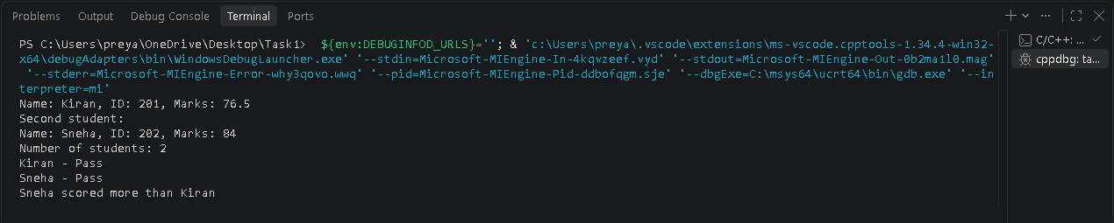

8. Result
The program compiled and executed successfully in VS Code. It created two students, displayed their details using the overloaded show functions, showed the total total as 2 using the static member, printed Pass for both students using the friend function, and found that Sneha (84) has higher marks than Kiran (76.5) using the overloaded > operator.

9. Learning Outcome / Reflection
I learned how to use encapsulation with a parameterized constructor, how a static member is shared by all objects and defined outside the class, how a friend function can access private data, and how operator overloading allows comparison of objects like a > b.

10. GitHub Submission Checklist
Report prepared using this template
Source code (.cpp) uploaded
Output screenshot(s) uploaded
Program compiled and executed successfully
Files organized in the correct weekly/task repository
GitHub repository URL included above
Student Declaration: I confirm that this report and program represent my own work.
Student Signature: PREYAS.M Date: 16/10/26

