  - FINTECH ANALYST INTERNSHIP

Bank of America
Historical Stock Analysis
  - Final Project Report
Week 6 | Reporting and Presentation

Data exploration, forecasting, risk analysis, hypothesis testing and interactive visualization.
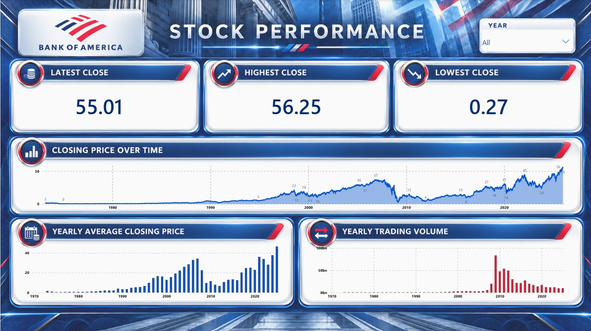
Project dashboard developed in Power BI
Prepared by Preyash Gandhi
Fintech Analyst Intern | October 2026
Dataset period: 21 February 1973 to 31 December 2025
Tools: Python, Pandas, Matplotlib, SciPy and Power BI

Executive Summary
This project examines Bank of America historical stock data to understand price patterns, evaluate simple forecasts, measure historical risk and communicate findings through Power BI. I used 13,329 daily records covering 21 February 1973 to 31 December 2025. The main finding is that a positive historical average daily price return coexisted with substantial volatility and severe losses. Average performance therefore needs to be interpreted alongside downside risk and data limitations.
I began by checking and preparing the data, retaining all records while flagging six zero-volume observations and 66 unusually high closing prices. I then compared two fixed forecasts over the final 60 sessions. The 20-session average achieved lower errors than the naive benchmark on this test period, although neither method captured the later upward price movement.
The risk analysis estimated annualized historical volatility at 37.52% and a maximum observed closing-price drawdown of 93.45%. A two-sided t-test found evidence of a positive historical mean daily return under its assumptions. Finally, two Power BI dashboard pages brought together stock performance and data-quality indicators with synchronized year filters.
The findings support closer validation of corporate-action adjustments, evaluation across multiple forecast periods and ongoing monitoring of changing volatility. They describe the historical dataset and do not establish future performance.

Report Guide
Section | Page
Dataset and exploratory analysis | 3
Forecasting and evaluation | 4
Historical risk analysis | 5
Hypothesis testing | 6
Power BI dashboards | 7
Overall insights and limitations | 8
Recommendations and conclusion | 9

Scope: This is a stock-data analysis project. It does not assess the bank’s loan portfolio, capital adequacy, internal operations or regulatory compliance.

Dataset and Exploratory Analysis
  - Week 1 | Data acquisition and preparation
I downloaded the Bank of America stock dataset from Kaggle, converted and sorted dates, and checked the original eight columns for missing values and duplicates. No missing values, duplicate rows or duplicate dates were found. The cleaned file retained 13,329 records and added Year, Zero_Volume_Flag and Close_Outlier_Flag, producing 11 columns.
Measure | Result
Historical coverage | 21 February 1973 to 31 December 2025
Mean and median closing price | $12.86 and $10.10
Minimum and maximum closing price | $0.27 and $56.25
Mean daily trading volume | 38.72 million shares
Flagged observations | 6 zero-volume records; 66 closing-price outliers

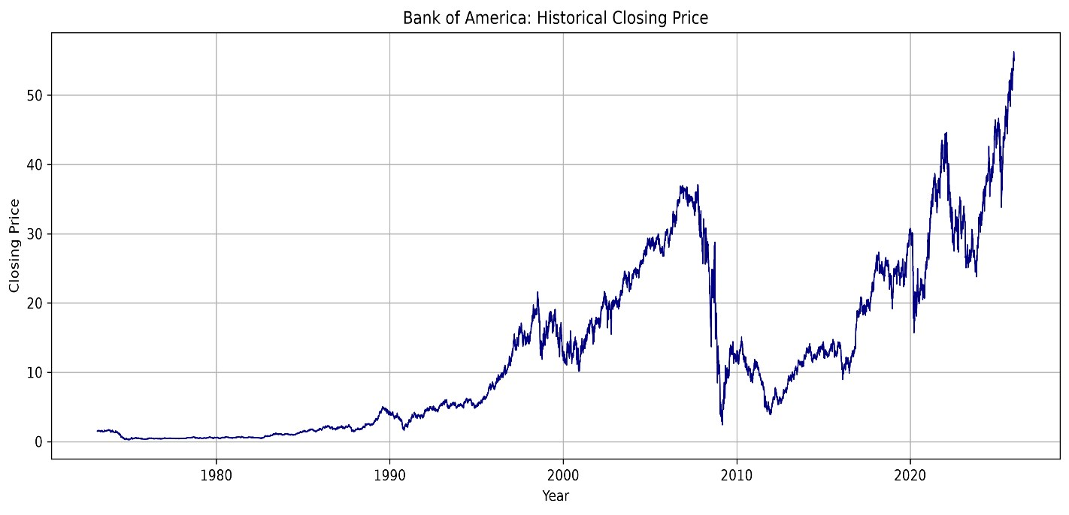
Figure 1. Historical closing prices reproduced from the Week 1 analysis.

What the Exploration Showed
The mean closing price exceeded the median, consistent with a right-skewed full-history distribution. The annual average closing price rose from $12.49 in 2016 to $46.61 in 2025, with declines in some intervening years. All five highest-volume sessions occurred in 2009; the largest daily volume was about 1.227 billion shares on 4 December 2009.
The global 1.5 × IQR rule flagged 66 closing prices above approximately $50.38, all in 2025. I retained these records because an unusually high historical price is not automatically incorrect. The cause of the six zero-volume records remains unverified. Price levels and annual averages should not be interpreted as total investment returns.

Forecasting and Evaluation
  - Week 2 | Closing-price forecasts
I reserved the final 60 trading sessions, from 7 October to 31 December 2025, for testing. The training set contained 13,269 records through 6 October 2025. Both methods generated the entire test forecast from the training cutoff, without updating from test-period prices.
Method | Fixed test forecast | MAE | RMSE
Naive benchmark | $50.13 | $2.86 | $3.28
20-session average | $50.95 | $2.23 | $2.64

The naive benchmark repeated the final training close. The alternative repeated the mean of the last 20 training closes. The 20-session window was fixed before comparing test errors. MAE and RMSE are measured in USD; lower values indicate smaller errors on the evaluated period.
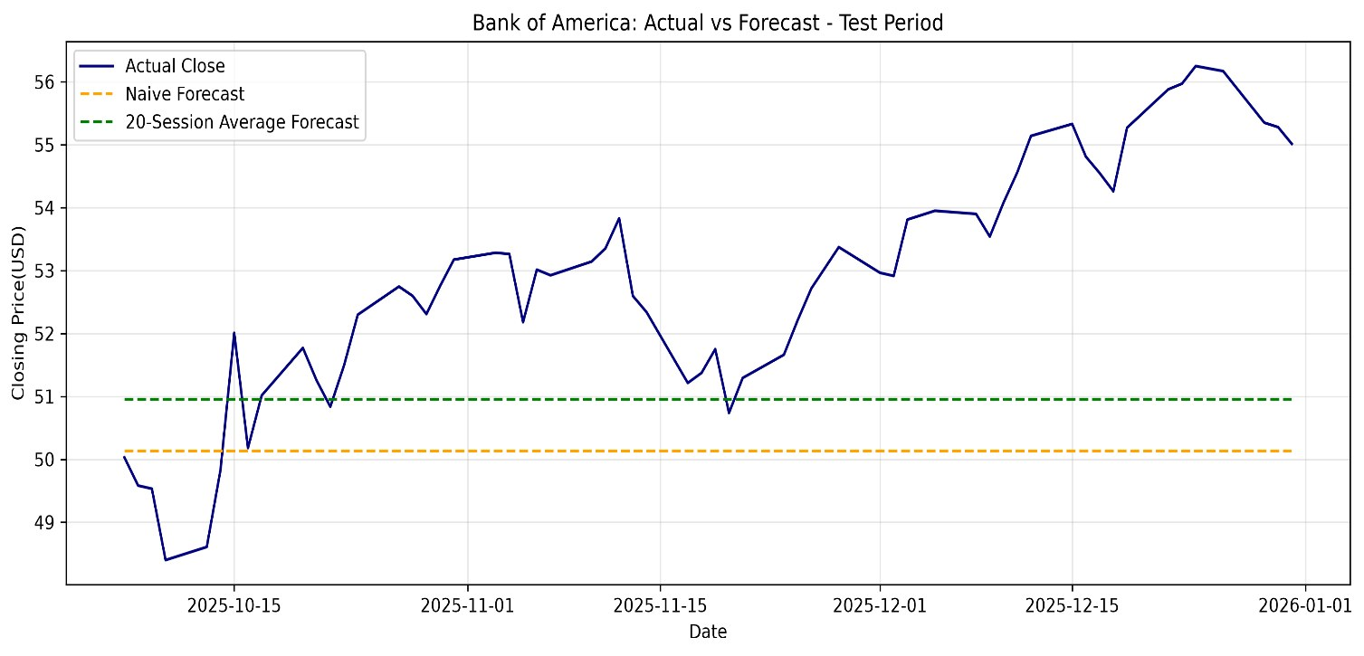
Figure 2. Actual prices and fixed forecasts during the 60-session test period.

Interpretation and Forecast Beyond the Dataset
The 20-session average performed better on both error measures in this test. However, both forecasts underestimated prices during the later upward movement. This single comparison does not establish that the average-based method will consistently outperform the benchmark.
Using the final 20 observations through 31 December 2025 produced a fixed estimate of approximately $54.85 for each of the next 60 trading sessions. This was a forecast from the historical dataset cutoff, not a current market forecast. Its subsequent accuracy was not measured, and prediction intervals were not calculated.

Historical Risk Analysis
  - Week 3 | Volatility and downside exposure
I calculated daily price returns from consecutive closing prices. Daily volatility was measured using their standard deviation, and annualized volatility was estimated by multiplying it by the square root of 252. Drawdown compared each close with the highest closing price observed up to that date.
Risk measure | Historical result
Daily return volatility | 2.36%
Annualized historical volatility | 37.52% using 252 sessions per year
Sessions with daily return at or below −5% | 225
Worst observed daily return | −28.97% on 20 January 2009
Maximum observed drawdown | 93.45% decline
Drawdown peak to trough | 5 October 2007 to 6 March 2009

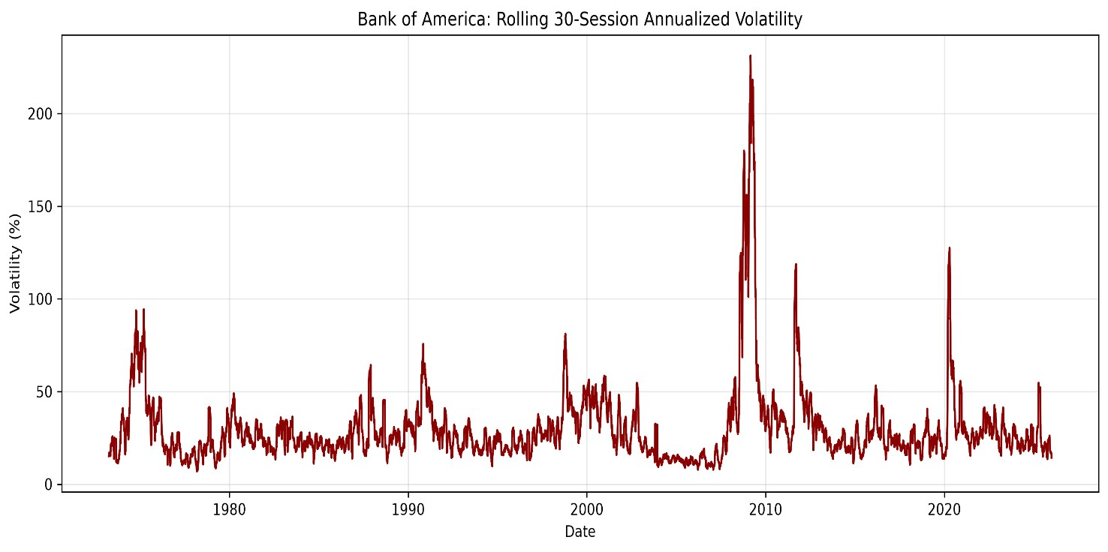
Figure 3. Annualized volatility over rolling 30-session windows from Week 3.

What the Risk Measures Mean
The rolling chart shows that volatility changed over time, so the full-history estimate should not be treated as a constant risk level. The severe drawdown and large-loss sessions show why an average return alone gives an incomplete picture of historical stock-price risk.
The −5% threshold was an exploratory definition of a large-loss session, not an official risk limit. Corporate-action adjustments were not confirmed, which may affect returns, volatility and drawdown. The square-root annualization is an estimate based on the chosen scaling convention.

Hypothesis Testing
  - Week 4 | Testing the historical mean daily return
I used a two-sided one-sample t-test to examine whether the mean daily price return differed from zero. Calculating returns removed the first price observation from the test because it had no previous close, leaving 13,328 daily returns. The significance level was 5%.

Hypotheses
Null hypothesis H₀: The population mean daily return is zero.
Alternative hypothesis H₁: The population mean daily return differs from zero.
Statistic | Result
Number of daily returns | 13,328
Mean daily return | 0.054831%
Median daily return | 0.000000%
Standard deviation | 2.363429%
t-statistic | 2.6783
Degrees of freedom | 13,327
p-value | 0.0074
95% confidence interval for mean daily return | 0.0147% to 0.0950%

Decision and Interpretation
Because the p-value was below 0.05, I rejected the null hypothesis under the test assumptions. The sample mean and confidence interval were positive, supporting a positive average daily price return over the historical sample.
This result does not imply that daily losses were rare, that the stock was low risk, or that future returns will be positive. Week 3 showed large losses and substantial drawdown within the same history. Statistical significance also does not establish economic importance, particularly with a large sample.

Assumptions That Affect the Result
The standard t-test assumes independent observations. Financial returns may show dependence and changing volatility, so the reported inference needs cautious interpretation. The closing-price adjustment method was also unverified. The calculated returns are therefore price-based measures, not confirmed total returns including dividends.

Power BI Dashboards
  - Week 5 | Communicating the findings
I created two pages with KPI cards, time-series and annual charts, and synchronized year slicers. The screenshots below show all years selected; the interactive report supports period-specific exploration.
Figure 4. Stock Performance dashboard. Full-history latest close $55.01, highest $56.25 and lowest approximately $0.27.
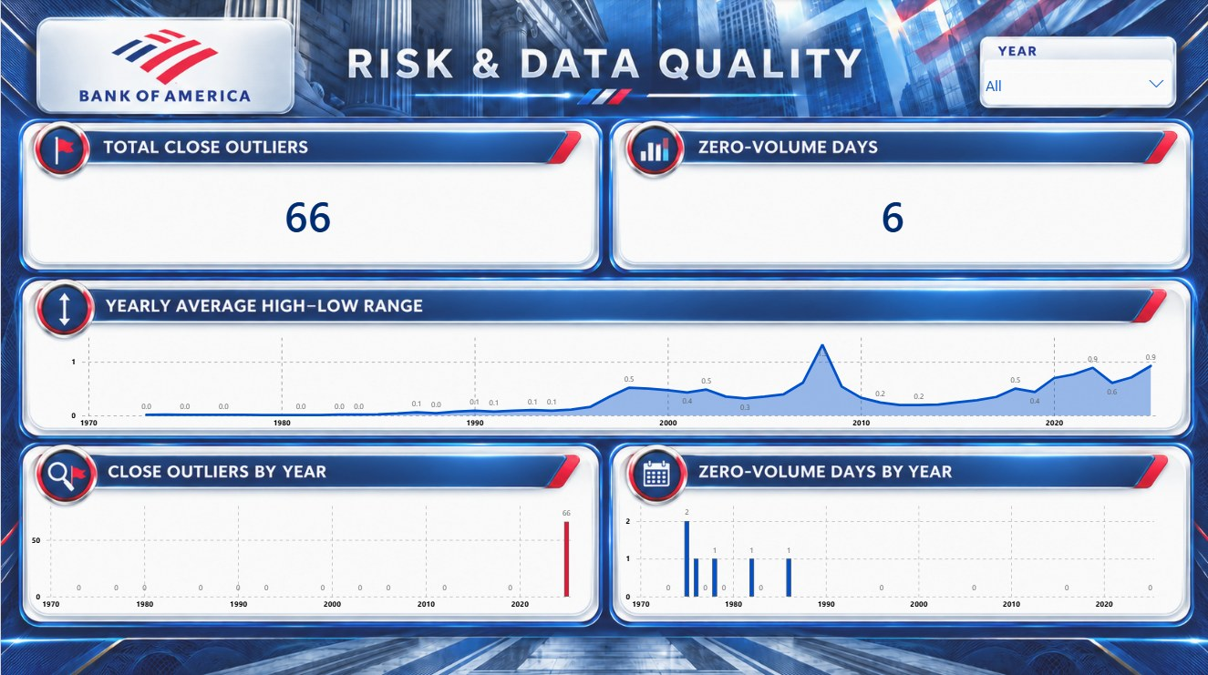
Figure 5. Risk and Data Quality dashboard. All 66 closing-price flags occur in 2025; six zero-volume records occur in earlier years.
The yearly high–low measure averages daily High minus Low in dollars. It is not percentage return volatility. Latest Close refers to the final available dataset date, not a live quote. Screenshot labels are rounded; precise interpretation should use the underlying values.

Overall Insights and Limitations

Positive Averages Coexisted With Severe Losses
The t-test and risk analysis answer different questions. The first assesses evidence about the historical mean; the second describes variation and downside movements. Taken together, they show that a positive average price return can coexist with a 93.45% peak-to-trough decline. A useful report should present both rather than relying on one summary statistic.

Price Trends Affected Both Flags and Forecasts
The concentration of all 66 IQR flags in 2025 is consistent with higher recent prices relative to the full history. It does not establish that the observations are invalid. The upward movement in the forecast test period also exposed the limits of constant predictions. These results show why the time period and changing price levels matter when applying simple statistical methods.

Trading Activity Needs Context
The largest daily trading volumes were concentrated in 2009, and the Power BI annual view also highlighted elevated volume around that period. High activity describes shares traded, not profit, price direction or a verified cause. Event-level explanations would require additional evidence.

Data Validation Affects Every Stage
The same cleaned file supported exploration, forecasting, risk measures, testing and dashboards. This kept the project consistent, but it also means that any unresolved source issue can carry through every stage. Retaining flagged records preserved the observations while making their review status visible.

Main Limitations
The analysis covers one company and ends on 31 December 2025. It excludes subsequent market observations and cannot represent the banking sector as a whole. The dataset contains no separate adjusted-close field, and its adjustment method has not been confirmed.
Forecast evaluation used one 60-session holdout, two constant methods and no prediction intervals. The t-test may be affected by dependence and changing volatility. Full-history averages combine different market conditions, annual totals depend on coverage, and dollar price ranges are influenced by price levels. None of these analyses establishes the causes of market movements or guarantees future performance.

Recommendations and Conclusion

Recommended Next Steps
1. Validate the source data. Confirm how splits and dividends are treated, check the six zero-volume records and review the 66 price flags against an independent reliable source. Keep a record of any corrections and their impact on the analysis.
2. Strengthen forecast evaluation. Use several chronological or rolling-origin test periods, retain a naive benchmark and compare additional methods under the same conditions. Evaluate uncertainty as well as point errors, and test the final forecast when subsequent actual data is available.
3. Extend the risk and statistical analysis. Compare rolling and period-specific volatility and drawdown, and assess statistical inference with methods that account for time-series dependence. If suitable adjusted data is obtained, distinguish price returns from total returns.
4. Improve comparison and monitoring. Add a relevant market or banking benchmark, show dataset coverage and refresh dates, and retain clear definitions for dashboard measures. These are proposed extensions and were not implemented in the completed weekly work.

Conclusion
Across the five analysis stages, I developed a workflow from data preparation to reporting. The project combined transparent data-quality flags, benchmark-based forecast evaluation, historical risk measures, hypothesis testing and interactive dashboards. The results demonstrate why financial analysis should consider data reliability, model limitations and downside outcomes alongside average performance.
The most useful next step is to validate adjustment details and flagged records before extending the analysis. Broader testing and benchmark comparisons would then make the findings more informative across different market conditions.

Sources and Project Files
Dataset: Bank of America Corp Stock Data, published by isaaclopgu on Kaggle. The snapshot used covers 21 February 1973 to 31 December 2025.
https://www.kaggle.com/datasets/isaaclopgu/bank-of-america-corp-stock-data-daily-updated
Analysis sources: My Week 1 EDA, Week 2 Forecasting, Week 3 Risk Analysis, Week 4 Hypothesis Testing and Week 5 Data Visualization reports. Figures 1–5 reproduce charts and dashboards from those reports.
Project repository:
https://github.com/preyashgandhi00-stack/Bank-of-America-Financial-Analysis

