BANK OF AMERICA
Financial Forecasting Report
Week 2: Creating Financial Forecasts
Prepared by: Preyash Gandhi
Role: Fintech Analyst Intern
Project Overview
This project uses the cleaned Week 1 dataset to forecast Bank of America’s closing stock price. Two simple methods—a naive forecast and a 20-session average forecast—are evaluated on the final 60 trading sessions using MAE and RMSE. The report explains the model design, compares forecast performance, and presents a 60-session forecast based on data available through 31 December 2025.

1. Project Objective
The objective of this project is to develop and evaluate a basic forecasting model for Bank of America’s closing stock price using the cleaned Week 1 dataset. A 20-session average forecast is compared with a naive benchmark. Performance is measured using Mean Absolute Error (MAE) and Root Mean Squared Error (RMSE).
After evaluation, a forecast is generated for the next 60 trading sessions beyond the dataset’s final date.
2. Dataset Overview
Item | Details
Dataset | Bank of America historical stock data
Source | Kaggle — dataset published by isaaclopgu
Input file | Bank_of_America_Cleaned.csv
Total records | 13,329
Date range | 21 February 1973–31 December 2025
Columns used | Date and Close
Forecast target | Closing stock price in USD
3. Data Preparation and Split
The cleaned dataset from Week 1 was loaded into Python. Dates were converted to datetime format in the America/New_York timezone, and observations were sorted chronologically. Only the Date and Close columns were selected for forecasting.
The final 60 trading sessions were reserved for testing. All earlier observations formed the training dataset.
Dataset | Records | Period
Training | 13,269 | 21 February 1973–6 October 2025
Testing | 60 | 7 October–31 December 2025
A chronological split preserves the order of events. Both methods generate all 60 test forecasts using only information available at the training cutoff. Test closing prices are used solely to evaluate those forecasts.
4. Model Design and Justification
4.1 Selected Financial Indicator
Closing stock price (Close), measured in USD, was selected because it provides a consistent daily measure of the stock’s price and was analysed during Week 1.
4.2 Naive Forecast — Benchmark
The naive method uses the last training closing price, approximately $50.13, as the forecast for all 60 test sessions. This provides a simple benchmark for evaluating the average-based method.
4.3 20-Session Average Forecast
This method calculates the mean of the final 20 closing prices in the training data. The resulting value, approximately $50.95, is used as a fixed forecast for all 60 test sessions.
Formula: Forecast = Sum of the last 20 observed closing prices ÷ 20
A 20-session window represents roughly one trading month. It gives equal weight to recent observations and reduces dependence on a single day’s price. The window was fixed before comparing test errors and was not tuned using the test results.
4.4 Model Assumptions
The average-based method assumes that the recent average price is a useful estimate for the forecast horizon. It does not explicitly model trends or daily fluctuations. Both methods keep their forecasts constant throughout the 60-session test period.

5. Implementation and Model Evaluation
The forecasting workflow was implemented in Python using Pandas for data preparation and calculations, and Matplotlib for visualisation. Predictions, absolute errors, model comparison metrics, and forecasts beyond the dataset were exported as CSV files.
Two metrics were used to evaluate forecasts on the same 60-session test period:
- Mean Absolute Error (MAE): The average absolute difference between actual and forecast prices.
- Root Mean Squared Error (RMSE): The square root of the average squared errors. It gives greater weight to larger errors.
Both metrics are expressed in USD. Lower values indicate better performance on the evaluated period.
Evaluation Results
- Naive forecast: MAE = $2.86; RMSE = $3.28.
- 20-session average forecast: MAE = $2.23; RMSE = $2.64.
The 20-session average produced lower errors on both metrics and was therefore used for the forecast beyond the dataset. However, this comparison covers only one test period and does not establish that the method will consistently outperform the naive benchmark.

6. Actual vs Forecast Analysis
The chart compares actual closing prices with both fixed forecasts during the test period. Actual prices fluctuated but generally increased, reaching levels above $56 in December. Both forecasts underestimated prices during the later part of the period.
The 20-session average forecast of approximately $50.95 was closer to actual prices overall than the naive forecast of $50.13, as reflected in its lower MAE and RMSE. However, neither method captured the upward trend because both produced constant forecasts.
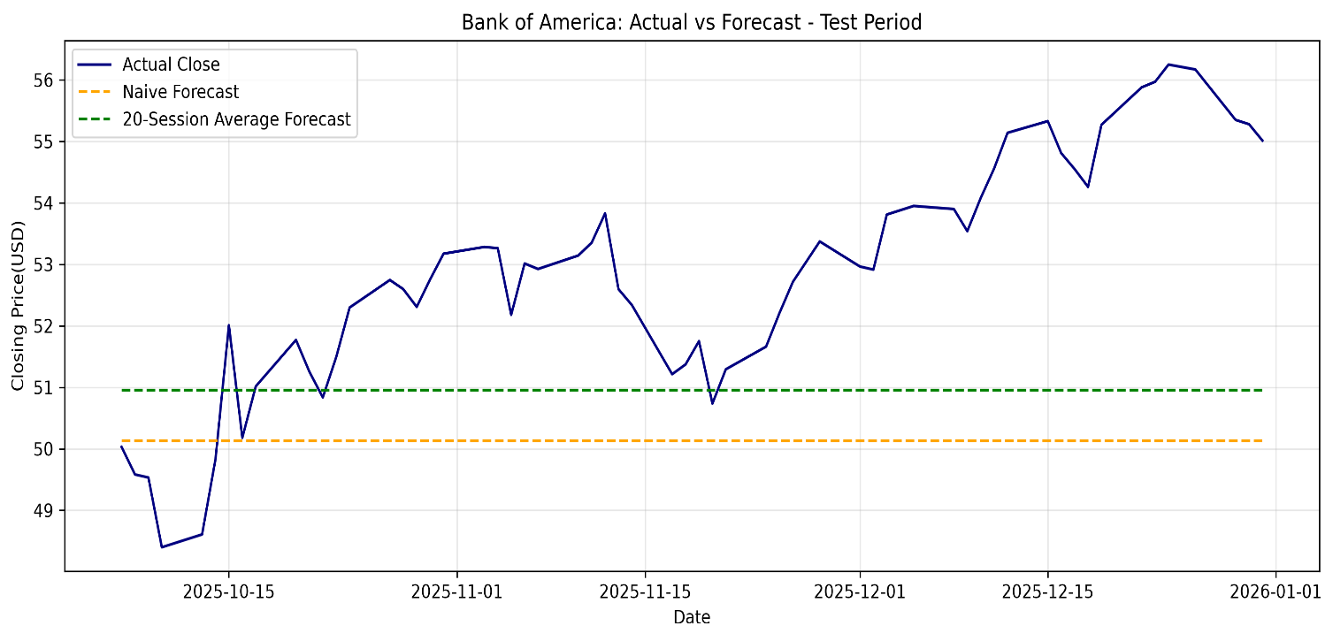

7. Forecast Beyond the Dataset
After evaluation, the 20-session average was recalculated using the final 20 closing prices available in the complete dataset through 31 December 2025.
The resulting forecast is approximately $54.85 for each of the next 60 trading sessions.
- Forecast origin: 31 December 2025.
- Forecast horizon: 60 trading sessions.
- Method: Fixed average of the final 20 observed closing prices.
- Output file: Week2_Future_Forecast.csv.
All 60 forecasts have the same value because the method assumes a constant price level based on the recent average. This does not mean actual prices will remain unchanged.
Sessions are numbered 1–60 rather than assigned calendar dates, as exchange holidays and weekends must be considered when identifying trading dates.
This forecast is based on the historical dataset cutoff, rather than current market data. Actual prices beyond the cutoff were not included, so the accuracy of this final forecast has not been measured.

8. Limitations
- Evaluation covers only one 60-session test period. Results may differ across other market conditions.
- Both methods produce constant forecasts and cannot capture future trends or daily price fluctuations.
- Only closing prices were used. News, economic indicators, trading volume, and company fundamentals were not included.
- The dataset ends on 31 December 2025, so the final forecast does not reflect current market information.
- Prediction intervals were not calculated; the forecasts do not quantify uncertainty.
- The final 60-session forecast has not been evaluated against subsequent actual prices.

9. Conclusion
This project implemented and compared two simple methods for forecasting Bank of America’s closing stock price. On the selected test period, the 20-session average achieved an MAE of $2.23 and an RMSE of $2.64, compared with $2.86 and $3.28 for the naive benchmark.
Although the average-based method produced lower errors, both methods underestimated prices during the later upward movement. Recalculating the average using the final 20 observations produced a fixed forecast of approximately $54.85 for each of the next 60 trading sessions beyond 31 December 2025.
The project demonstrates chronological evaluation, benchmark comparison, and interpretation of forecast errors. Further evaluation across multiple periods would be needed to assess reliability.

