Bank of America — Data Visualization Report

Week 5: Fintech Analyst Internship

Prepared by: Preyash Gandhi

1.Objective:

The objective of this project is to visualize historical Bank of America stock data using Power BI and communicate meaningful patterns through clear charts. Two dashboard pages were created: Stock Performance and Risk & Data Quality. The analysis explores closing-price trends, yearly average closing prices, trading volume, average daily high–low price ranges, and previously identified data-quality flags. Synchronized year slicers allow users to explore the same selected period across both pages.

2. Dataset and Tools:

The project uses the cleaned Bank of America historical stock dataset containing 13,329 observations. The main fields include Date, Open, High, Low, Close, Volume, and Year. Two existing flags—Close_Outlier_Flag and Zero_Volume_Flag—identify unusual closing prices and records with zero reported trading volume. Power BI was used to create interactive charts, KPI cards, and synchronized year slicers. DAX measures calculate the latest, highest, and lowest closing prices, flag counts, and the average daily high–low price range.

3. Stock Performance Dashboard:

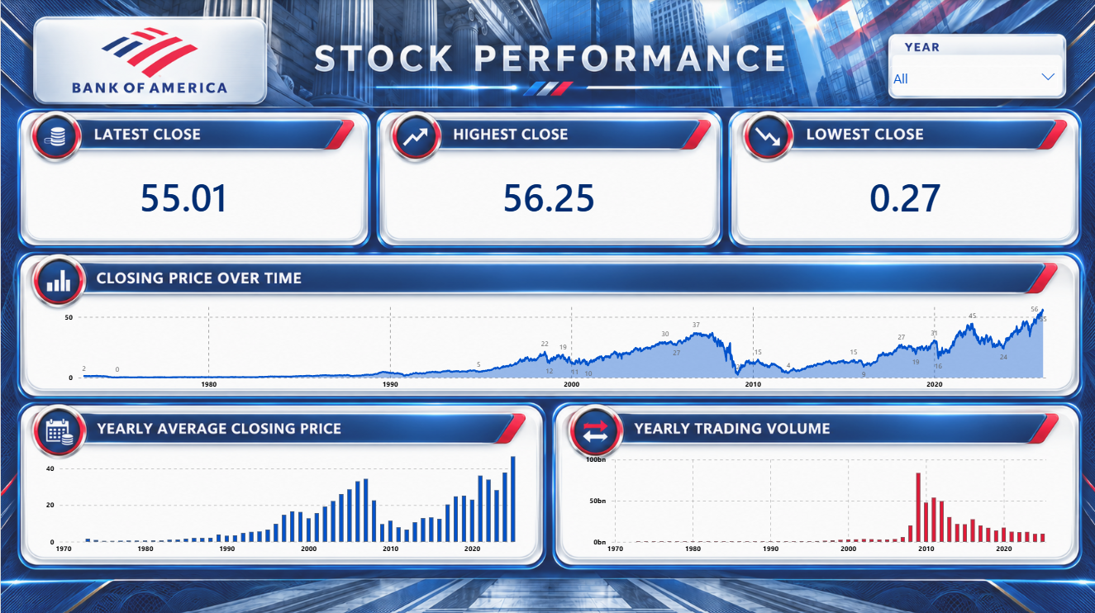
Figure 1: Stock Performance dashboard with all years selected.

3.1 Closing Price KPI Cards:
The three KPI cards summarize closing prices for the selected period. With all years selected, the latest available closing price is $55.01, the highest closing price is $56.25, and the lowest closing price is approximately $0.27. “Latest Close” refers to the last available date in the dataset, rather than a live market quote. These cards update when the year selection changes, allowing users to compare the closing-price summary for different periods.

3.2 Closing Price Over Time:
This chart plots daily closing prices against date, showing long-term trends and shorter-term fluctuations. The displayed series rises substantially from its early levels, falls sharply around 2008–2009, and subsequently recovers with further fluctuations. The latest observations approach the highest closing prices recorded in the dataset. A line chart with light area shading makes the timing and scale of these movements easy to identify. This visualization describes historical price changes; it does not represent total investment returns or predict future performance.

3.3 Yearly Average Closing Price:
This column chart compares the average daily closing price for each year. Annual averages summarize the daily observations, making broader changes easier to compare. The chart shows rising average prices before the sharp decline around 2008–2009, followed by an uneven recovery. The final year displayed, 2025, has the highest annual average closing price in the chart. Each column represents an average price level, not an annual investment return. Annual averages also hide some of the daily fluctuations visible in the previous chart.

3.4 Yearly Trading Volume:
This column chart shows the sum of reported daily trading volume for each year, with values displayed in billions of shares. The largest annual volume appears around 2009, followed by lower totals in subsequent years. This highlights a period of unusually high trading activity. Trading volume measures how many shares were traded; it does not indicate whether investors made a profit or whether prices increased. Annual totals also depend on the number of observations available, so incomplete years should be compared cautiously.

4. Risk & Data Quality Dashboard:

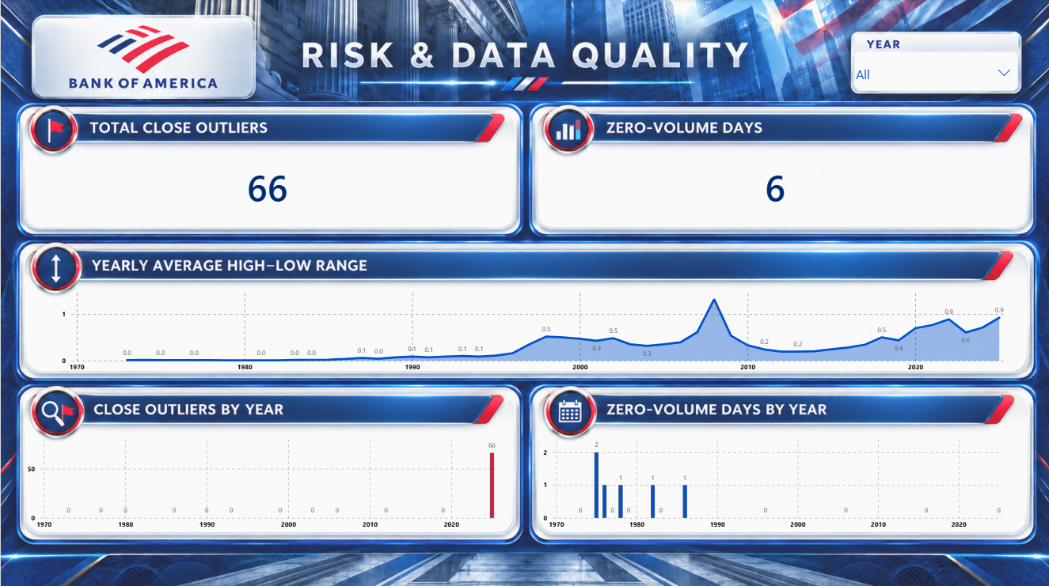
Figure 2: Risk & Data Quality dashboard with all years selected.

4.1 Data Quality KPI Cards:
With all years selected, the KPI cards show 66 closing-price observations flagged as outliers and 6 records with zero reported trading volume. These counts use the flags created during the earlier data preparation stage and update with the year slicer. An outlier flag identifies an unusual price under the chosen detection method; it does not automatically indicate an error. Similarly, zero reported volume requires investigation before being interpreted as an absence of trading. Both cards help identify records that may need further review.

4.2 Yearly Average High–Low Range:
This chart shows the yearly average of each day’s highest price minus its lowest price. A larger value indicates a wider average intraday price range in dollars. The chart displays a prominent peak around 2008 and wider ranges in several recent years compared with the early observations. This helps compare the size of daily price movements across years. However, the measure is an absolute dollar range, not percentage volatility, so differences in stock-price levels affect comparisons. Very small or zero ranges may also reflect limitations in the recorded historical prices.

4.3 Close Outliers by Year:
This column chart groups flagged closing-price observations by year. All 66 flagged observations occur in 2025, showing that the flags are concentrated in the most recent year of the dataset. The flags were created using an interquartile range (IQR) rule applied to closing prices across the full dataset. Since stock-price levels change over time, this concentration may reflect higher recent prices rather than incorrect records. These observations should therefore be reviewed in context instead of being automatically removed.

4.4 Zero-Volume Days by Year:
This column chart shows the number of records with zero reported trading volume in each year. The six flagged records are concentrated in the earlier years of the dataset, with one year containing two records and four other years containing one each. Grouping these records by year helps locate potential data-quality issues for further investigation. Zero reported volume alone does not prove that no trading occurred; it may also reflect missing or incomplete historical reporting. These records were retained and flagged for review.

5. Limitations:

The visualizations describe the available historical dataset and do not predict future stock performance. Adjustments for dividends and corporate actions have not been verified, so price changes should not be interpreted as total investment returns. Annual averages hide daily fluctuations, while annual volume totals depend on data coverage. The high–low range is measured in dollars and is affected by stock-price levels. Outlier and zero-volume flags identify records for review; they do not establish that those records are incorrect.

6. Conclusion:

The two Power BI dashboard pages summarize Bank of America’s historical price patterns, trading activity, and flagged observations. They highlight the sharp price decline around 2008–2009, subsequent recovery, a period of elevated trading volume, and changes in daily high–low ranges. The data-quality visuals show that all 66 closing-price outliers occur in 2025, while six zero-volume records occur in earlier years. Synchronized year slicers support exploration across both pages. Together, these visualizations communicate historical patterns and identify areas for further data review.

