BANK OF AMERICA

HISTORICAL STOCK RISK ANALYSIS

Week 3 Internship Project

Prepared by: Preyash Gandhi
Role: Fintech Analyst Intern

Dataset: Bank of America Historical Stock Data
Tools: Python, Pandas and Matplotlib

October 2026

Executive Summary:
This report assesses historical market-price, downside, data-quality, and forecasting risks using Bank of America daily stock data. The dataset contains 13,329 observations covering February 21, 1973, to December 31, 2025. During the analysis, daily return volatility was 2.36%, and annualized historical volatility was estimated at 37.52%, using 252 trading sessions per year. The largest observed one-day decline was 28.97% on January 20, 2009. The historical maximum drawdown was 93.45% from October 5, 2007, to March 6, 2009. The data also contained 225 sessions with daily losses of at least 5%, six zero-volume rows, and 66 closing-price outlier flags. These results highlight substantial historical price risk and the need to validate flagged data. The dataset does not include an adjusted closing-price field, so corporate-action effects may influence some calculations. This report focuses on risks visible in the historical stock data; it does not assess Bank of America’s internal credit, operational, cybersecurity, or regulatory risks.

Objective and Scope:

Objective: The objective of this report is to identify and assess risks that can be observed in Bank of America’s historical stock-price data, measure their potential impact, and recommend practical monitoring and mitigation steps.
Scope: The analysis uses daily closing prices, daily returns, trading volume, and the dataset’s existing zero-volume and closing-price outlier flags. It covers the available historical period from February 21, 1973, to December 31, 2025. The assessment focuses on market-price volatility, downside events, historical drawdown, data quality, and the limits of simple forecasts. It does not evaluate the bank’s financial statements, loan portfolio, capital adequacy, internal operations, cybersecurity, or regulatory compliance. The findings describe the available historical data and should not be treated as a prediction of future performance.

Data and Methodology:

The analysis used 13,329 daily observations from the cleaned Bank of America dataset, covering February 21, 1973, to December 31, 2025. The data was sorted by date, and daily returns were calculated as the percentage change in the closing price from one session to the next. Daily volatility was measured using the standard deviation of daily returns. Annualized historical volatility was estimated by multiplying daily volatility by the square root of 252, the assumed number of trading sessions in a year. Maximum drawdown was calculated by comparing each closing price with the highest closing price observed up to that date. For this exploratory analysis, a daily return of −5% or lower was counted as a large-loss session; this is an analysis threshold, not an official risk limit. Existing zero-volume and closing-price outlier flags were reviewed as data-quality signals. Flagged rows were retained and were not assumed to be errors without further validation.

Key Findings:

Volatility risk: Daily return volatility was 2.36%, corresponding to an estimated annualized historical volatility of 37.52%. This shows that the stock’s daily returns varied substantially over the full dataset period. The rolling-volatility chart also helps show that risk was not constant over time.
Downside risk: The dataset recorded 225 sessions with daily losses of 5% or more. The worst observed daily return was −28.97% on January 20, 2009. Large losses can materially affect the value of a stock position, especially when exposure is concentrated.
Drawdown risk: The maximum observed drawdown was 93.45%, from October 5, 2007, to March 6, 2009. This measures the decline from a previous price peak to a later trough in the historical closing-price series.
Data-quality risk: Six rows had zero trading volume, and 66 rows were flagged as closing-price outliers by the dataset’s existing rule. These flags require review; they do not by themselves prove that the observations are incorrect. The dataset also lacks an adjusted closing-price field, which limits assessment of corporate-action effects.
Risk Assessment and Mitigation:

1. Market volatility risk
Evidence: Annualized historical volatility was 37.52%.
Potential impact: A stock position’s value may change sharply, creating significant short-term losses and reducing forecast reliability.
Mitigation: Monitor volatility, set exposure limits, diversify across assets, and test how a portfolio may behave under high-volatility scenarios.
2. Downside and drawdown risk
Evidence: There were 225 sessions with losses of at least 5%. The worst daily return was −28.97%, and the maximum observed drawdown was 93.45%.
Potential impact: A sharp or prolonged decline can cause substantial capital loss and may take a long time to recover.
Mitigation: Monitor daily losses and peak-to-trough drawdowns, review position size, and run severe downside scenarios.
3. Data-quality and corporate-action risk
Evidence: Six rows had zero trading volume, 66 rows were flagged as closing-price outliers, and the dataset has no adjusted closing-price field.
Potential impact: Unverified records or unaccounted corporate actions may distort return, volatility, or drawdown calculations.
Mitigation: Verify flagged records against a reliable source, check corporate-action adjustments, and document any corrections before analysis.
4. Forecast-model risk
Evidence: The Week 2 forecasts were constant baseline estimates evaluated on one 60-session test period. The 20-Session Average had an MAE of $2.23 and an RMSE of $2.64 for that period.
Potential impact: A simple model may not capture changing market conditions or sudden movements; its test-period accuracy may not continue in future periods.
Mitigation: Test models across multiple historical periods, compare them with suitable alternatives, review errors regularly, and treat forecasts as uncertain estimates.

Rolling Volatility Chart:

The chart below shows how Bank of America’s annualized volatility changed across rolling 30-session periods. Spikes indicate periods when recent daily returns fluctuated more; the chart alone does not identify the cause.

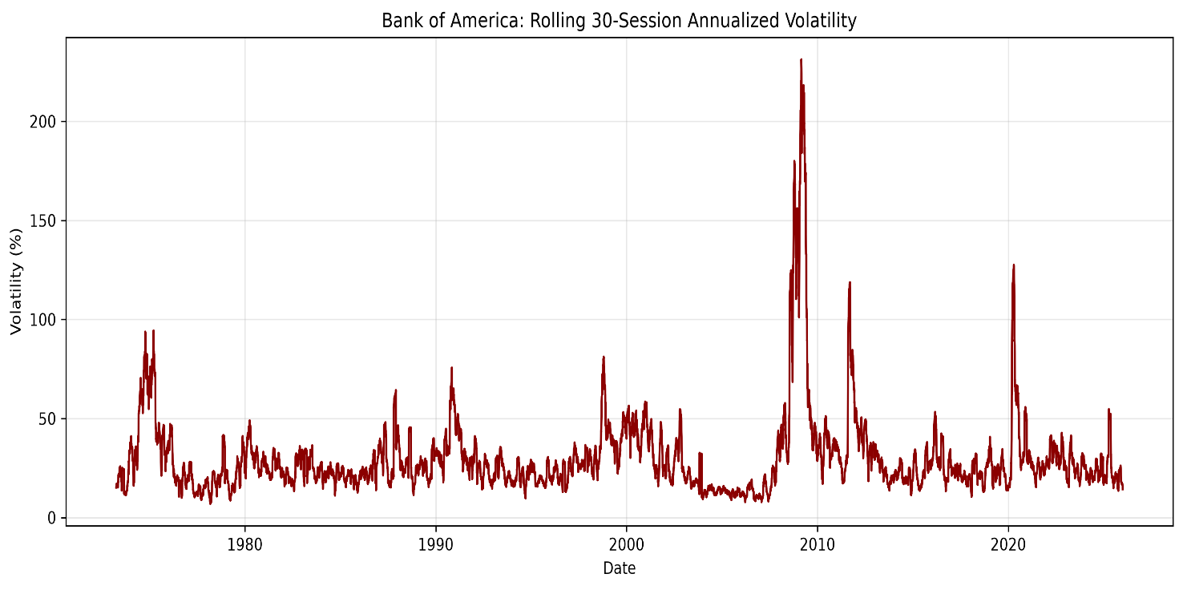

Conclusion:

The historical analysis shows that Bank of America’s stock experienced substantial volatility and severe downside movements during the period studied. The 37.52% annualized historical volatility, 225 sessions with losses of at least 5%, and 93.45% maximum drawdown highlight the importance of monitoring market risk. The zero-volume rows, closing-price outlier flags, and absence of adjusted closing prices also show why data validation matters before drawing conclusions. These findings support regular risk monitoring, scenario testing, exposure controls, and careful validation of financial data and forecasts. The results describe this dataset’s historical record and do not predict future performance.

Data Source:
Bank of America Corp. stock data, downloaded from Kaggle: Bank of America Corp Stock Data (Daily Updated).
Dataset period used: February 21, 1973, to December 31, 2025.
Accessed: October 6, 2026.

