Bank of America Stock Data Analysis
Week 1: Data Acquisition, Cleaning and Exploratory Data Analysis
Prepared by: Preyash Gandhi
Role: Junior Data Analyst – Banking & Financial Services
Tools Used: Python, Pandas and Matplotlib
Dataset Period: 21 February 1973 – 31 December 2025

1. Project Objective
The objective of this project is to acquire and explore a public financial dataset containing Bank of America’s historical stock prices and trading volume. The analysis checks data quality, prepares the dataset, summarizes key variables, and identifies historical patterns through charts. This work provides a foundation for further analysis in subsequent weeks.
2. Dataset Source and Overview
The dataset was downloaded from Kaggle and contains historical stock data for Bank of America Corporation, identified by the ticker BAC.
Source:
https://www.kaggle.com/datasets/isaaclopgu/bank-of-america-corp-stock-data-daily-updated
Attribute | Details
Total records | 13,329
Original columns | 8
Start date | 21 February 1973
End date | 31 December 2025
Frequency | Daily trading records
File name | Bank_of_America_historical_data.csv
3. Description of Columns
Column | Description
Date | Date of the trading record
Open | Opening stock price
High | Highest stock price during the trading day
Low | Lowest stock price during the trading day
Close | Closing stock price
Volume | Number of shares traded
ticker | Stock symbol: BAC
name | Company and dataset description

Data limitation: The price adjustment method for stock splits and dividends has not been confirmed. The downloaded file ends on 31 December 2025, despite the dataset title mentioning daily updates.

4. Data Cleaning and Preparation
The dataset was loaded using Pandas and inspected to understand its structure and data types. The following checks and preparation steps were performed:
Check or Step | Result and Action
Date conversion | Converted Date to datetime and standardized it to the America/New_York timezone.
Missing values | No missing values were found in the original eight columns.
Duplicate records | No duplicate rows or duplicate dates were found.
Chronological sorting | Sorted records by Date and reset the row index.
Zero trading volume | Identified six zero-volume records. Retained them and added Zero_Volume_Flag because their cause was unconfirmed.
Year extraction | Created a Year column for annual summaries.
Closing-price outliers | The 1.5 × IQR rule flagged 66 records, all from 2025. Added Close_Outlier_Flag and retained these records.
Export | Saved the prepared dataset as Bank_of_America_Cleaned.csv with all 13,329 rows retained.
Outlier treatment: The IQR boundaries were approximately −27.40 and 50.38. All flagged closing prices exceeded the upper boundary. These values were identified by comparing prices across the full historical period. Being statistically unusual does not establish that a value is incorrect, so no records were removed solely on this basis.
Final dataset: The exported file contains 13,329 rows and 11 columns: eight original columns, the Year column, and two flag columns.

5. Descriptive Statistics
The following table summarizes closing prices and daily trading volume across all 13,329 records.
Statistic | Closing Price | Volume (Shares)
Count | 13,329 | 13,329
Mean | 12.86 | 38,717,124.16
Standard deviation | 12.28 | 76,606,483.08
Minimum | 0.27 | 0
25th percentile (Q1) | 1.77 | 489,600
Median | 10.10 | 7,504,200
75th percentile (Q3) | 21.21 | 46,978,800
Maximum | 56.25 | 1,226,791,300
Values are rounded to two decimal places where applicable.
Interpretation:
- The mean closing price of 12.86 exceeds the median of 10.10, consistent with the right-skewed distribution observed in the histogram.
- The middle 50% of closing prices fall between approximately 1.77 and 21.21.
- Mean daily volume is approximately 38.72 million shares, compared with a median of 7.50 million. High-volume days raise the average substantially.
- The minimum volume of zero corresponds to the six records flagged during cleaning.
- These statistics combine prices from 1973–2025. The standard deviation of closing-price levels should not be interpreted as daily return volatility.

6. Exploratory Data Analysis

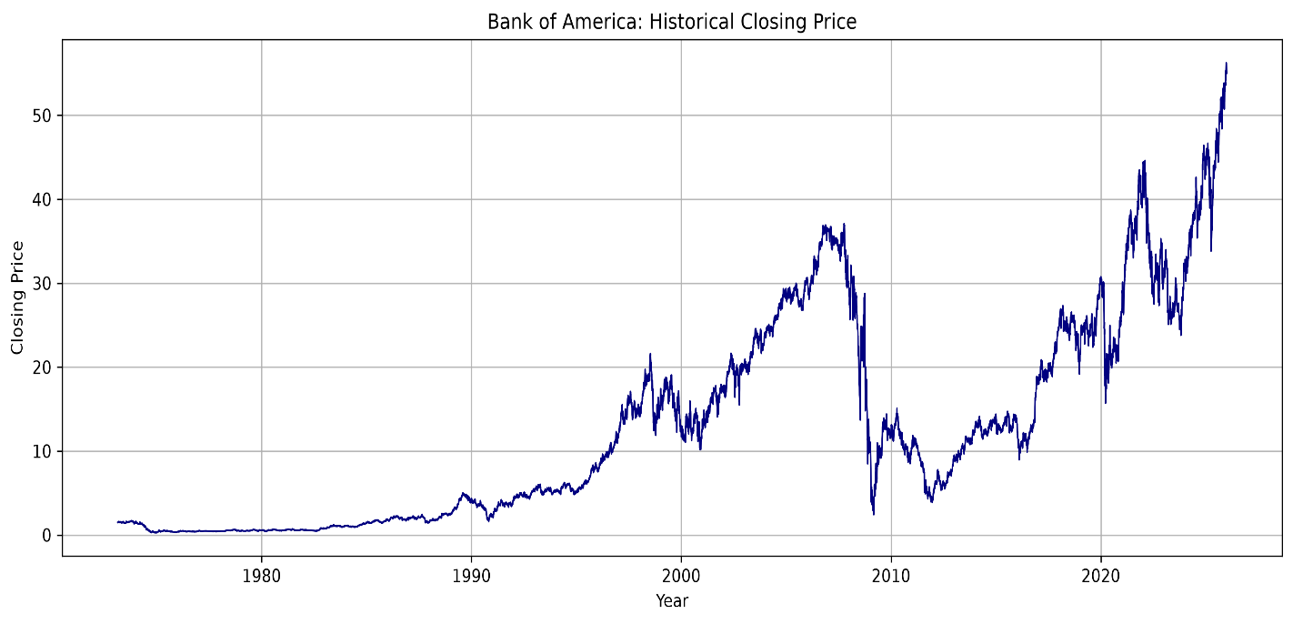
6.1 Historical Closing Price Trend
Figure 1: Bank of America’s historical closing prices, 1973–2025.
The line chart shows how the closing prices recorded in the dataset changed over time. The lowest recorded closing price was approximately 0.27 on 20 December 1974, while the highest was 56.25 on 24 December 2025.
These observations describe price levels in the supplied dataset. They should not be treated as an investor’s total return because the treatment of stock splits and dividends has not been confirmed.

6.2 Annual Average Closing Price (2016–2025)
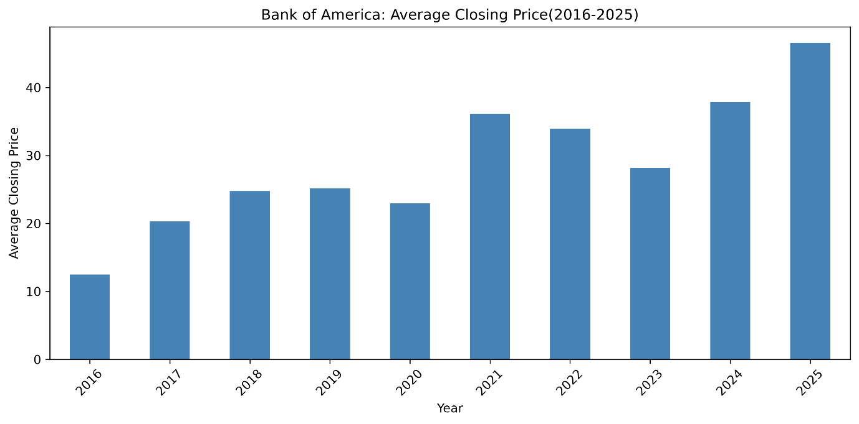
Figure 2: Average daily closing price for each year from 2016 to 2025.
The annual average closing price increased from 12.49 in 2016 to 25.20 in 2019, before declining to 22.98 in 2020. It rose to 36.14 in 2021, followed by declines to 33.93 in 2022 and 28.15 in 2023.
The average increased again to 37.87 in 2024 and reached 46.61 in 2025, the highest annual average within the ten-year period shown.
Each bar represents the mean of the available daily closing prices for that year. These values are annual average price levels, not annual investment returns.

6.3 Daily Trading Volume
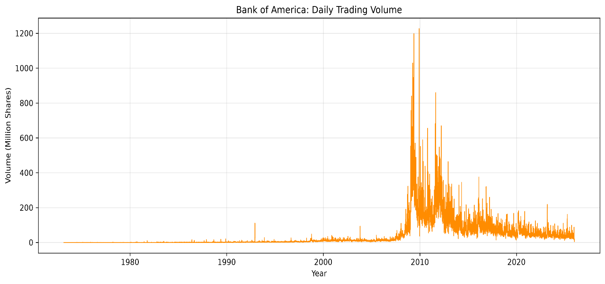
Figure 3: Daily trading volume in millions of shares, 1973–2025.
The chart shows substantial variation in daily trading activity, with prominent spikes around 2008–2010. All five highest-volume trading days in the dataset occurred in 2009.
Date | Volume (Shares)
4 December 2009 | 1,226,791,300
20 May 2009 | 1,197,984,500
9 April 2009 | 1,029,694,600
7 May 2009 | 946,806,700
6 May 2009 | 924,590,100
The highest recorded daily volume was approximately 1,226.79 million shares on 4 December 2009. High volume indicates increased trading activity, but does not by itself establish whether the stock price increased or decreased. The causes of these spikes were not verified in this analysis.

6.4 Closing Price Distribution
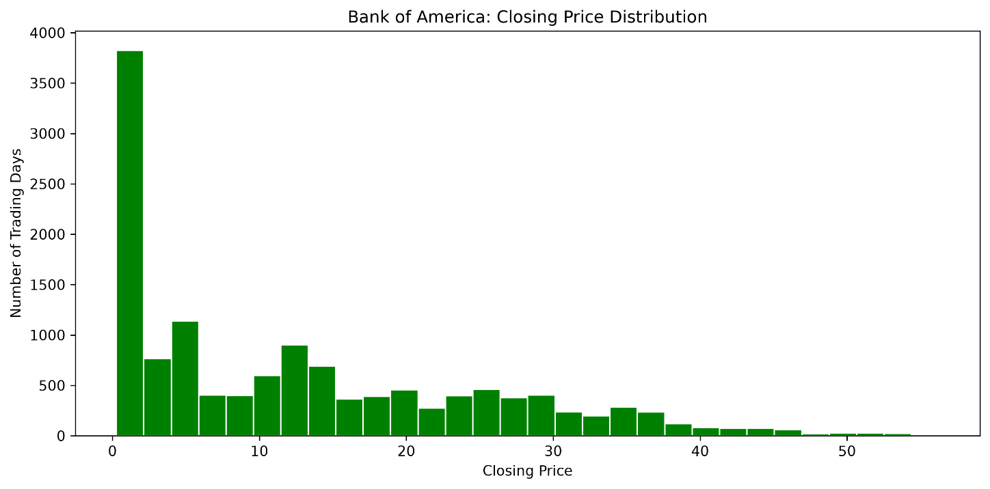
Figure 4: Distribution of daily closing prices across the full dataset.
The histogram groups closing prices into 30 intervals. The height of each bar represents the number of trading days with closing prices in that interval.
The distribution is right-skewed: more observations occur in lower price ranges, with a long tail extending toward higher prices. This is consistent with the mean closing price of 12.86 being higher than the median of 10.10.
The chart combines observations from 1973–2025, during which price levels changed considerably. It describes the historical dataset and should not be interpreted as a probability distribution for future stock prices.

6.5 Closing Price Outlier Analysis

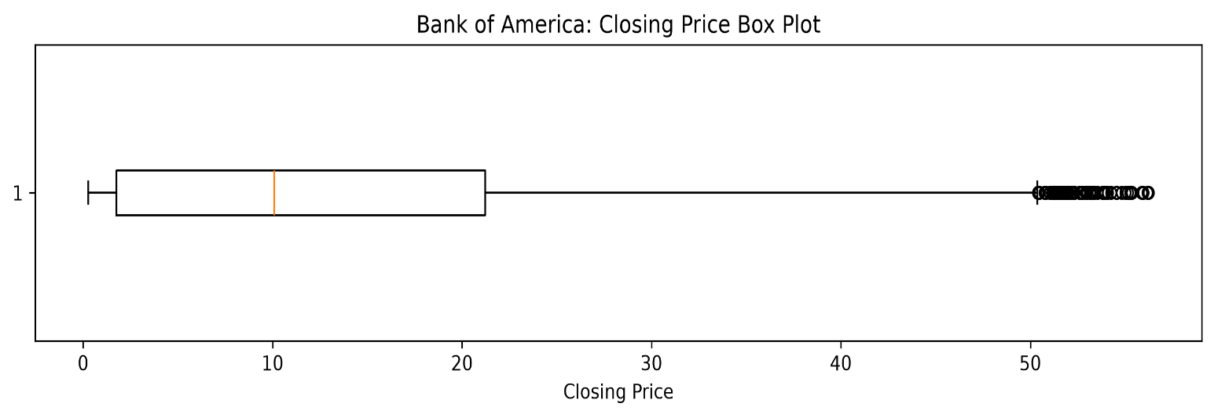
Figure 5: Box plot of closing prices using the 1.5 × IQR rule.
The box represents the middle 50% of closing prices, approximately 1.77–21.21, with a median of 10.10. Points beyond the whiskers indicate values flagged by the IQR rule.
The calculated lower and upper boundaries were approximately −27.40 and 50.38. A total of 66 closing prices exceeded the upper boundary, all occurring in 2025. The negative lower boundary is a statistical threshold, not an observed negative price.
These records are unusually high relative to the full historical dataset, but this does not establish that they are errors. They were retained and marked using the Close_Outlier_Flag column to preserve the historical observations.

7. Limitations
- The dataset covers one company, so the findings cannot represent the entire banking sector.
- The downloaded file ends on 31 December 2025 and does not include 2026 trading data.
- The adjustment of prices for stock splits and dividends has not been confirmed, limiting investment-return interpretation.
- The cause of the six zero-volume records remains unverified.
- Full-history price summaries combine different market periods. Outlier flags depend on the selected period and do not prove data errors.
- The analysis describes historical patterns; it does not establish their causes or predict future performance.
8. Conclusion and Next Steps
This analysis examined 13,329 Bank of America stock records covering 1973–2025. No missing values, duplicate rows, or duplicate dates were found. Dates were standardized and sorted, while six zero-volume records and 66 high closing-price observations were flagged and retained.
The visualizations revealed a right-skewed full-history closing-price distribution, concentrated high-volume trading days in 2009, and the highest annual average closing price of the displayed 2016–2025 period in 2025.
The prepared dataset was exported for subsequent work. The next stage will define a forecasting target and time horizon, use a chronological training and test split, and evaluate forecasts against a simple baseline. Price-adjustment details should be verified before interpreting investment returns.

