Name: Preyash Date: 06-01-2022

Registration Number: 20BPS1022

**LAB-01**

**Socket Programming**

**AIM:** To print the day and time in the client side using the socket functions.

**ALGORITHM**

**Server-side Algorithm**

1. Start.

2. Declare variables.

3. Take the port number as input from the user.

4. Using socket(), create TCP socket for server.

5. Using bind(), bind the socket to server address.

6. Using listen(), put the server socket in a passive mode, where it waits for the client to approach the server to make a connection

7. Using accept(), at this point, connection is established between client and server, and they are ready to transfer data.

**Client-Side Algorithm**

1. Start.

2. Declare variables.

3. Take port as input from user.

4. Using socket(), create TCP socket for client.

5. Using connect(),connect the client to server to exchange information.

6. Using recv() ,receive the data from server side.

7. If the connection will be successful data will be revived.

8. The date and time received from server side is printed at client side.

**Server Program Source Code:**

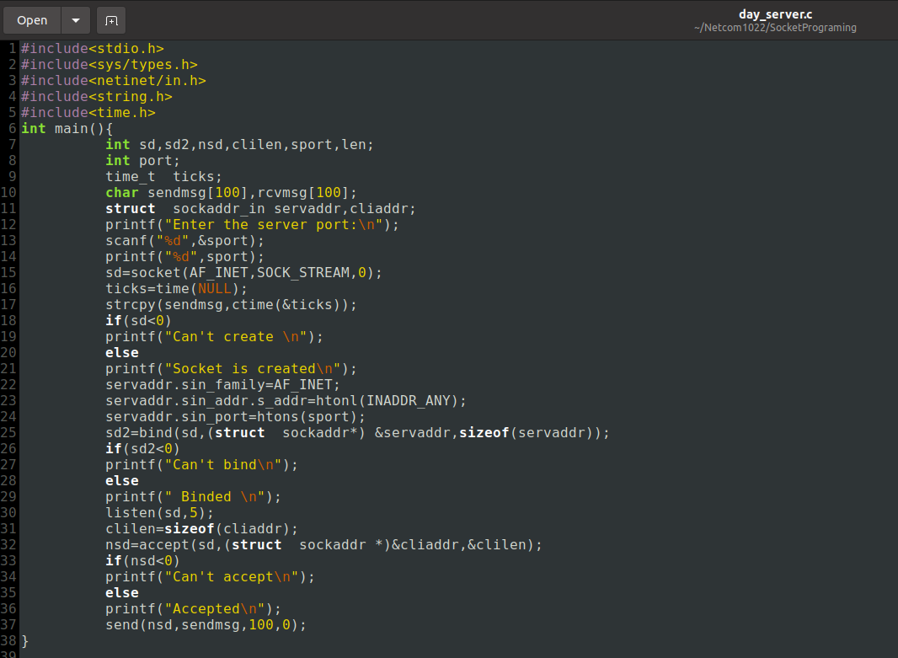

**Output:**

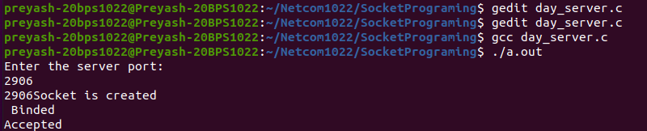

**Client Program Source Code:**

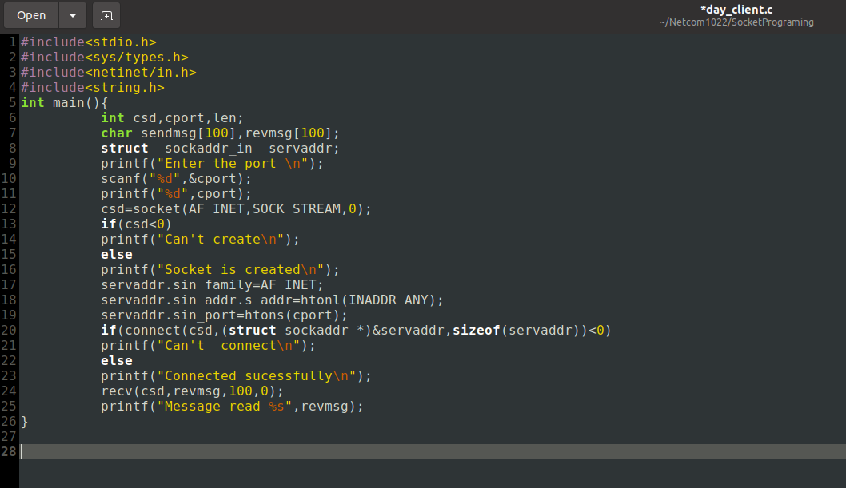

**Output:**

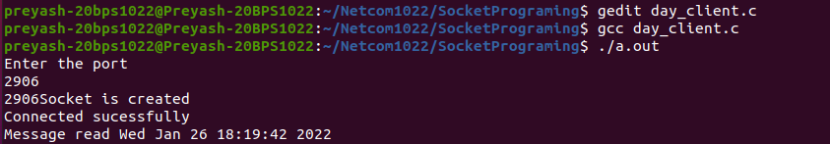

**Result:** A successful connection between the client and server is established.