Name: Preyash Date: 20-01-2022

Registration Number: 20BPS1022

**LAB-03**

**Networking Commands**

**IFCONFIG COMMANDS:**

ifconfig

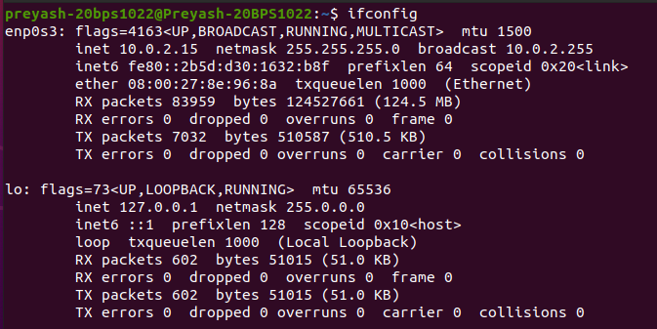

ifconfig -a

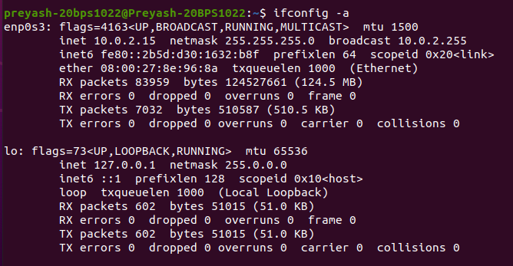

ifconfig -s

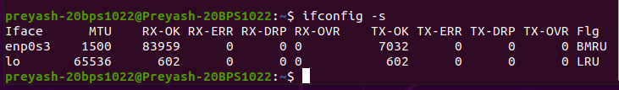

ifconfig [interface-name] down

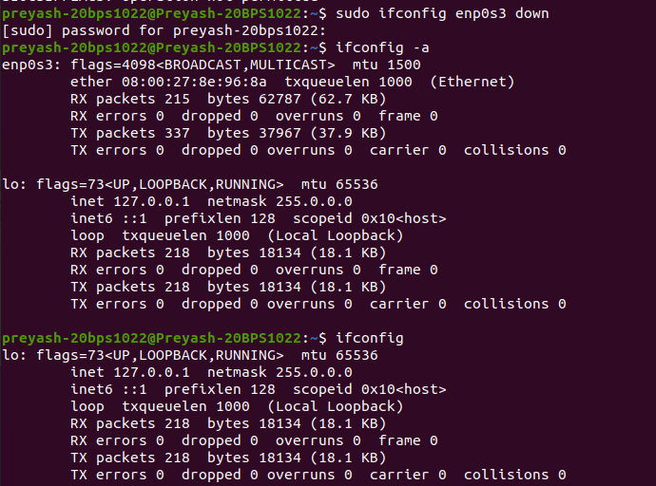

ifconfig [interface-name] promisc

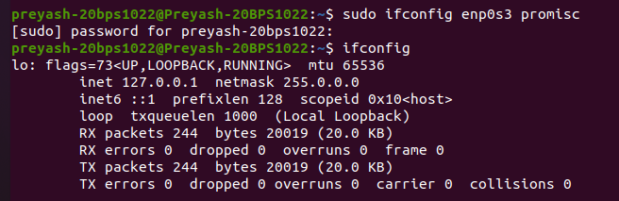

ifconfig [interface-name] -promisc

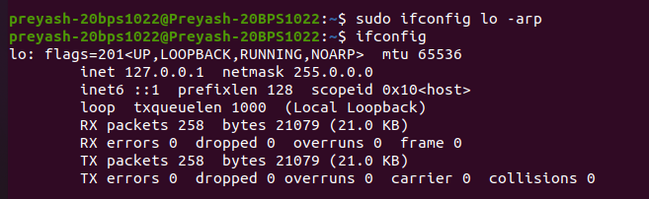

**PING COMMANDS:**

ping -V

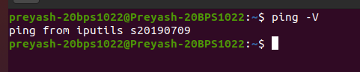

ping [Domain Name]

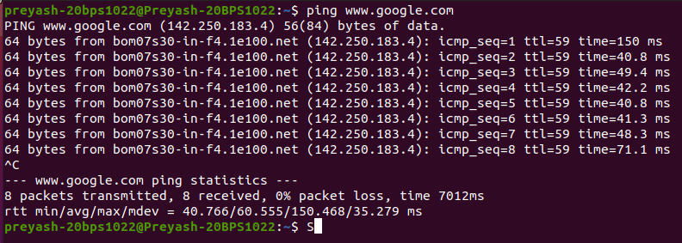

ping [ipaddress]

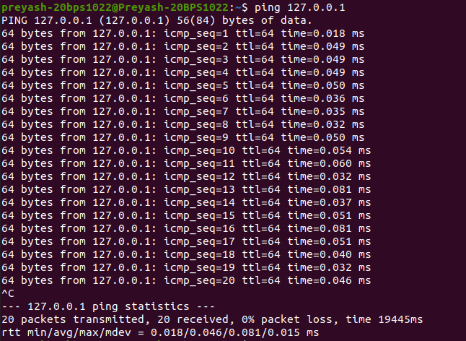

ping -c number [Domain name]

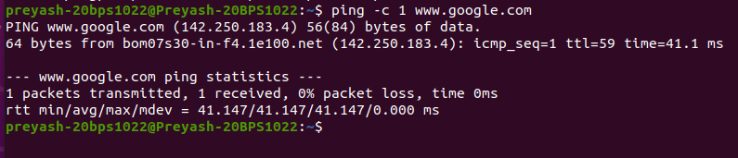

ping -c number -q [Domain name]

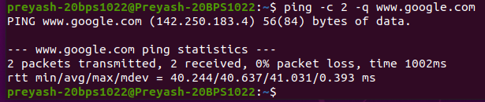

ping -i time [Domain name]

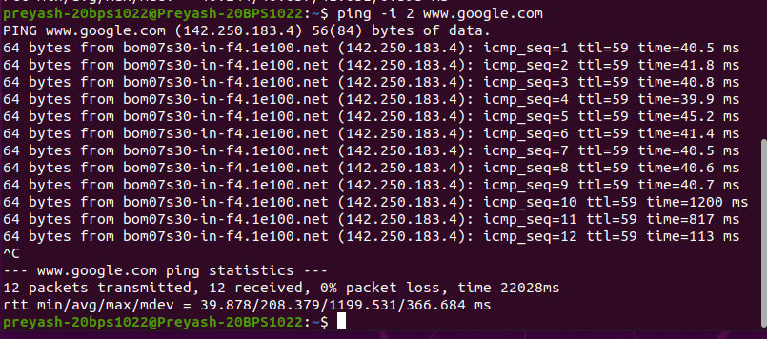

ping -s size(bytes) [Domain Name]

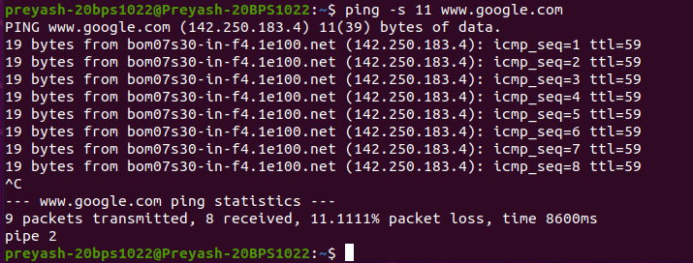

. ping -w number [Domain name]

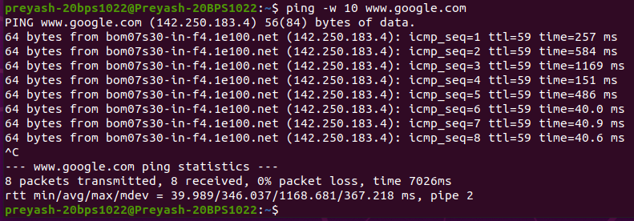

**TRACEROUTE COMMANDS:**

traceroute -I [Domain name]

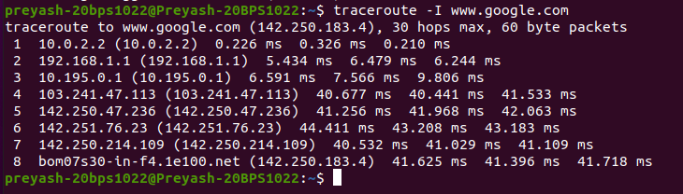

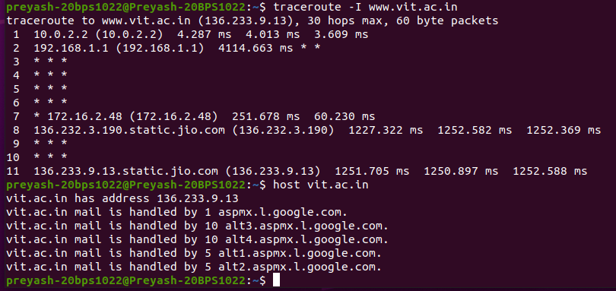

traceroute [Domain name]

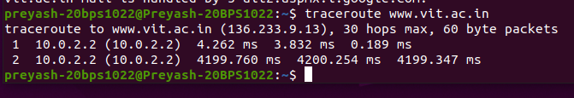

**HOSTNAME COMMANDS:**



**NSLOOKUP COMMANDS:**

nslookup [Domain name]

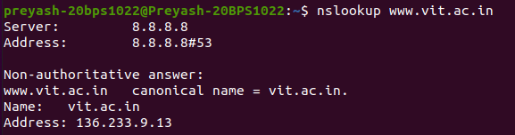

**NETSTAT COMMANDS:**

netstat -a | more/less (list all listening ports)

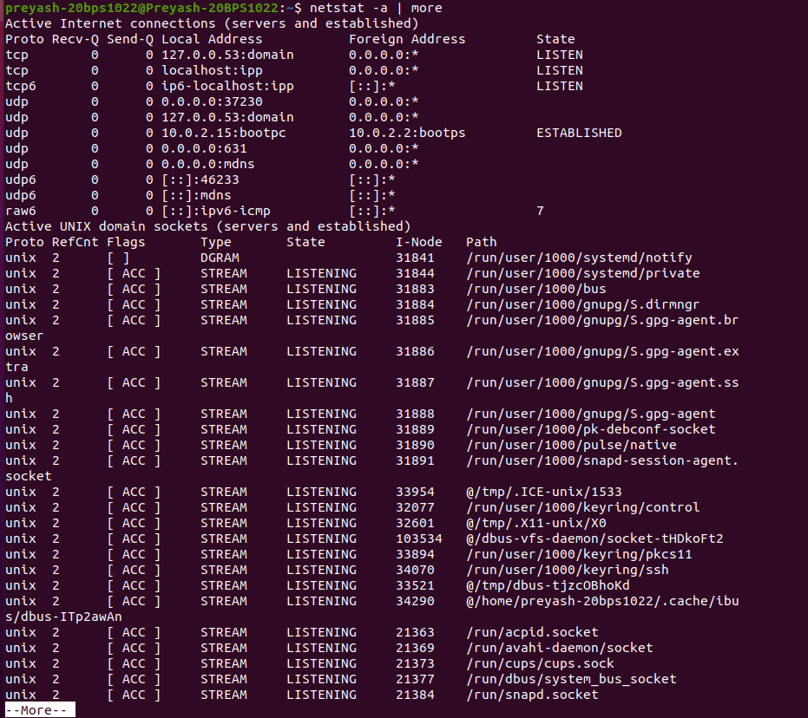

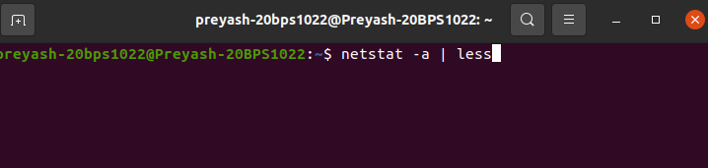

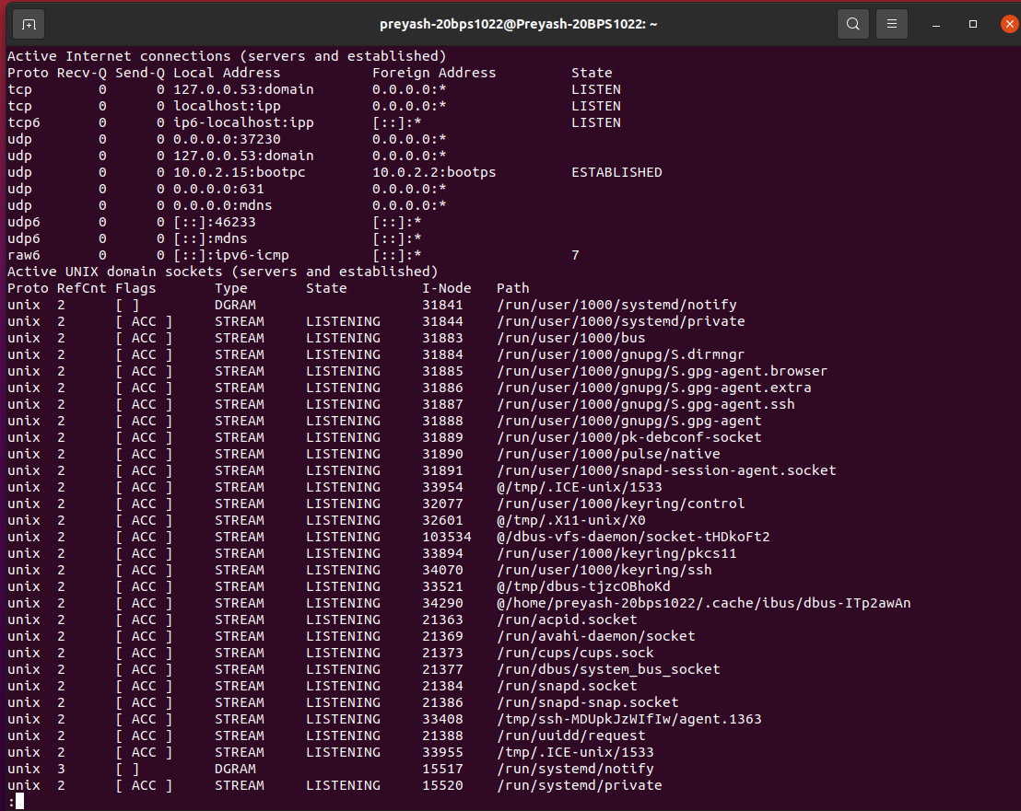

netstat -at

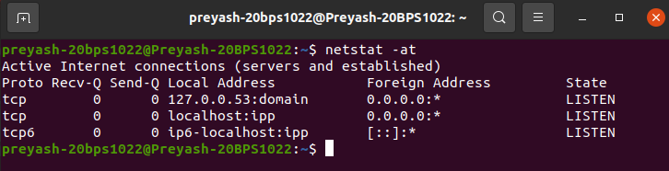

netstat -au

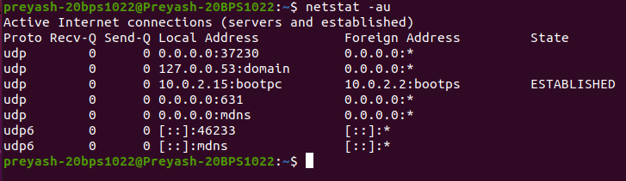

netstat -l

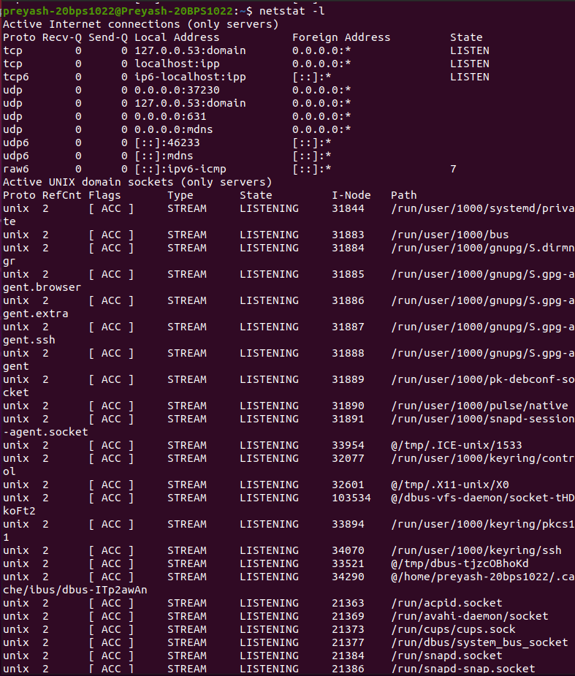

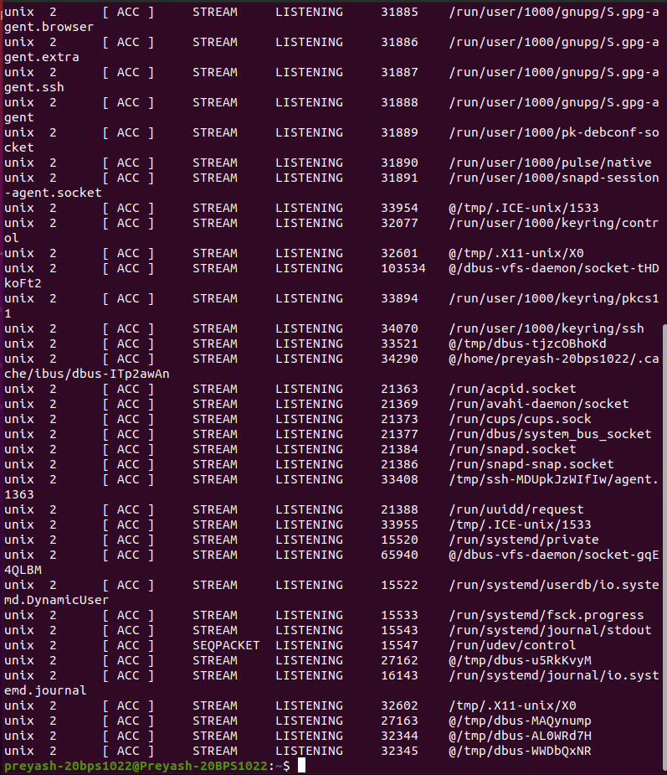

netstat -lt (list active TCP listening ports)

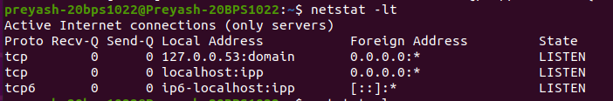

netstat -lu (list active UDP listening ports)

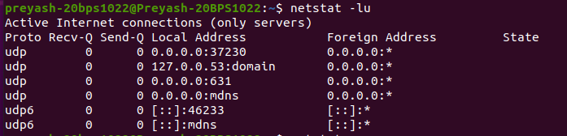

netstat -s

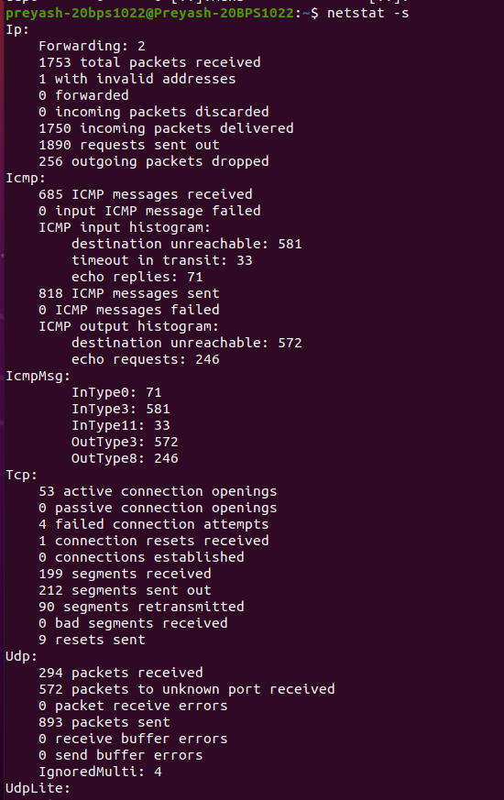

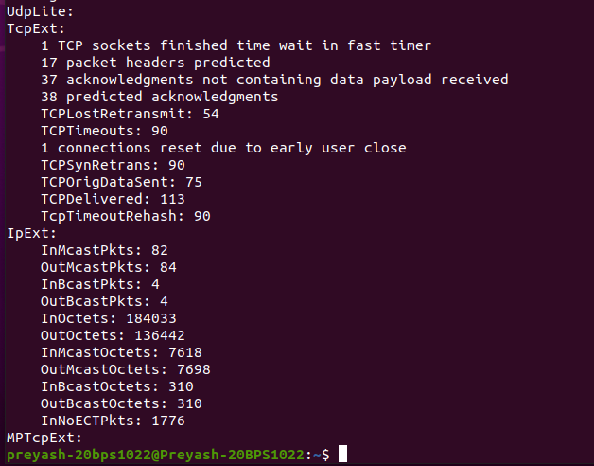

netstat -st (TCP Protocol Statistics)

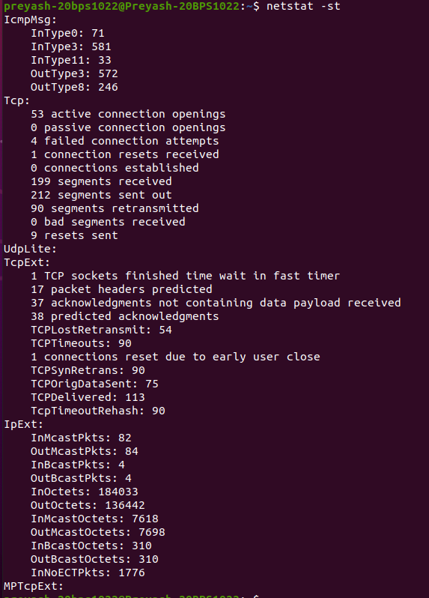

netstat -su (UDP Protocol Statistics)

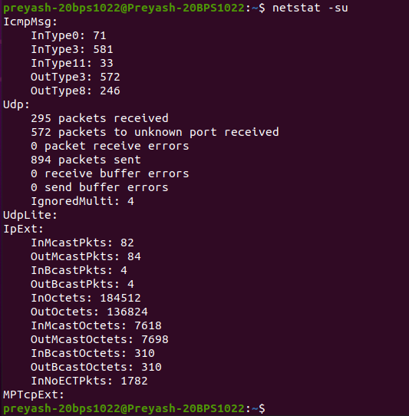

netstat -i (Interface statistics)

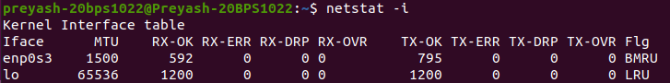

netstat -p (list service by PID)

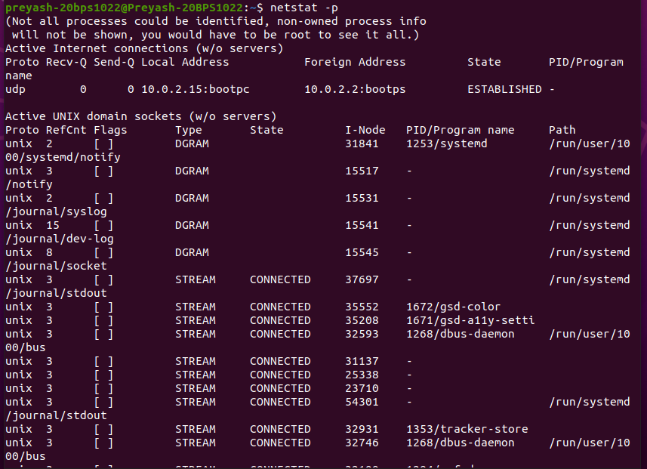

netstat -r (routing table info)

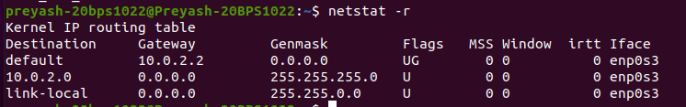

**ARP COMMANDS:**

