Name: Preyash Date: 10-02-2022

Registration Number: 20BPS1022

**LAB-06**

**UDP Socket Programming**

**AIM:** To compute the sum of the first 'n' even numbers, write a UDP socket application and run it. The server computes the sum using the 'n' value provided by the client, and the result should be shown on the client side.

**ALGORITHM**

**Server-side Algorithm:**

* Start
* Include the sys/socket.h> and arpa/inet.h header files.
* Using the socket() method, create a socket that returns a socket descriptor.
* Set the server address based on the port and IP.
* Bind the socket to the server address with bind().
* Using the recvfrom() method, get the value of "n" from the client. Then, using n*(n+1), calculate the value of the sum of "n" even integers.
* Send the result back to the client.
* End.

**Client-Side Algorithm:**

* Start
* Include the sys/socket.h> and arpa/inet.h header files.
* Create a datagram socket and use the connect() function to connect to the server.
* Take the user's value for "n."
* If you're connected, send the value to the server.
* Using the recvfrom() method, wait for a response from the server.
* Obtain the server's result and print it.
* To cease the conversation, close the socket.

**Server Program Source Code:**

**Code window:**

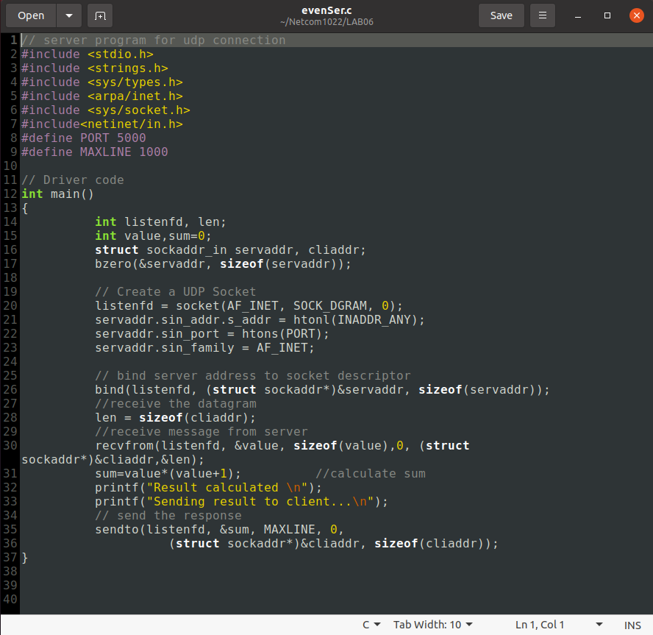

**Code:**

// server program for udp connection

#include <stdio.h>

#include <strings.h>

#include <sys/types.h>

#include <arpa/inet.h>

#include <sys/socket.h>

#include<netinet/in.h>

#define PORT 5000

#define MAXLINE 1000

// Driver code

int main()

{

int listenfd, len;

int value,sum=0;

struct sockaddr_in servaddr, cliaddr;

bzero(&servaddr, sizeof(servaddr));

// Create a UDP Socket

listenfd = socket(AF_INET, SOCK_DGRAM, 0);

servaddr.sin_addr.s_addr = htonl(INADDR_ANY);

servaddr.sin_port = htons(PORT);

servaddr.sin_family = AF_INET;

// bind server address to socket descriptor

bind(listenfd, (struct sockaddr*)&servaddr, sizeof(servaddr));

//receive the datagram

len = sizeof(cliaddr);

//receive message from server

recvfrom(listenfd, &value, sizeof(value),0, (struct sockaddr*)&cliaddr,&len);

sum=value*(value+1); //calculate sum

printf("Result calculated \n");

printf("Sending result to client...\n");

// send the response

sendto(listenfd, &sum, MAXLINE, 0,

(struct sockaddr*)&cliaddr, sizeof(cliaddr));

}

**Output:**

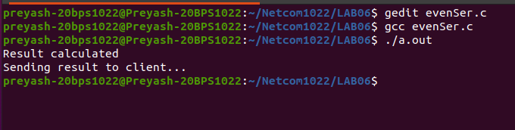

**Client Program Source Code:**

**Code window:**

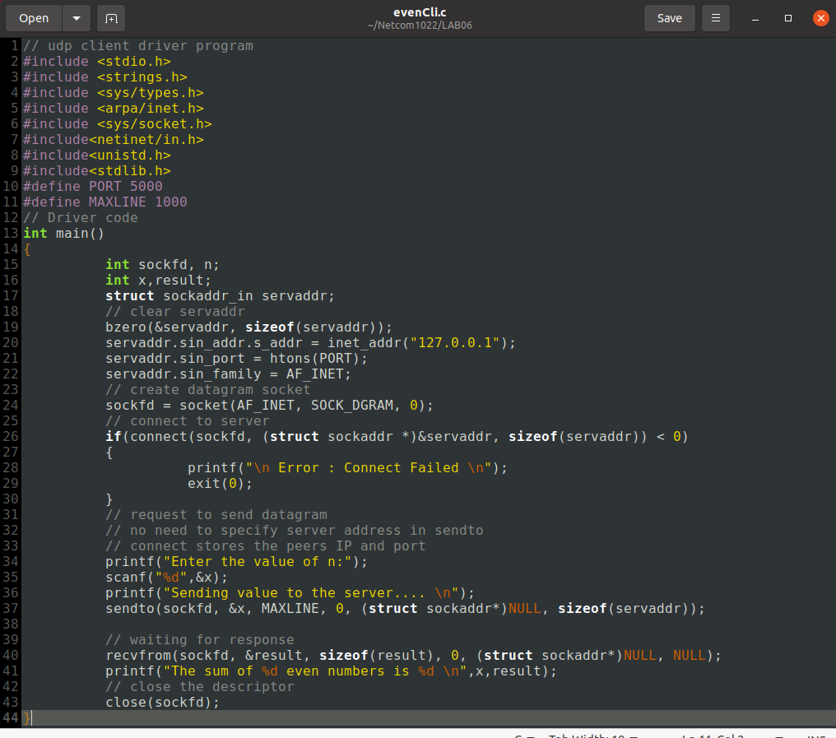

**Code:**

// udp client driver program

#include <stdio.h>

#include <strings.h>

#include <sys/types.h>

#include <arpa/inet.h>

#include <sys/socket.h>

#include<netinet/in.h>

#include<unistd.h>

#include<stdlib.h>

#define PORT 5000

#define MAXLINE 1000

// Driver code

int main()

{

int sockfd, n;

int x,result;

struct sockaddr_in servaddr;

// clear servaddr

bzero(&servaddr, sizeof(servaddr));

servaddr.sin_addr.s_addr = inet_addr("127.0.0.1");

servaddr.sin_port = htons(PORT);

servaddr.sin_family = AF_INET;

// create datagram socket

sockfd = socket(AF_INET, SOCK_DGRAM, 0);

// connect to server

if(connect(sockfd, (struct sockaddr *)&servaddr, sizeof(servaddr)) < 0)

{

printf("\n Error : Connect Failed \n");

exit(0);

}

// request to send datagram

// no need to specify server address in sendto

// connect stores the peers IP and port

printf("Enter the value of n:");

scanf("%d",&x);

printf("Sending value to the server.... \n");

sendto(sockfd, &x, MAXLINE, 0, (struct sockaddr*)NULL, sizeof(servaddr));

// waiting for response

recvfrom(sockfd, &result, sizeof(result), 0, (struct sockaddr*)NULL, NULL);

printf("The sum of %d even numbers is %d \n",x,result);

// close the descriptor

close(sockfd);

}

**Output:**

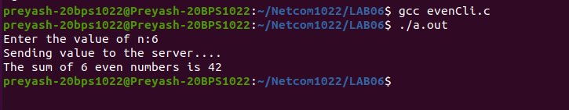

**Result:** We successfully created a program to perform the required output.