**Name: Preyash Date: 03-03-2022**

**Registration Number: 20BPS1022**

**LAB-07**

**CISCO Packet Tracer**

**Aim:** To design different types of topologies in CISCO Packet Tracer and transfer data through the end devices as directed.

1. **Bus Topology**

***Designing:***

PC2-> PC3

**I.P. Address:**

PC2: 29.06.20.02

PC3: 29.06.20.03

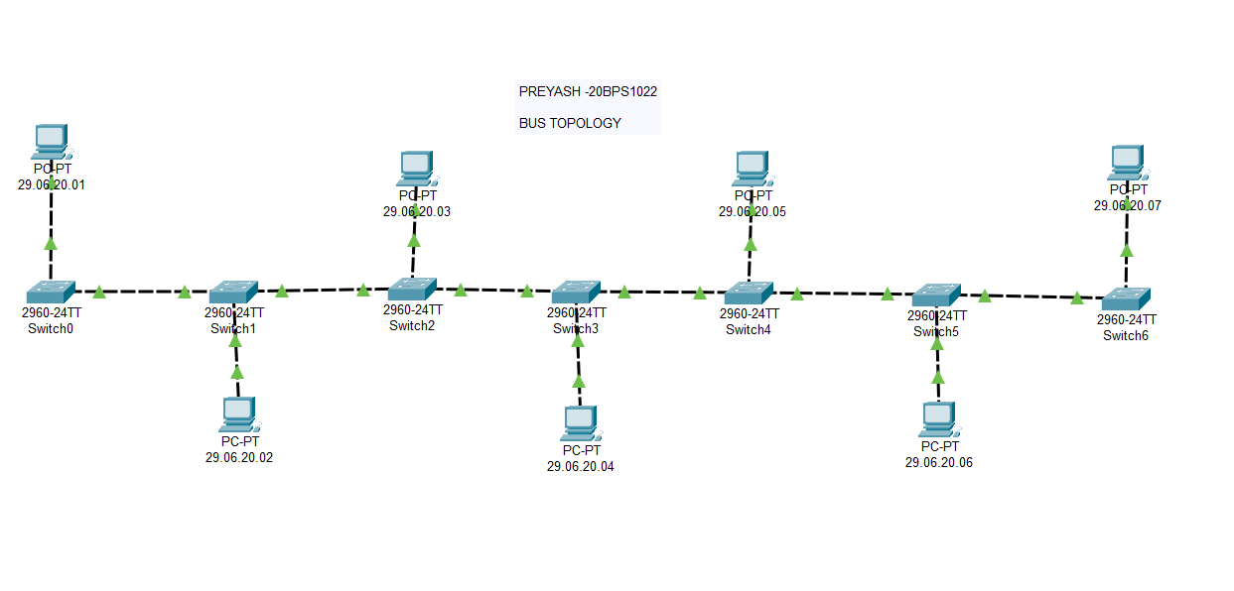

**Source:**

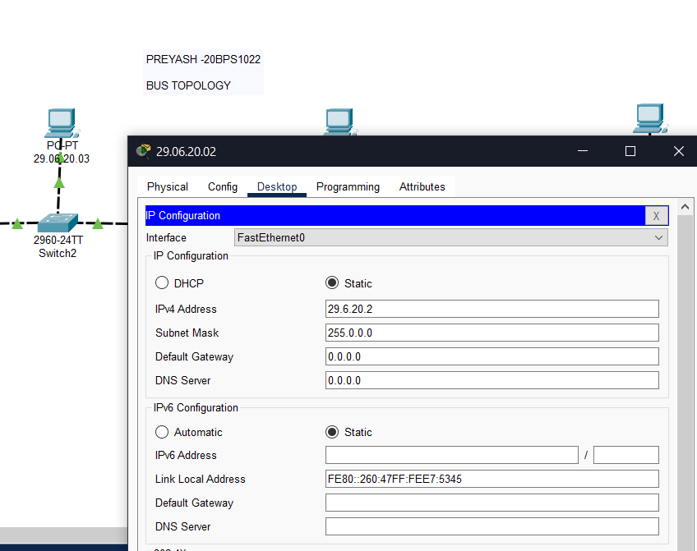

**Destination:**

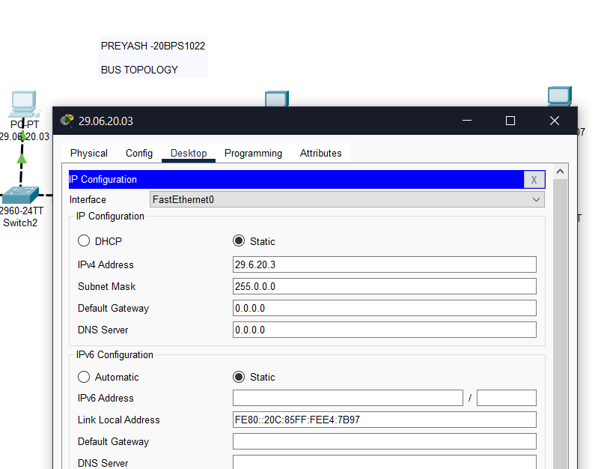

**Success:**

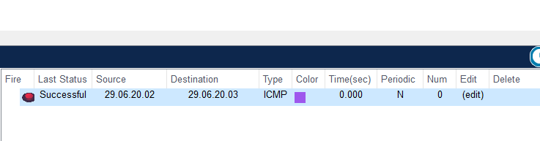

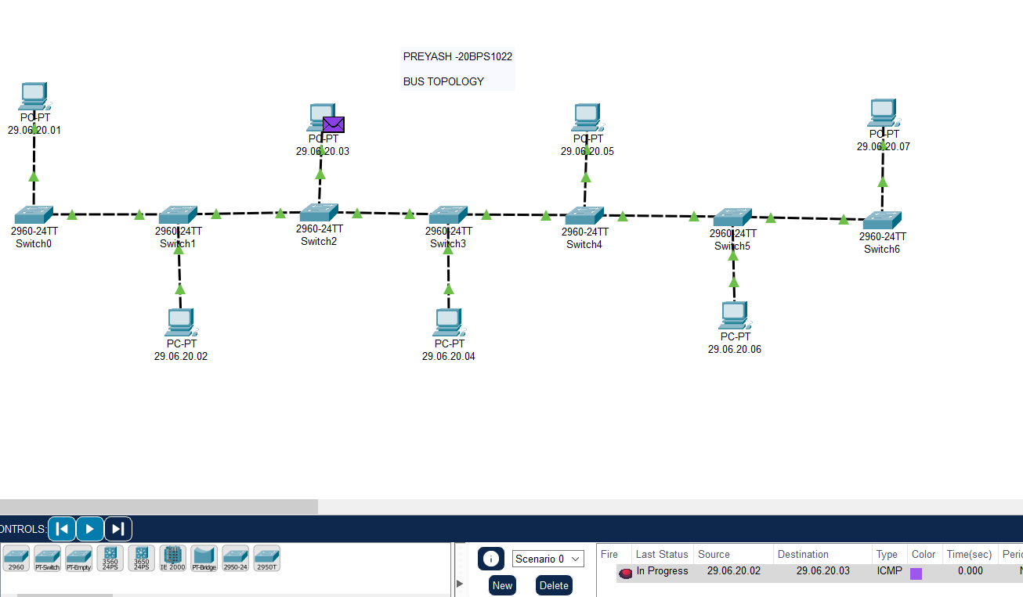

1. **Star Topology**

***Designing:***

PC0-> PC5

**I.P. Address:**

PC0: 1.11.20.01

PC5: 1.11.20.06

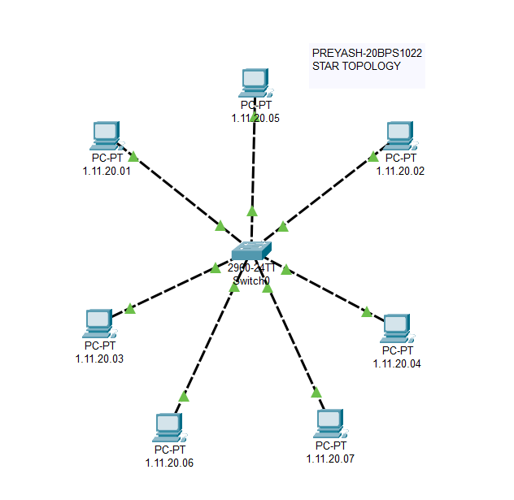

**Source:**

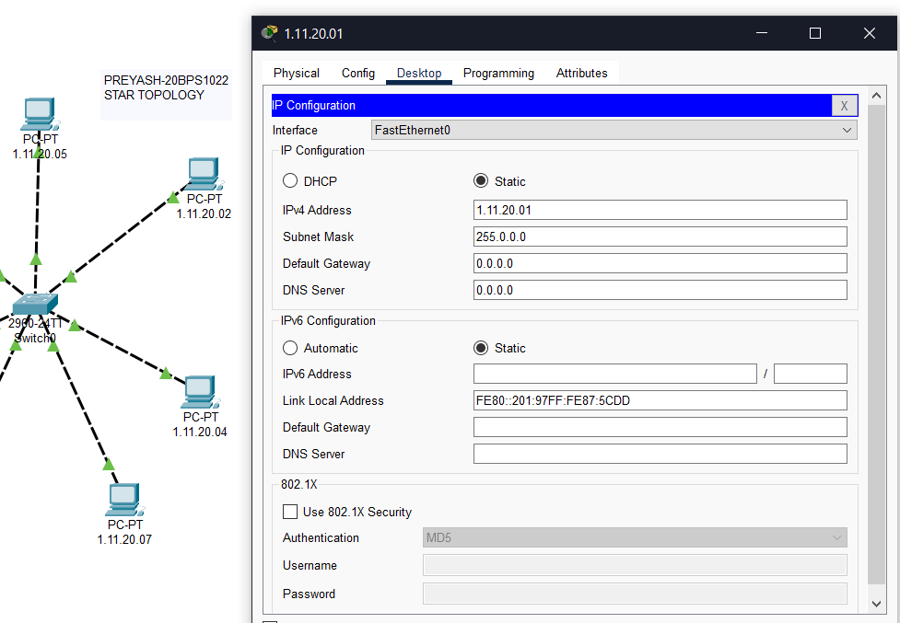

**Destination:**

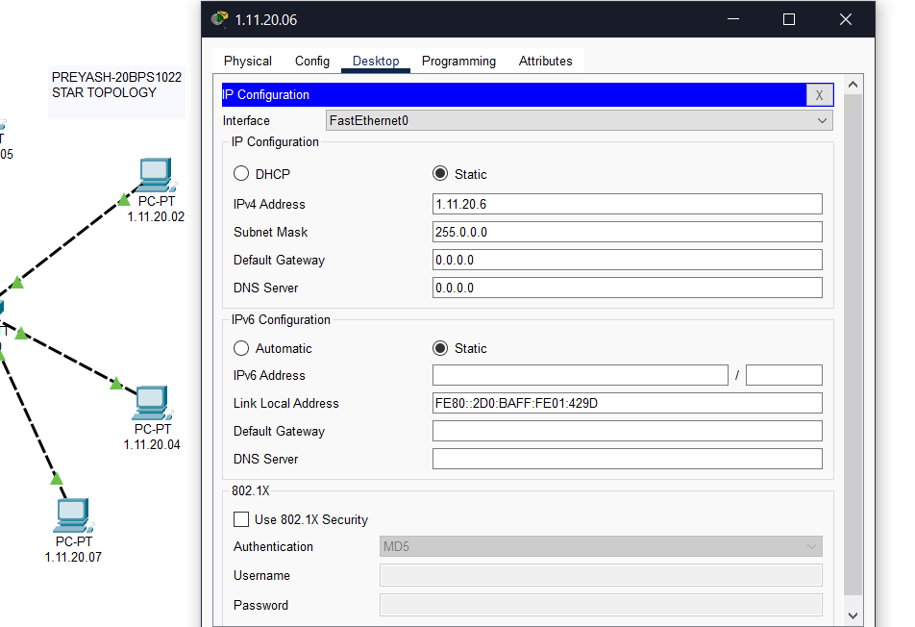

**Success:**

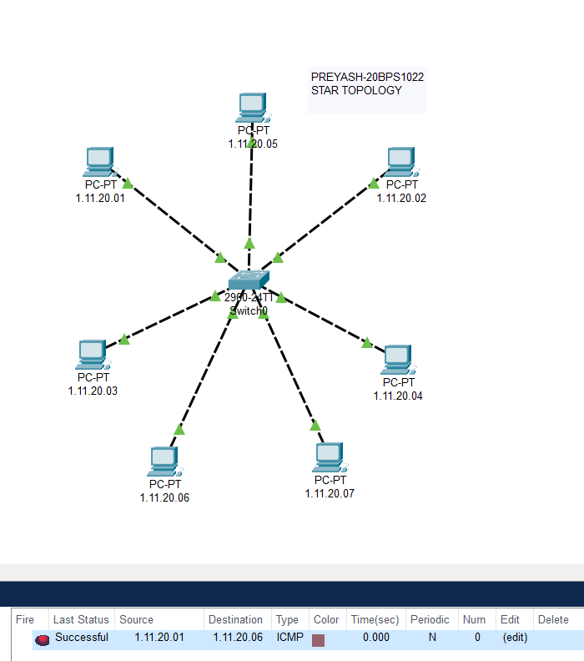

1. **Ring Topology**

***Designing:***

PC6-> PC0

**I.P. Address:**

PC0: 10.0.0.1

PC6: 10.0.0.7

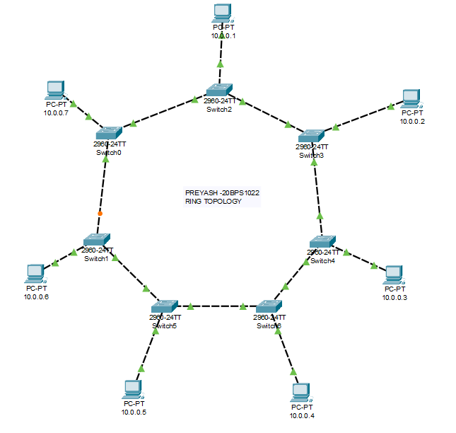

**Source:**

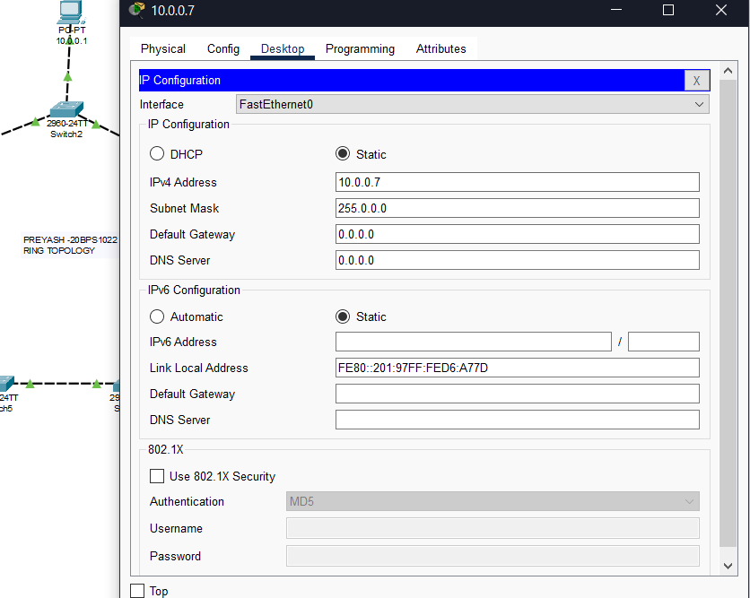

**Destination:**

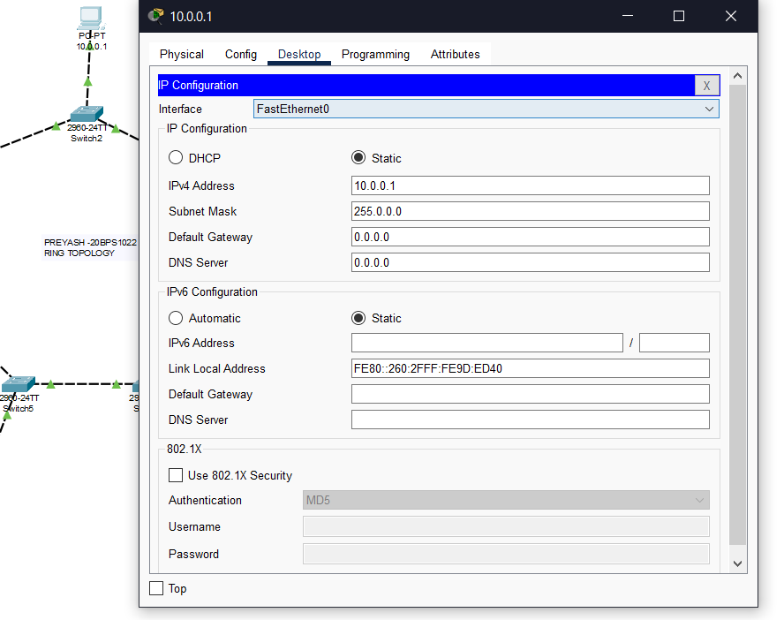

**Success:**

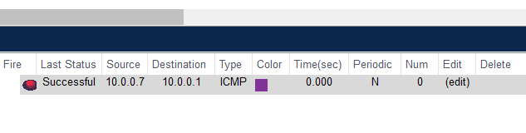

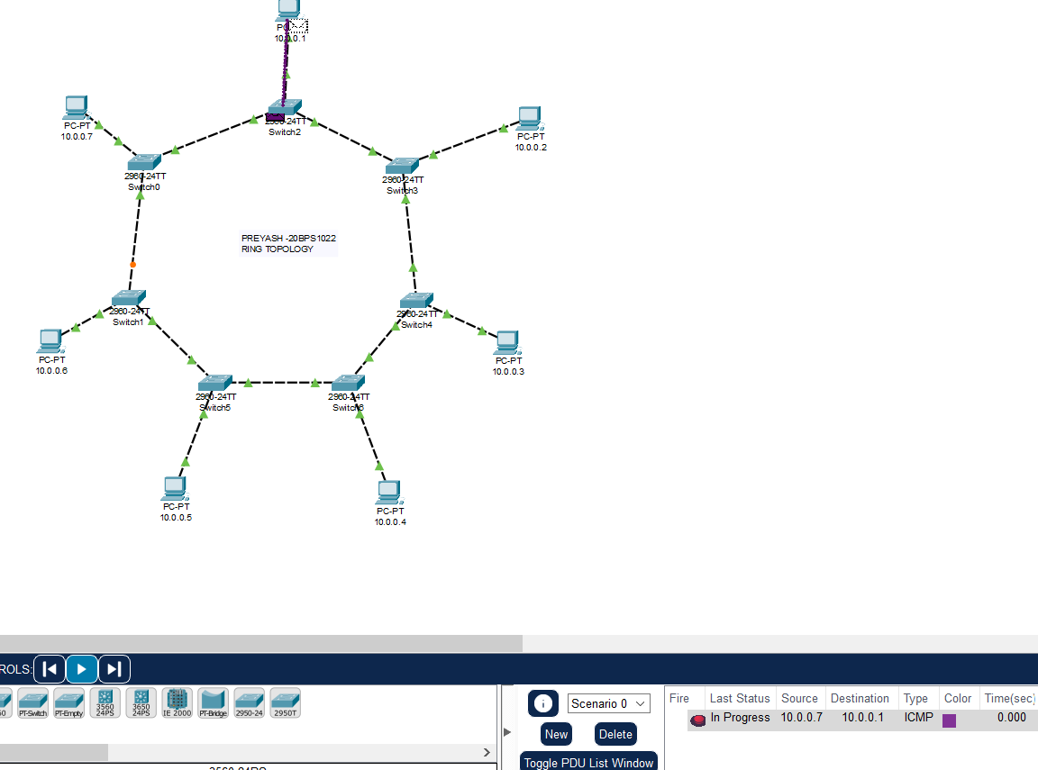

1. **Mesh Topology**

***Designing:***

PC1-> PC4

**I.P. Address:**

PC1: 10.0.0.1

PC4: 10.0.0.4

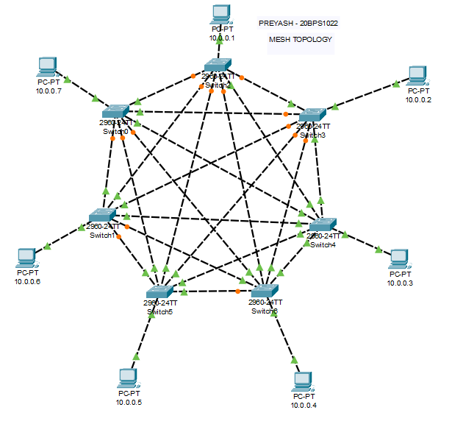

**Source:**

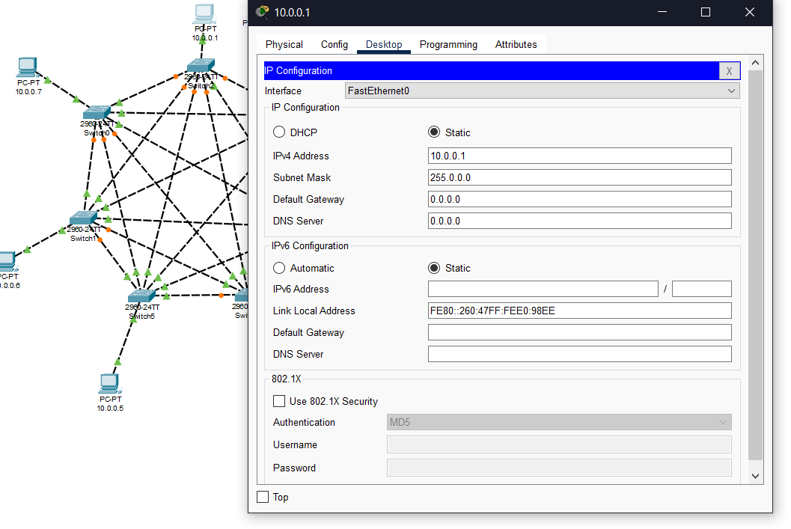

**Destination:**

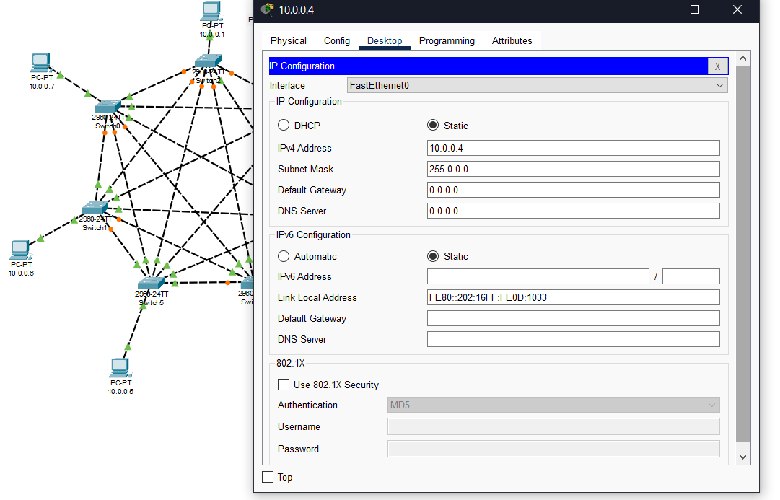

**Success:**

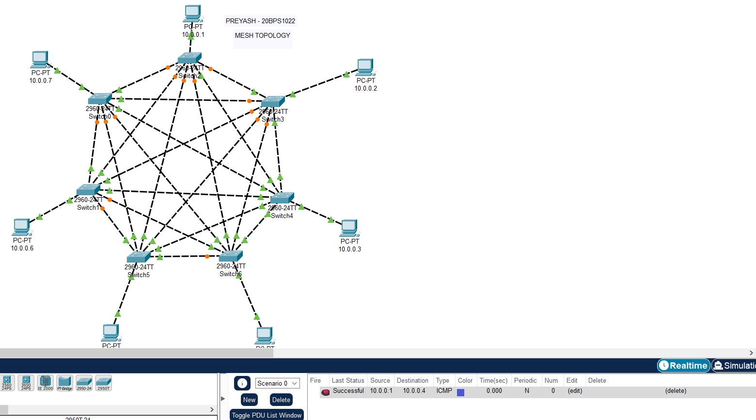

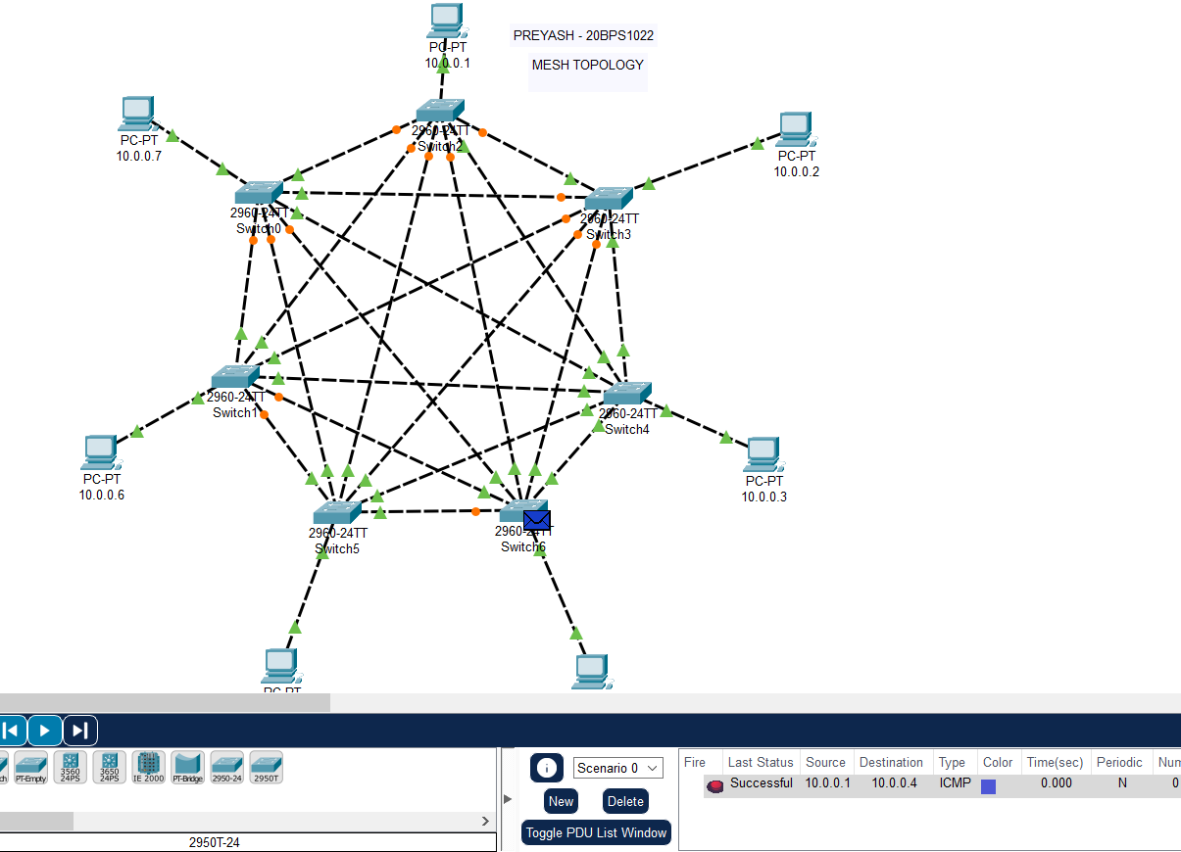

**Result:** **We successfully designed the topologies and transferred the PDUs from the source to the destination.**