**NETWORK & COMMUNICATION**

**NETWORK TOPOLOGY – CISCO PACKET TRACER**

**LAB - 08**

**Name: Preyash**

**Registration Number: 20BPS1022**

1. Construct the topologies given below using CISCO packet tracer.
2. Topology 1

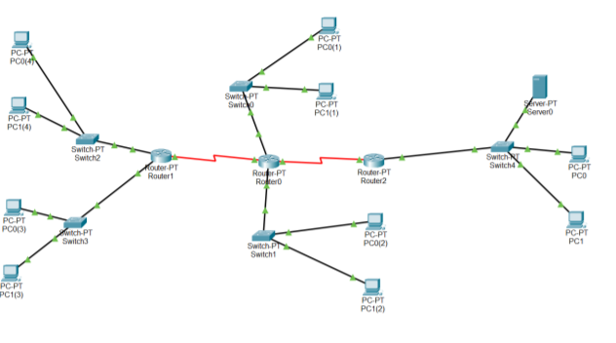

Transfering Message

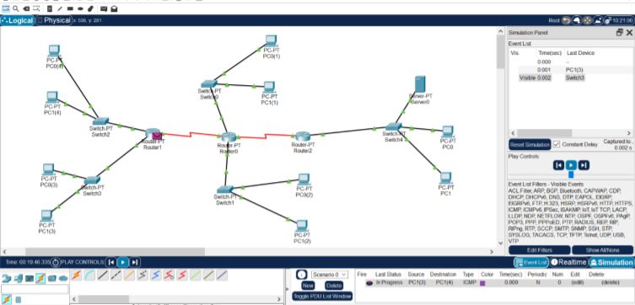

1. Topology 2

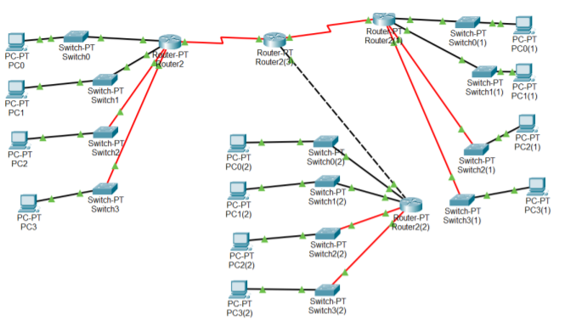

Transfering Message

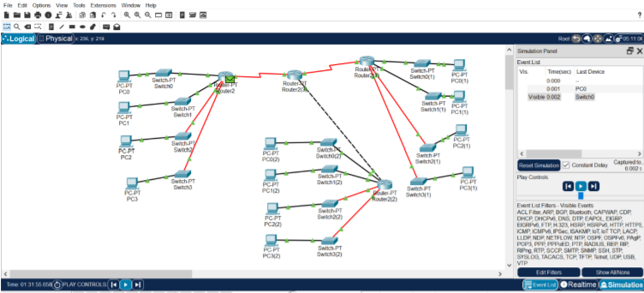

1. Topology 3

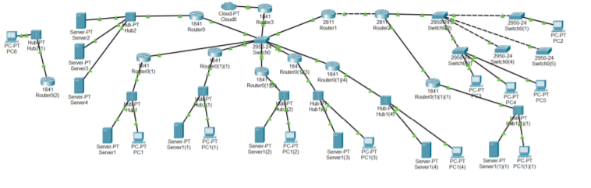

Message Transfer:

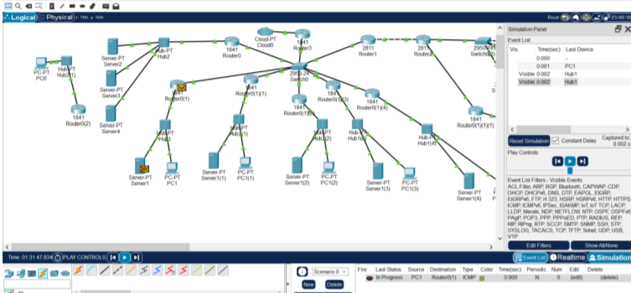

1. Fill the Configuration details of each device in a) Topology 1 using the table given below:

|  |  |  |
| --- | --- | --- |
| Devices | Interface | IP address |
| Router 0 | Serial 2/0 | 1.0.0.1 |
| Serial 3/0 | 2.0.01 |
| Fa 0/0 | 3.0.0.1 |
| Fa 1/0 | 4.0.0.1 |
| Router1 | Fa 0/0 | 1.0.0.1 |
| Fa 1/0 | 5.0.0.1 |
| Router 2 | Fa 0/0 | 2.0.0.1 |
| Fa 1/0 | 6.0.0.1 |
| PC1 | Fa0 | 1.0.0.2 |
| PC2 | Fa0 | 1.0.0.3 |
| PC3 | Fa0 | 5.0.0.2 |
| PC4 | Fa0 | 5.0.0.3 |
| PC5 | Fa0 | 3.0.0.2 |
| PC6 | Fa0 | 3.0.0.3 |
| PC7 | Fa0 | 4.0.02 |
| PC8 | Fa0 | 4.0.0.3 |
| PC9 | Fa0 | 2.0.0.2 |
| Server 0 | Fa0 | 2.0.0.3 |