**NETWORK & COMMUNICATION LAB - 9**

**NETWORK TOPOLOGY – CISCO PACKET**

Name: Preyash

Registration Number: 20BPS1022

**Topology 1:**

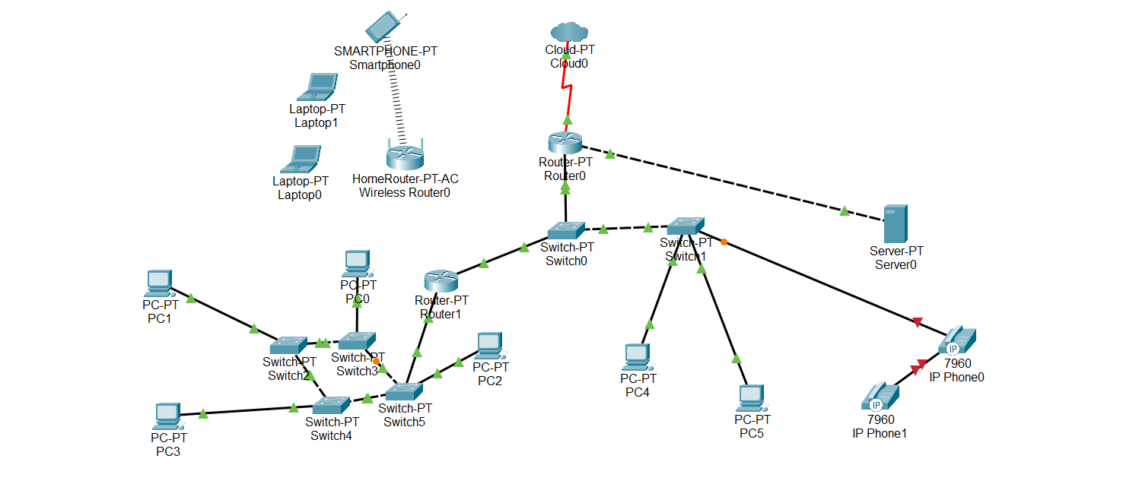**Network-**

**Message Transfer –**

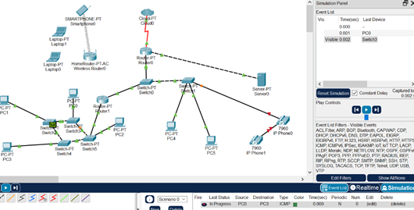

**Topology 2:**

**Network-**

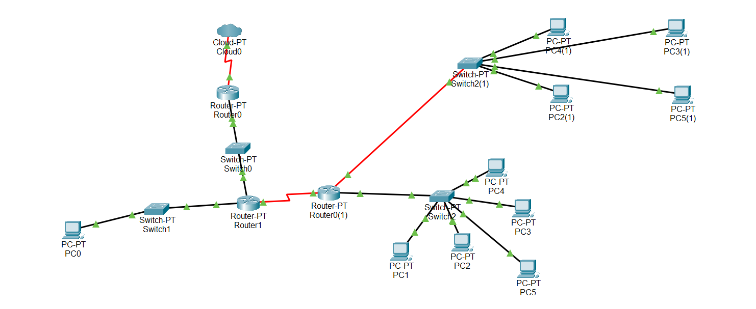

**Message Transfer -**

