**Lab-10**

**RIP Protocol Configuration**

**Name:** Preyash **Registration Number:** 20BPS1022

**Network to be created:**

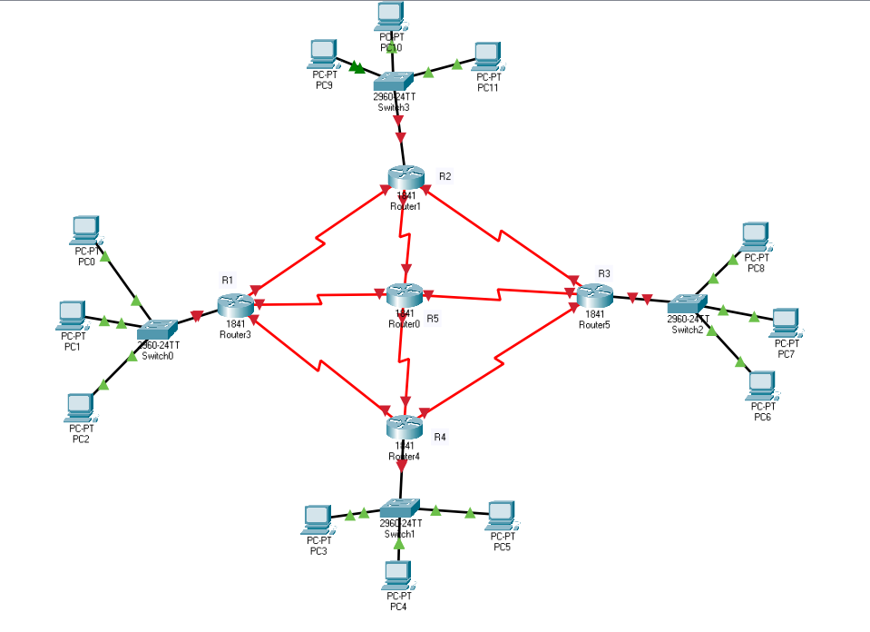

**Network is created:**

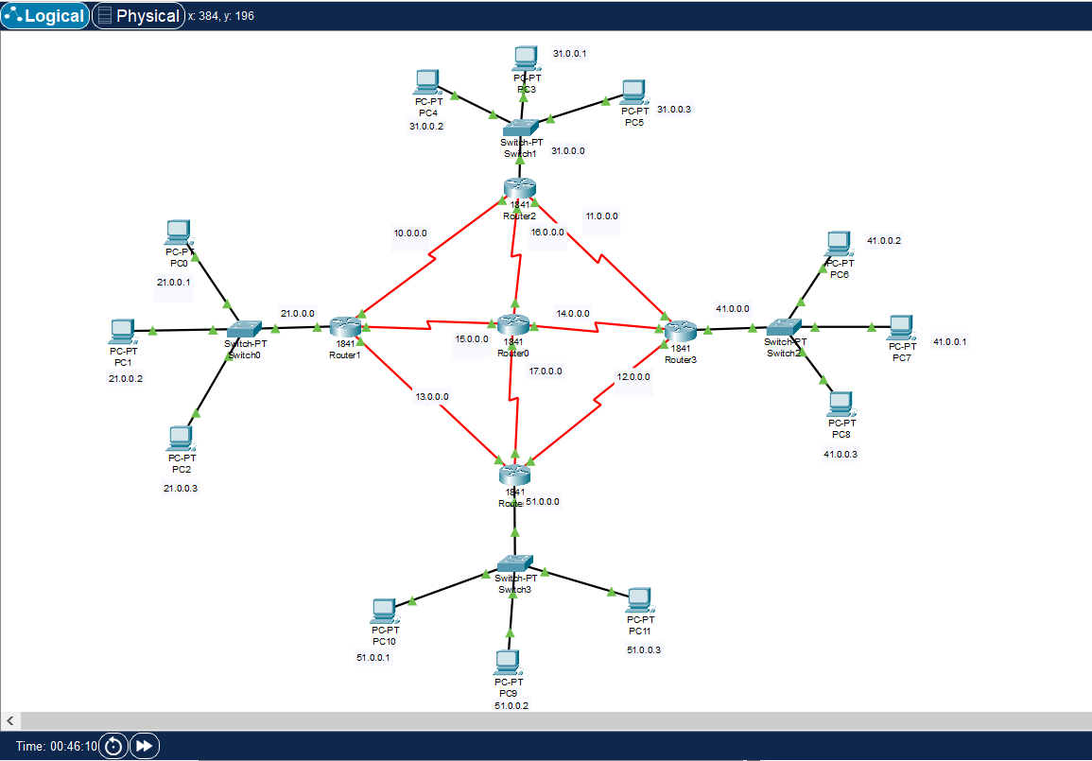

|  |  |
| --- | --- |
| **Data Transmission** | **Routing Path** |
| PC0 -> PC7 |  |
| PC9 -> PC4 |  |
| PC8 -> PC11 |  |
| PC1 -> PC10 |  |