**CSE2012**

**DAA LAB**

Name: Preyash

Registration Number: 20BPS1022

Ex2: Merge Sort

**Code window:**

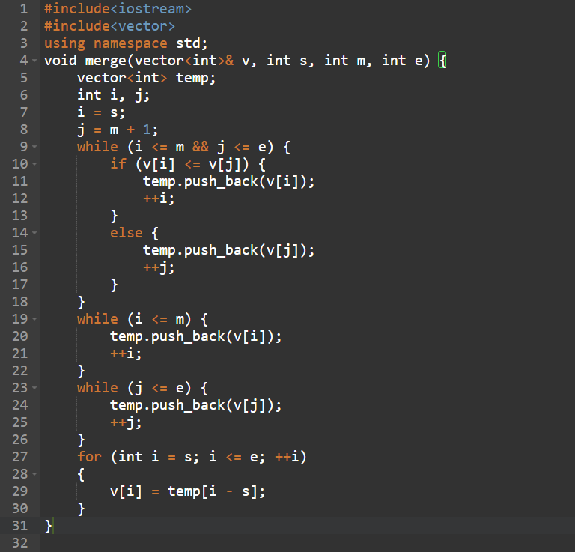

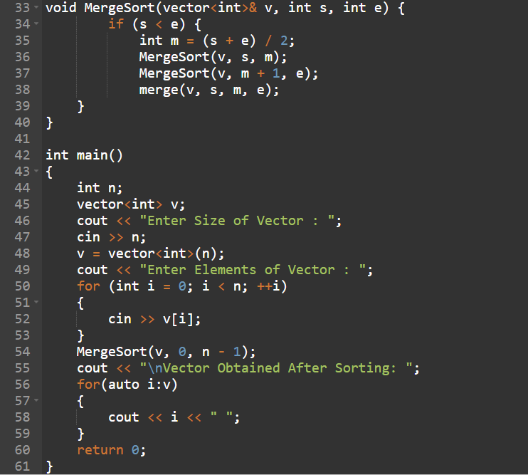

**Code:**

#include<iostream>

#include<vector>

using namespace std;

void merge(vector<int>& v, int s, int m, int e) {

vector<int> temp;

int i, j;

i = s;

j = m + 1;

while (i <= m && j <= e) {

if (v[i] <= v[j]) {

temp.push_back(v[i]);

++i;

}

else {

temp.push_back(v[j]);

++j;

}

}

while (i <= m) {

temp.push_back(v[i]);

++i;

}

while (j <= e) {

temp.push_back(v[j]);

++j;

}

for (int i = s; i <= e; ++i)

{

v[i] = temp[i - s];

}

}

void MergeSort(vector<int>& v, int s, int e) {

if (s < e) {

int m = (s + e) / 2;

MergeSort(v, s, m);

MergeSort(v, m + 1, e);

merge(v, s, m, e);

}

}

int main()

{

int n;

vector<int> v;

cout << "Enter Size of Vector : ";

cin >> n;

v = vector<int>(n);

cout << "Enter Elements of Vector : ";

for (int i = 0; i < n; ++i)

{

cin >> v[i];

}

MergeSort(v, 0, n - 1);

cout << "\nVector Obtained After Sorting: ";

for(auto i:v)

{

cout << i << " ";

}

return 0;

}

**Output:**

