**CSE2012**

**DAA LAB**

Name: Preyash

Registration Number: 20BPS1022

Ex3: Matrix Multiplication

**1. Matrix Multiplication**

**Code Window:**

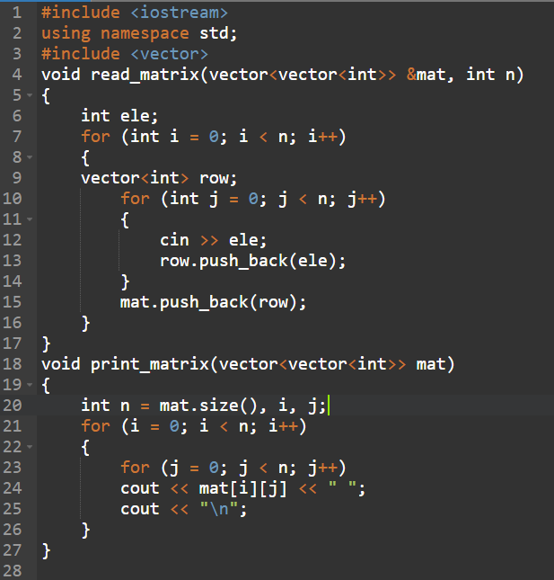

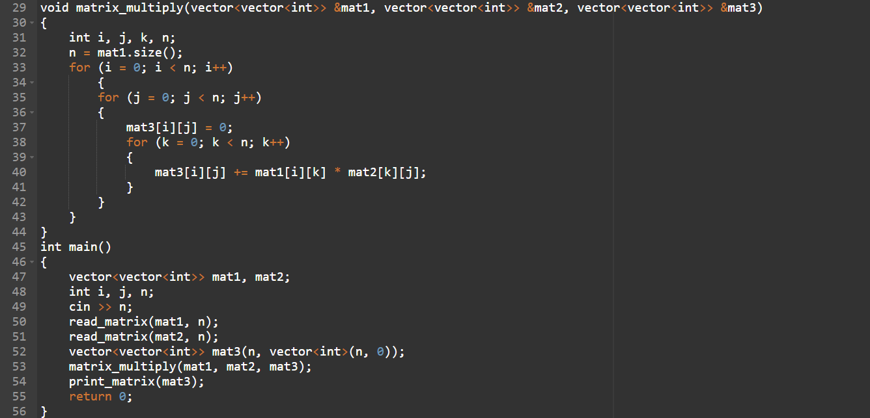

**Code:**

#include <iostream>

using namespace std;

#include <vector>

void read_matrix(vector<vector<int>> &mat, int n)

{

int ele;

for (int i = 0; i < n; i++)

{

vector<int> row;

for (int j = 0; j < n; j++)

{

cin >> ele;

row.push_back(ele);

}

mat.push_back(row);

}

}

void print_matrix(vector<vector<int>> mat)

{

int n = mat.size(), i, j;

for (i = 0; i < n; i++)

{

for (j = 0; j < n; j++)

cout << mat[i][j] << " ";

cout << "\n";

}

}

void matrix_multiply(vector<vector<int>> &mat1, vector<vector<int>> &mat2, vector<vector<int>> &mat3)

{

int i, j, k, n;

n = mat1.size();

for (i = 0; i < n; i++)

{

for (j = 0; j < n; j++)

{

mat3[i][j] = 0;

for (k = 0; k < n; k++)

{

mat3[i][j] += mat1[i][k] * mat2[k][j];

}

}

}

}

int main()

{

vector<vector<int>> mat1, mat2;

int i, j, n;

cin >> n;

read_matrix(mat1, n);

read_matrix(mat2, n);

vector<vector<int>> mat3(n, vector<int>(n, 0));

matrix_multiply(mat1, mat2, mat3);

print_matrix(mat3);

return 0;

}

**Output:**

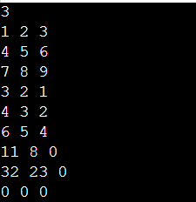

**2. Iterative Method:**

**Code window:**

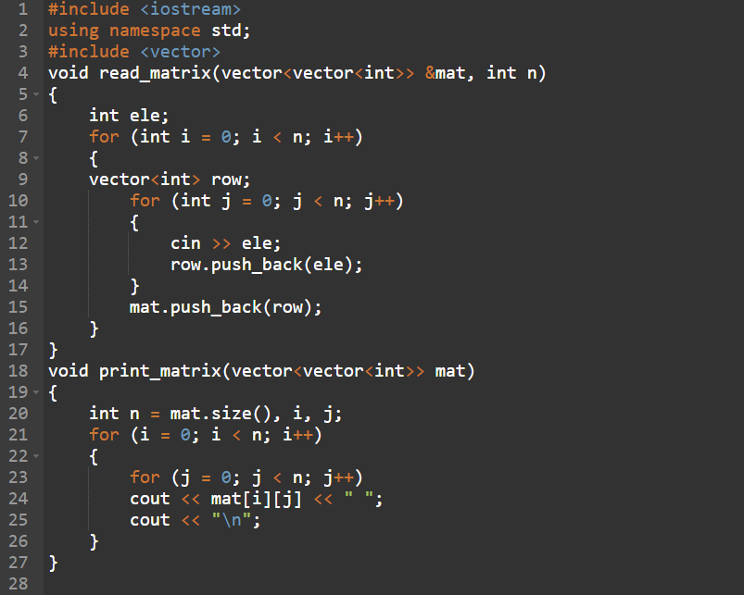

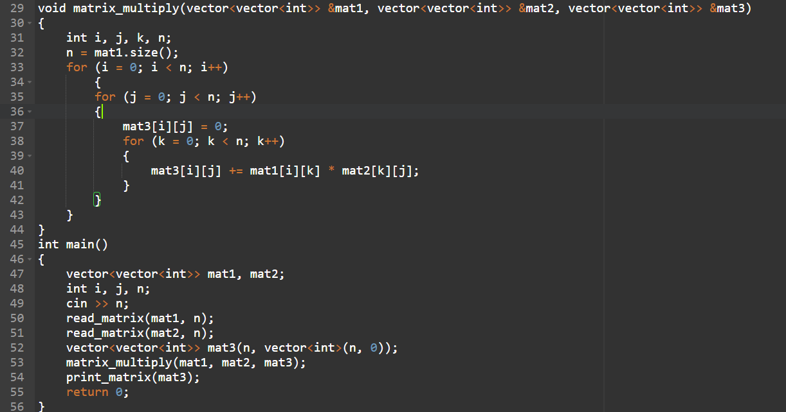

**Code:**

#include <iostream>

using namespace std;

#include <vector>

void read_matrix(vector<vector<int>> &mat, int n)

{

int ele;

for (int i = 0; i < n; i++)

{

vector<int> row;

for (int j = 0; j < n; j++)

{

cin >> ele;

row.push_back(ele);

}

mat.push_back(row);

}

}

void print_matrix(vector<vector<int>> mat)

{

int n = mat.size(), i, j;

for (i = 0; i < n; i++)

{

for (j = 0; j < n; j++)

cout << mat[i][j] << " ";

cout << "\n";

}

}

void matrix_multiply(vector<vector<int>> &mat1, vector<vector<int>> &mat2, vector<vector<int>> &mat3)

{

int i, j, k, n;

n = mat1.size();

for (i = 0; i < n; i++)

{

for (j = 0; j < n; j++)

{

mat3[i][j] = 0;

for (k = 0; k < n; k++)

{

mat3[i][j] += mat1[i][k] * mat2[k][j];

}

}

}

}

int main()

{

vector<vector<int>> mat1, mat2;

int i, j, n;

cin >> n;

read_matrix(mat1, n);

read_matrix(mat2, n);

vector<vector<int>> mat3(n, vector<int>(n, 0));

matrix_multiply(mat1, mat2, mat3);

print_matrix(mat3);

return 0;

}

**Output:**

