**DAA**

**CSE2012**

**LAB-08**

**LPS**

**Name: Preyash Registration Number: 20BPS1022**

1. **Optimized Naive approach for String matching**

**Code:**

#include <bits/stdc++.h>

using namespace std;

void search(string pat, string txt)

{

int M = pat.size();

int N = txt.size();

int i = 0;

while (i <= N - M)

{

int j;

for (j = 0; j < M; j++)

if (txt[i + j] != pat[j])

break;

if (j == M)

{

cout << "Pattern found at index " << i << endl;

i = i + M;

}

else if (j == 0)

i = i + 1;

else

i = i + j;

}

}

int main()

{

string txt = "ABCEABCDABCEABCD";

string pat = "ABCD";

search(pat, txt);

return 0;

}

**Output:**

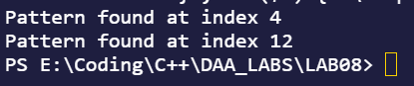

**2.) The user enters a character in place of the dollar sign and then perform string pattern searching using optimized naïve approach.**

**Code:**

#include <bits/stdc++.h>

using namespace std;

void search(string pat, string txt)

{

int M = pat.size();

int N = txt.size();

int i = 0;

while (i <= N - M)

{

int j;

for (j = 0; j < M; j++)

if (txt[i + j] != pat[j])

break;

if (j == M)

{

cout << "Pattern found at index " << i << endl;

i = i + M;

}

else if (j == 0)

i = i + 1;

else

i = i + j; *// slide the pattern by j*

}

}

*/* Driver code*/*

int main()

{

string txt = "ABCEABCDABCEABCD";

cout<<"Enter the value of dollar AB$D";

string k;

cin>>k;

string pat = "AB"+k+"D";

search(pat, txt);

return 0;

}

**Output:**

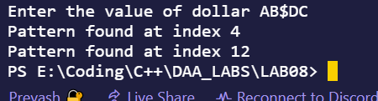

1. **String pattern searching where dollar can be any character or characters.**

**Code:**

#include <bits/stdc++.h>

using namespace std;

int search(string pat, string txt)

{

 int M = pat.size();

 int N = txt.size();

 int i = 0;

 while (i <= N - M)

 {

 int j;

 for (j = 0; j < M; j++)

 if (txt[i + j] != pat[j])

 break;

 if (j == M)

 {

 return i;

 i = i + M;

 }

 else if (j == 0)

 i = i + 1;

 else

 i = i + j; *// slide the pattern by j*

 }

 return 0;

}

int main()

{

 string txt = "ABCEABCDABCEABCD";

 cout << "check for regex BC$ABCD where $ can be any character" << endl;

 string pat1 = "BC";

 string pat2 = "ABCD";

 int i1 = search(pat1, txt);

  int i2 = search(pat2, txt)+ pat2.length()-1;

 if (i1 < i2)

 {

 cout << "Pattern found at index " << i1 << " to " << i2;

 }

 return 0;

}

**Output:**

