**LAB-01**

**CSE2020**

**INTRODUCTION TO CPS LAB**

**Name: Preyash**

**Reg No.: 20BPS1022 Date: January 10, 2022**

**Task 1: Single LED on/off connected in breadboard**

**Circuit:**

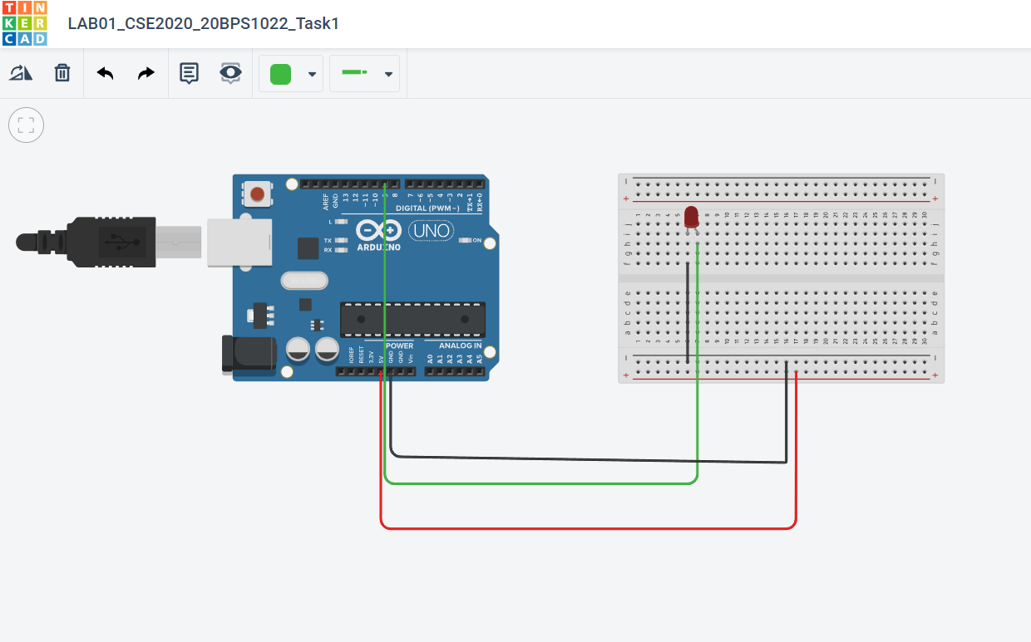

**Code:**

// C++ code

void setup()

{

pinMode(9, OUTPUT);

}

void loop()

{

delay(1000); // Wait for 1000 millisecond(s)

digitalWrite(9, HIGH);

delay(1000);

digitalWrite(9, LOW);

}

**Output:**

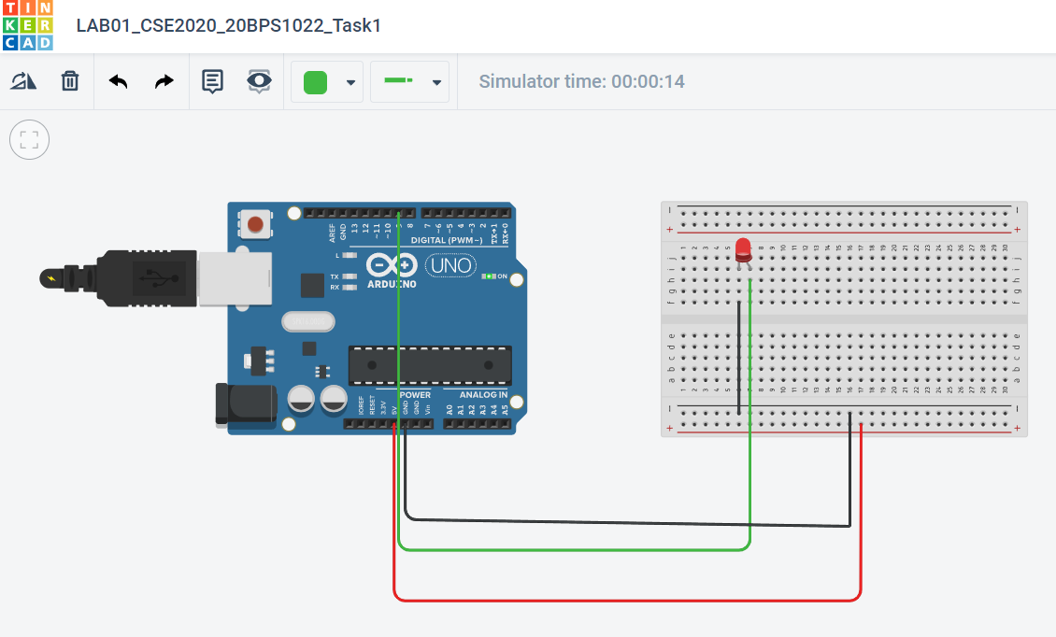

**Link:** <https://www.tinkercad.com/things/42WhK8pZ58L-lab01cse202020bps1022task1/editel>

**Task 2: Single LED on/off connected in breadboard in Tinker CAD.**

**Circuit:**

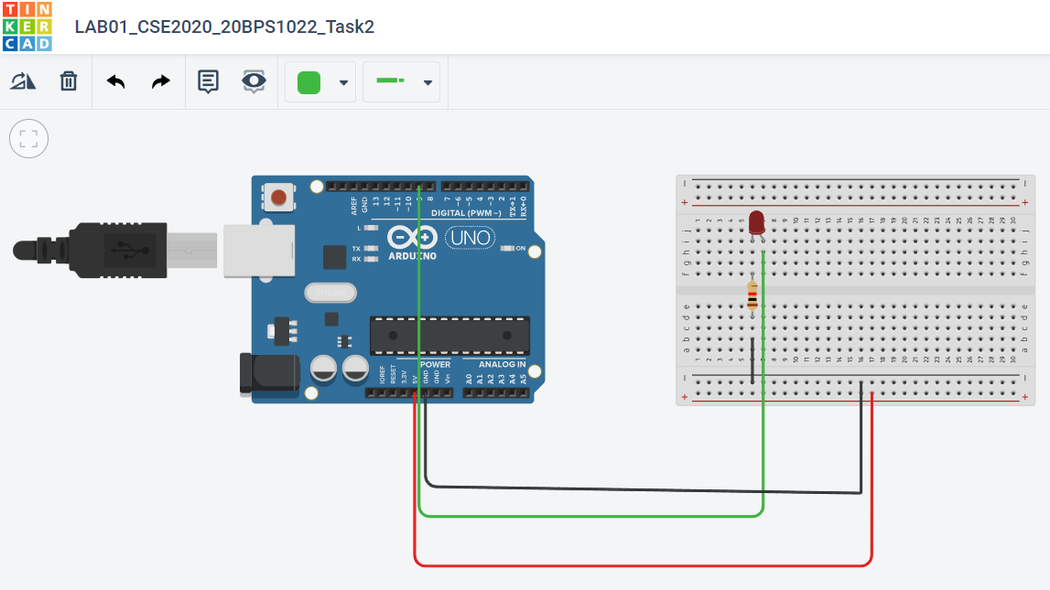

**Code:**

// C++ code

void setup()

{

pinMode(9, OUTPUT);

}

void loop()

{

delay(1000); // Wait for 1000 millisecond(s)

digitalWrite(9, HIGH);

delay(1000);

digitalWrite(9, LOW);

}

**Output:**

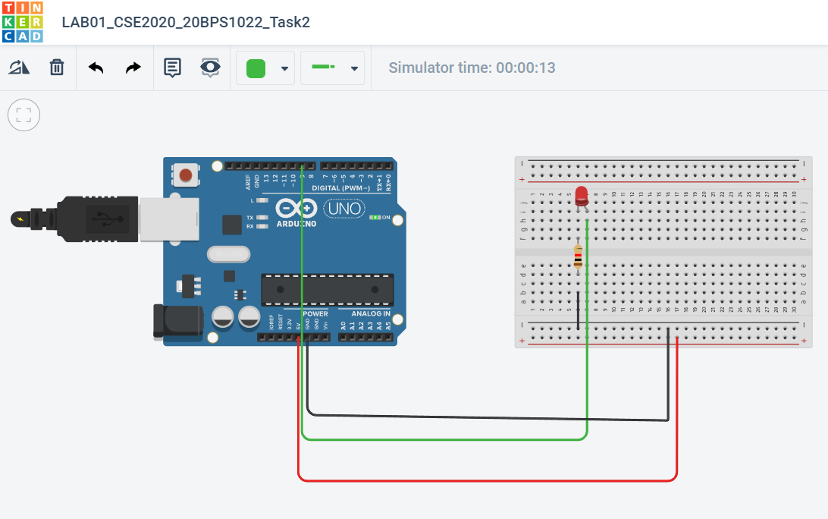

**Link:** <https://www.tinkercad.com/things/3C5txwcAYEx-lab01cse202020bps1022task2/editel>

**Task 3:** **Three LED with different color connected with resistor in breadboard (on/off) in Tinker CAD .**

**Circuit:**

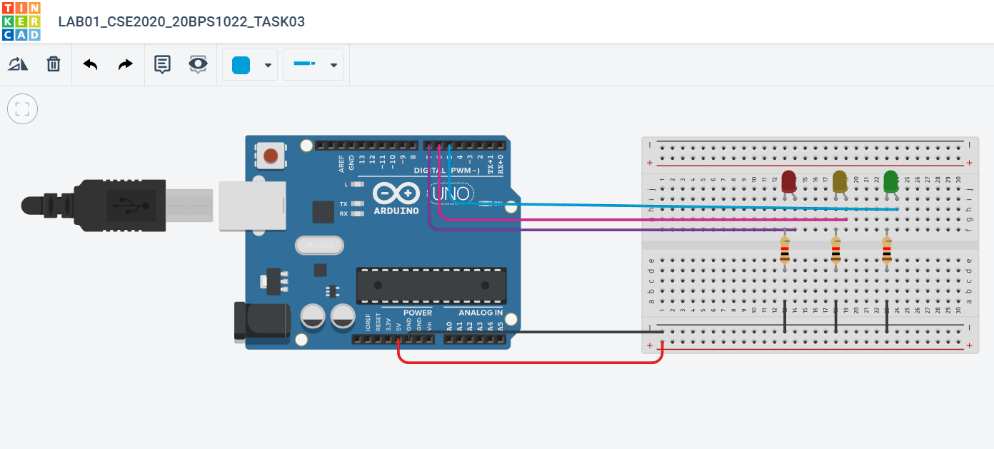

**Code:**

// C++ code

void setup()

{

pinMode(5, OUTPUT);

pinMode(6, OUTPUT);

pinMode(7, OUTPUT);

}

void loop()

{

delay(1000); // Wait for 1000 millisecond(s)

digitalWrite(5, HIGH);

delay(1000);

digitalWrite(5, LOW);

delay(1000); // Wait for 1000 millisecond(s)

digitalWrite(6, HIGH);

delay(1000);

digitalWrite(6, LOW);

delay(1000); // Wait for 1000 millisecond(s)

digitalWrite(7, HIGH);

delay(1000);

digitalWrite(7, LOW);

}

**Output:**

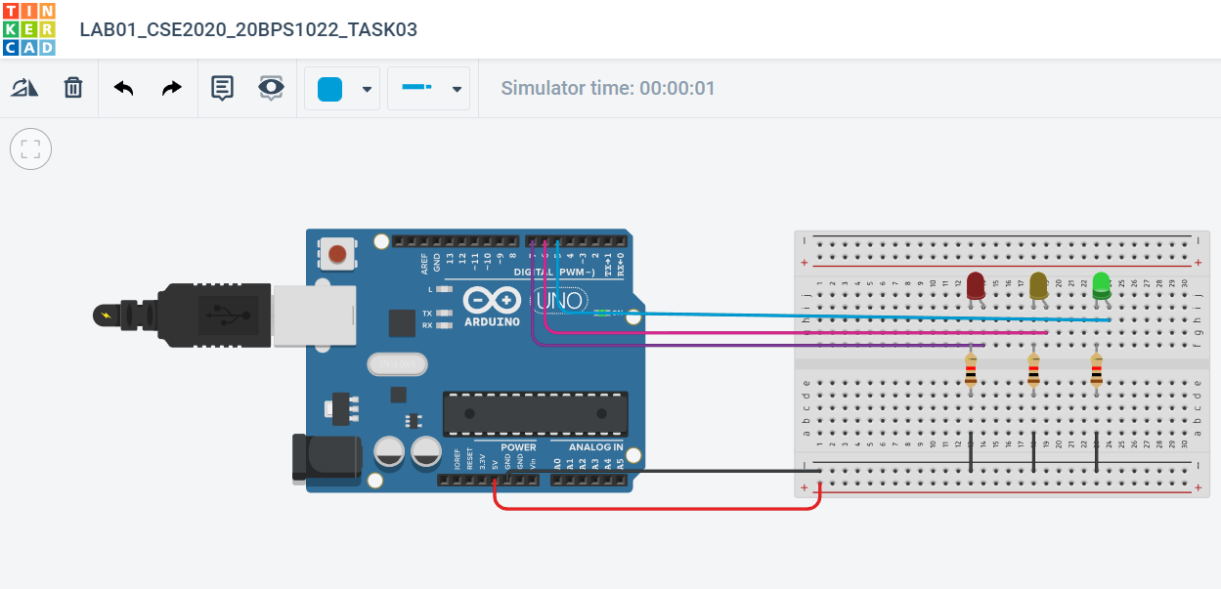

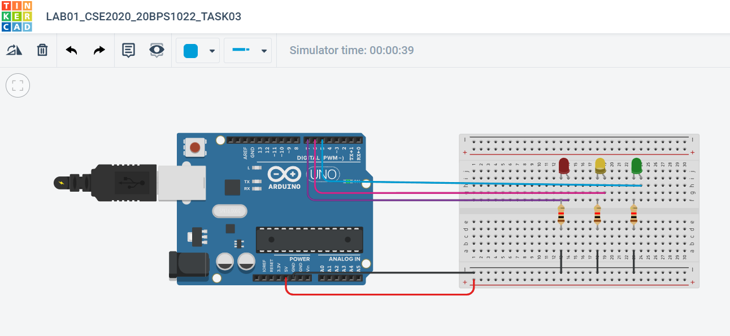

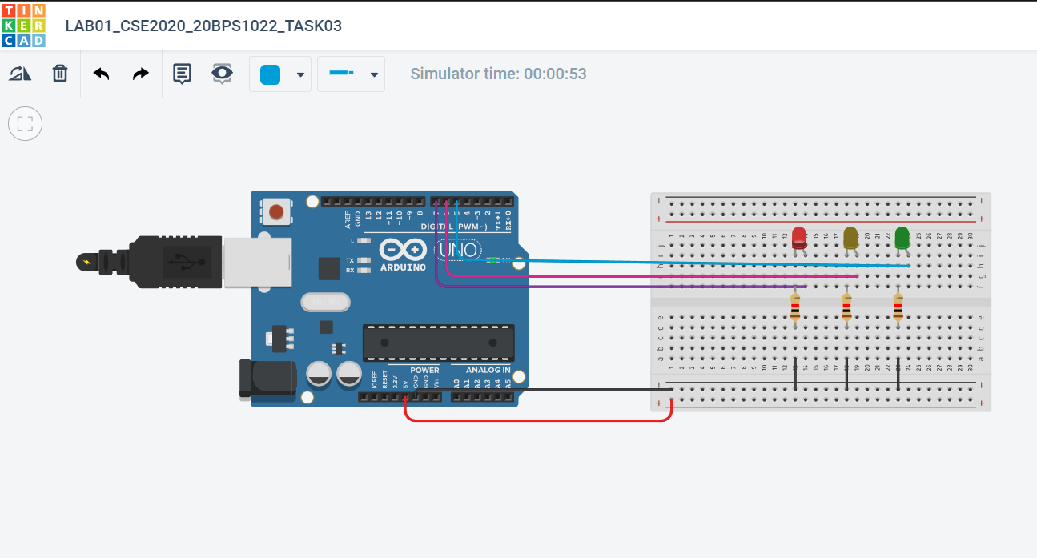

**Link:**

<https://www.tinkercad.com/things/fgsGIMrFpPp-incredible-maimu-wluff/editel?tenant=circuits>

**Task 4: Between on/off of each LED, display a message for each LED.**

**Circuit:**

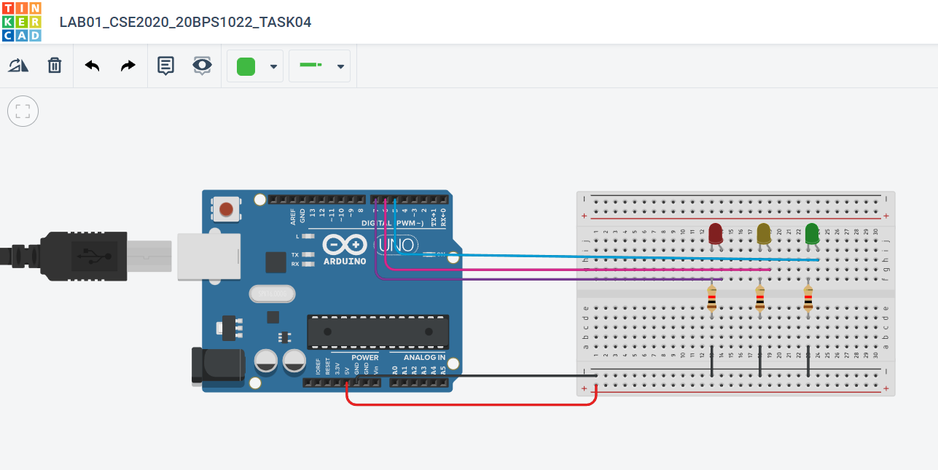

**Code:**

// C++ code

void setup()

{

pinMode(5, OUTPUT);

pinMode(6, OUTPUT);

pinMode(7, OUTPUT);

Serial.begin(9600);

}

void loop()

{

delay(1000); // Wait for 1000 millisecond(s)

digitalWrite(5, HIGH);

Serial.println("Hello!");

delay(1000);

digitalWrite(5, LOW);

delay(1000); // Wait for 1000 millisecond(s)

digitalWrite(6, HIGH);

Serial.println("I'm Preyash");

delay(1000);

digitalWrite(6, LOW);

delay(1000); // Wait for 1000 millisecond(s)

digitalWrite(7, HIGH);

Serial.println("20BPS1022");

delay(1000);

digitalWrite(7, LOW);

}

**Output:**

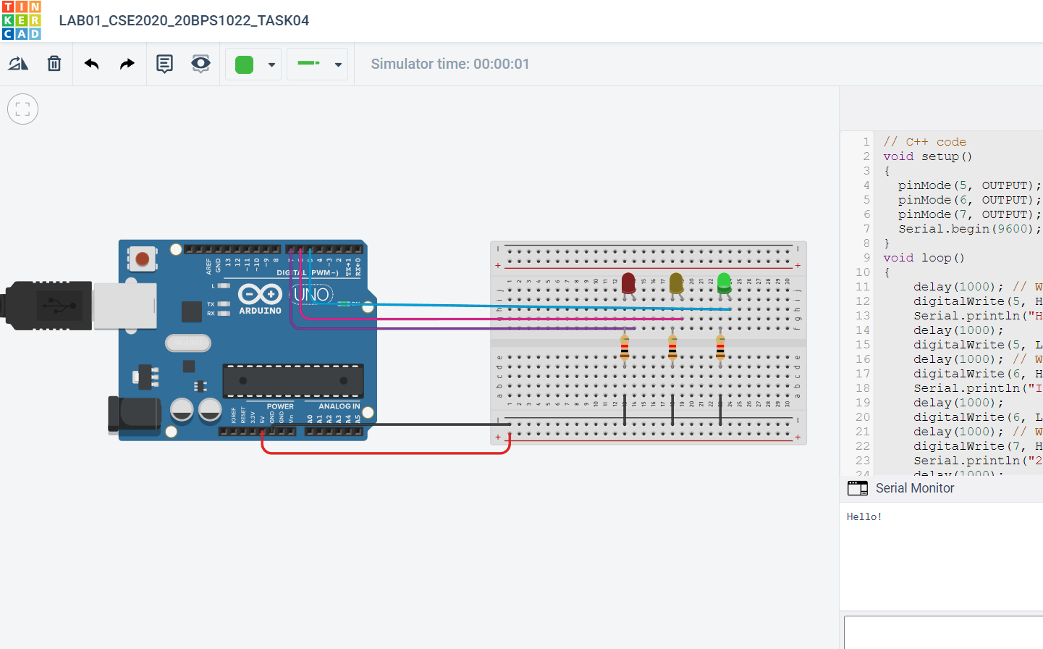

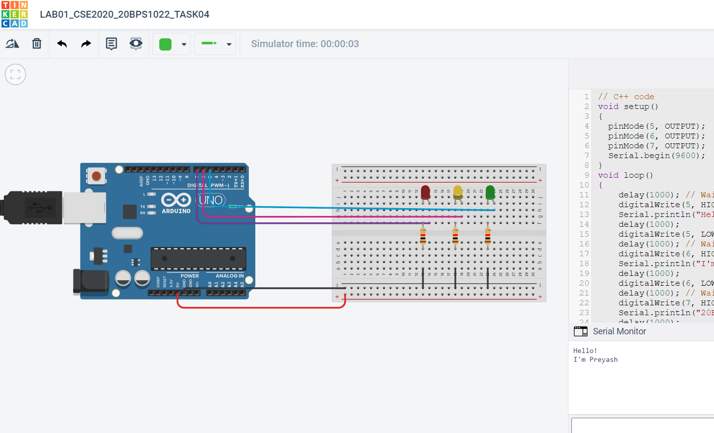

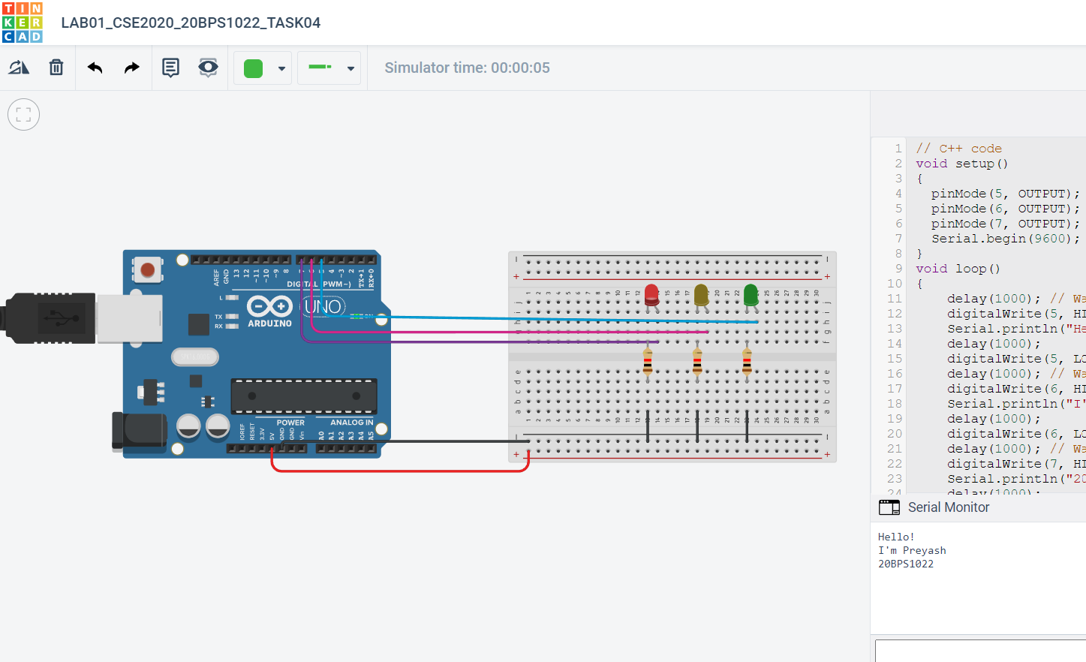

**Link:**

<https://www.tinkercad.com/things/hso01393Cf6-lab01cse202020bps1022task04/editel>

**Task 5: Add a pushbutton to the breadboard with 1 LED connected with resistor. Whenever u push the button, LED should turn on, in Tinker CAD**.

**Circuit:**

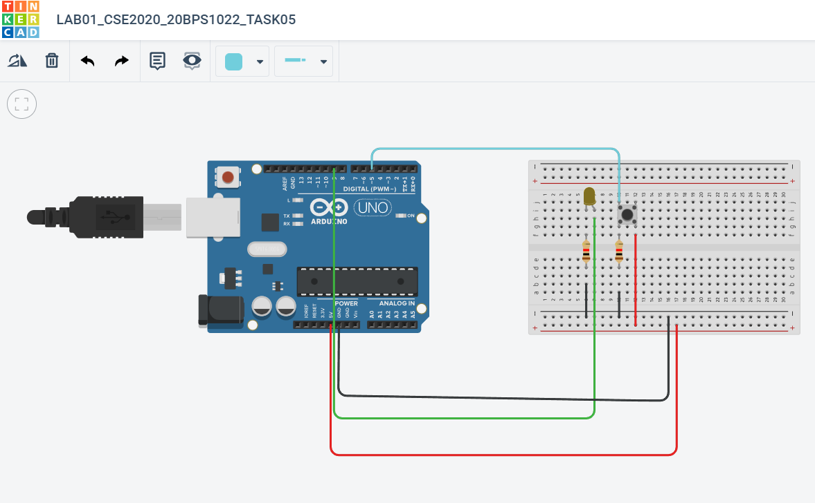

**Code:**

int button =0;

void setup()

{

pinMode(5,INPUT);

pinMode(9, OUTPUT);

}

void loop()

{

// read the state of the pushbutton

button = digitalRead(5);

// check if pushbutton is pressed. if it is, the

// button state is HIGH

if (button == HIGH) {

digitalWrite(9, HIGH);

delay(1000);

} else {

digitalWrite(9, LOW);

}

delay(1000); // Delay a little bit to improve simulation performance

}

**Output:**

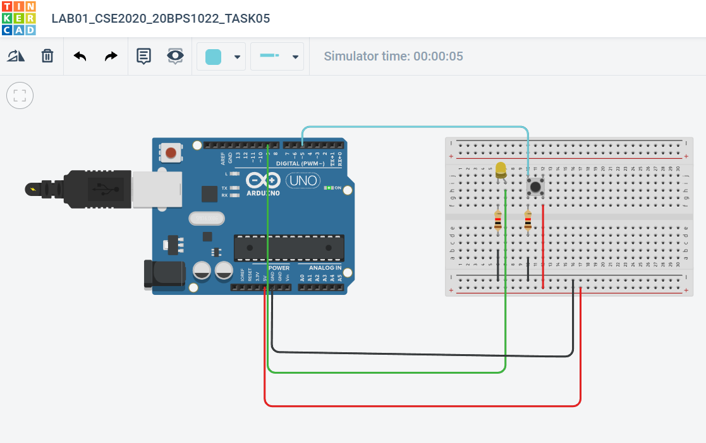

**Link:**

<https://www.tinkercad.com/things/4C2Git940b5-lab01cse202020bps1022task05/editel>

**Task 6: Add a pushbutton to the breadboard with 3 LED connected with corresponding resistor. Whenever u push the button, LED should turn ON in sequence. Like, first time push the button, 1st LED will turn ON, second button press, 2nd LED will turn ON, 3rd time push the button, 3rd LED will turn ON.**

**Circuit:**

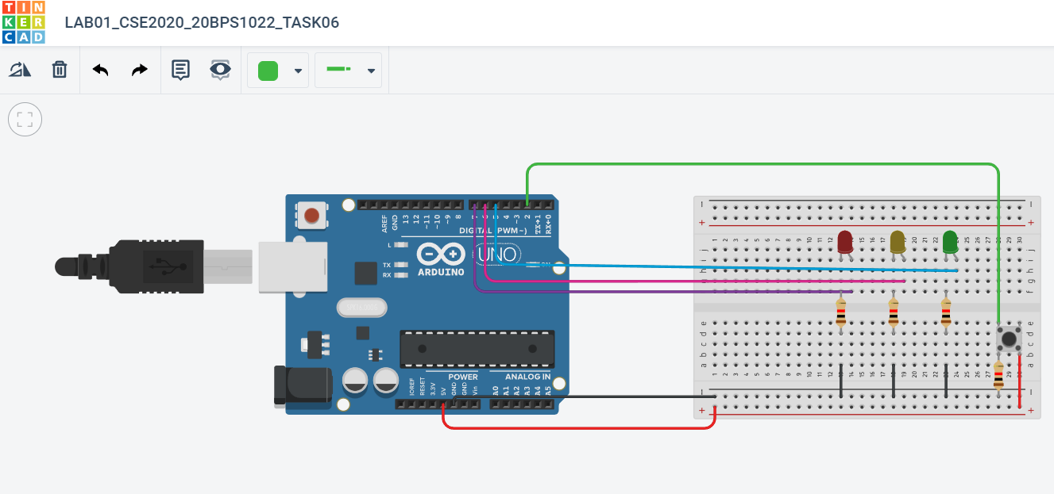

**Code:**

int LED1=5;

int LED2=6;

int LED3=7;

int button =0;

int c=0;

void setup()

{

pinMode(LED1, OUTPUT);

pinMode(LED2, OUTPUT);

pinMode(LED3, OUTPUT);

pinMode(4,INPUT);

}

void loop()

{

if(digitalRead(2)&&c==0)

{

digitalWrite(LED1, HIGH);

digitalWrite(LED2, LOW);

digitalWrite(LED3, LOW);

delay(1000);

c++;

}

if(digitalRead(2)&&c==1)

{

digitalWrite(LED1, LOW);

digitalWrite(LED2, HIGH);

digitalWrite(LED3, LOW);

delay(1000);

c++;

}

if(digitalRead(2)&&c==2)

{

digitalWrite(LED1, LOW);

digitalWrite(LED2, LOW);

digitalWrite(LED3, HIGH);

delay(1000);

c=0;

}

delay(10);

}

**Output:**

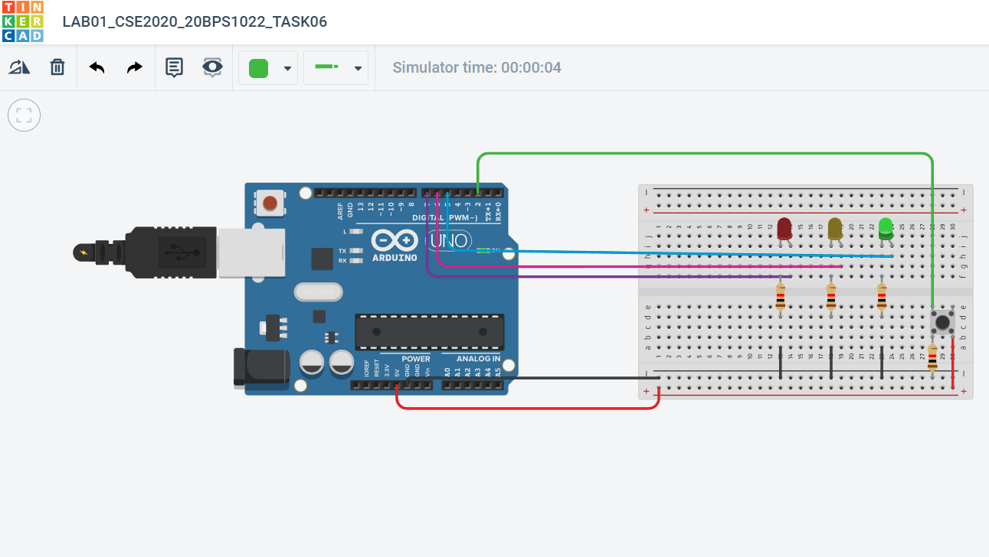

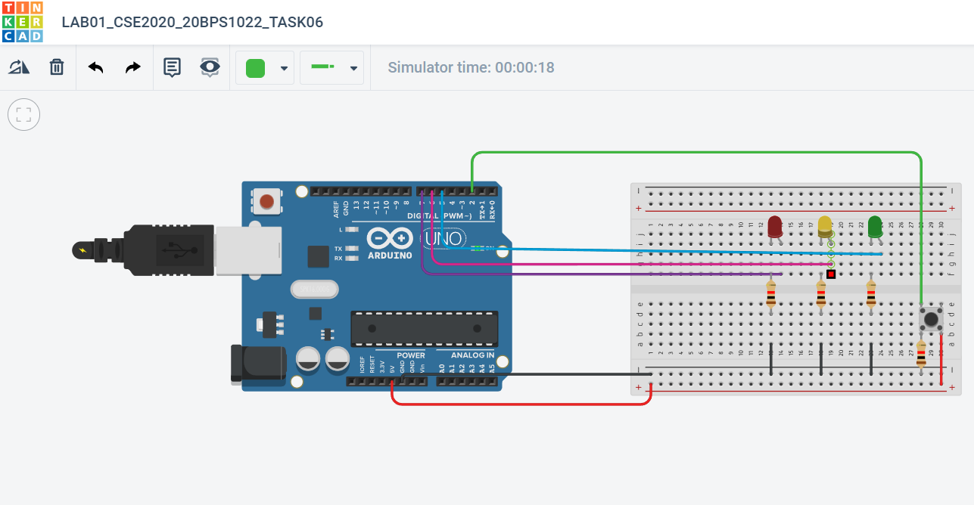

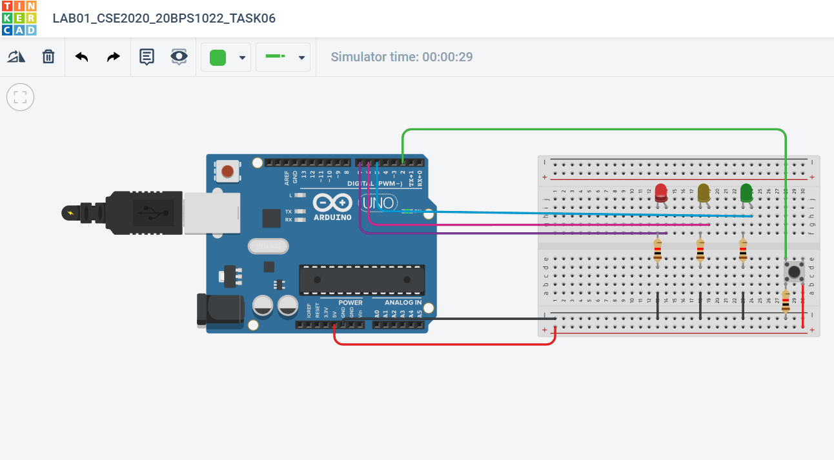

**Link:**

<https://www.tinkercad.com/things/i5OQtLvIM5G-lab01cse202020bps1022task06/editel>