**LAB-02**

**CSE2020**

**INTRODUCTION TO CPS LAB**

**Name: Preyash**

**Reg No.: 20BPS1022 Date: January 17, 2022**

**Task 1: Connect Arduino with photo resistor n resistor and regulate it supply n make single LED to glow accordingly.**

**Circuit:**

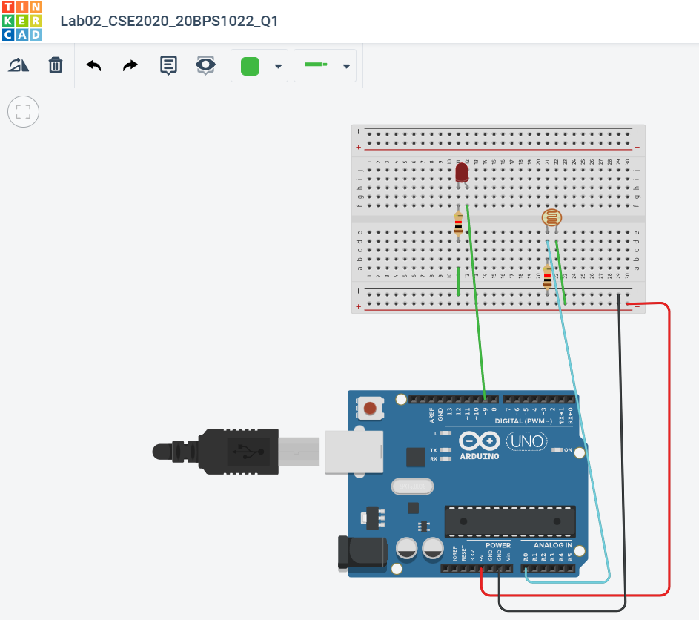

**Code:**

// C++ code

int sensorValue = 0;

void setup()

{

pinMode(A0, INPUT);

Serial.begin(9600);

pinMode(9, OUTPUT);

}

void loop()

{

sensorValue = analogRead(A0);

Serial.println(sensorValue);

analogWrite(9, map(sensorValue, 0, 1023, 0, 255));

delay(100);

}

**Output:**

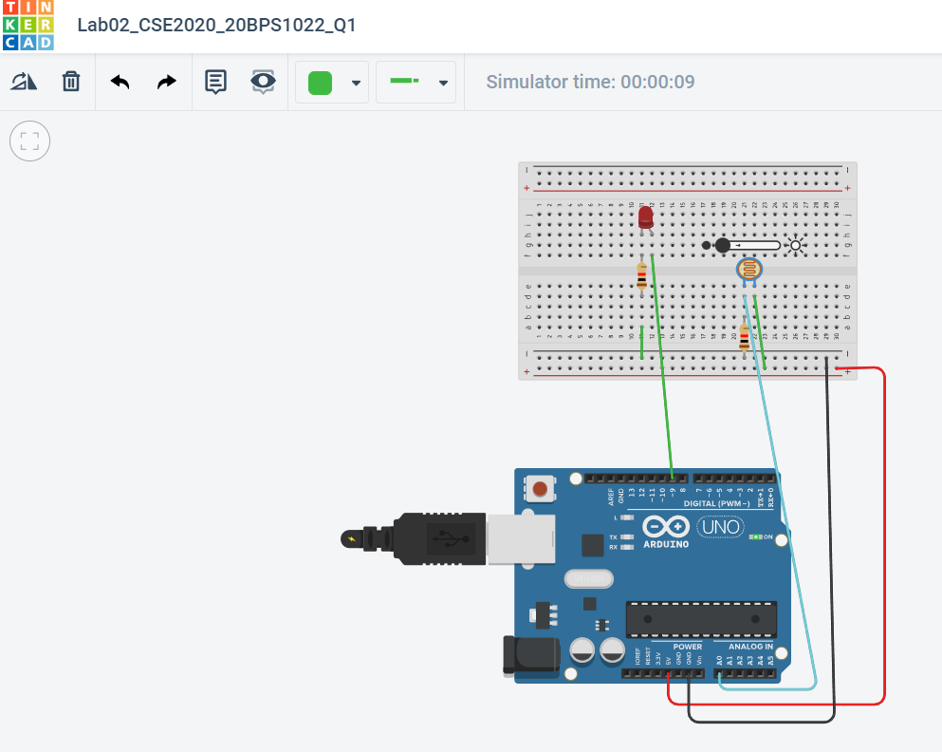

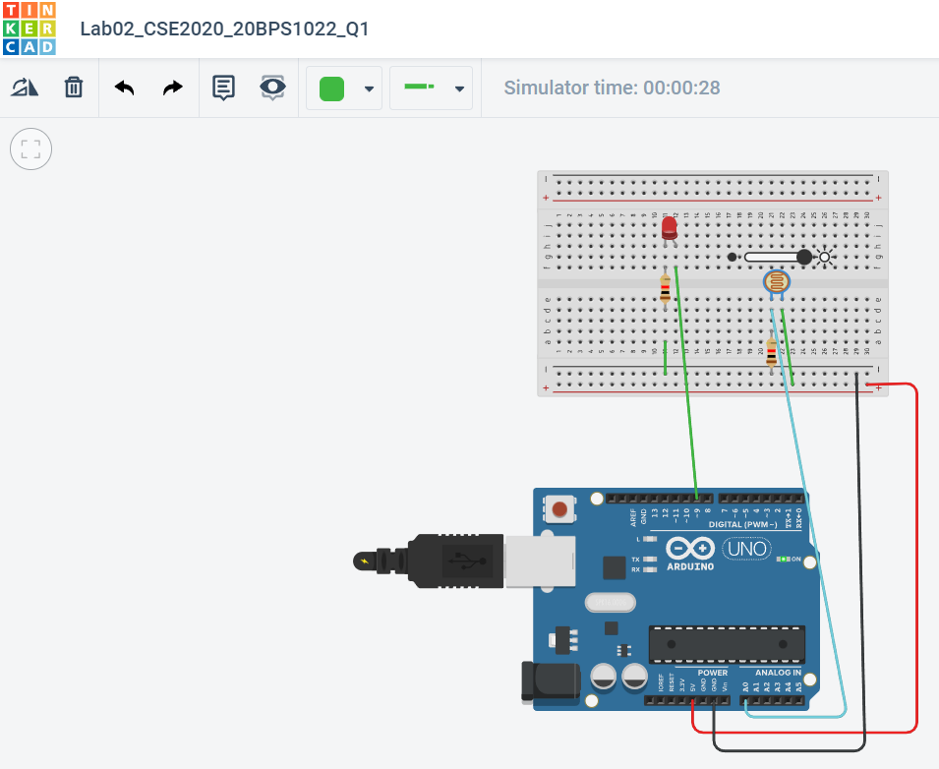

**Link:** <https://www.tinkercad.com/things/aNpWyNrjSaT-lab02cse202020bps1022q1/editel>

**Task 2:** **Connect Arduino with 16x2 LCD display and a button option. When you press the button, it should display "Hello, Your name" in LCD.**

**Circuit:**

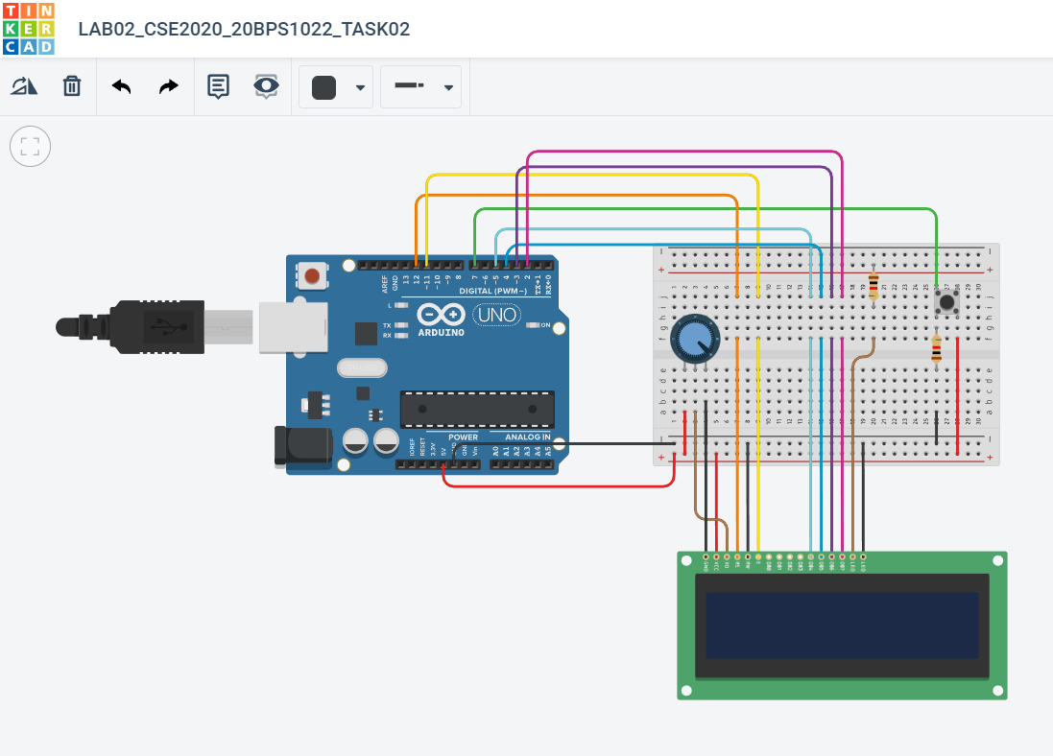

**Code:**

#include <LiquidCrystal.h>

LiquidCrystal lcd(12, 11, 5, 4, 3, 2);

void setup() {

lcd.begin(16, 2);

pinMode(7, INPUT);

}

void loop() {

lcd.setCursor(0, 1);

if(digitalRead(7)==HIGH){

lcd.print("Hello!,Preyash");

}

}

**Output:**

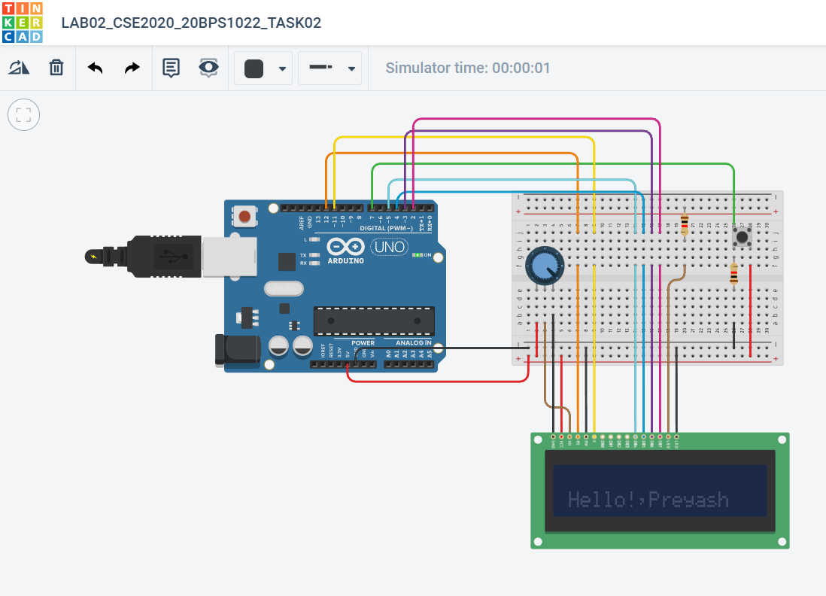

**Link:**

<https://www.tinkercad.com/things/6AcHmIDx6v3-lab02cse202020bps1022task02/editel>

**Task 3:** **Connect Arduino with 16x2 LCD display and connect a temperature sensor. The temperature reading must be displayed in the LCD and serial monitor.**

**Circuit:**

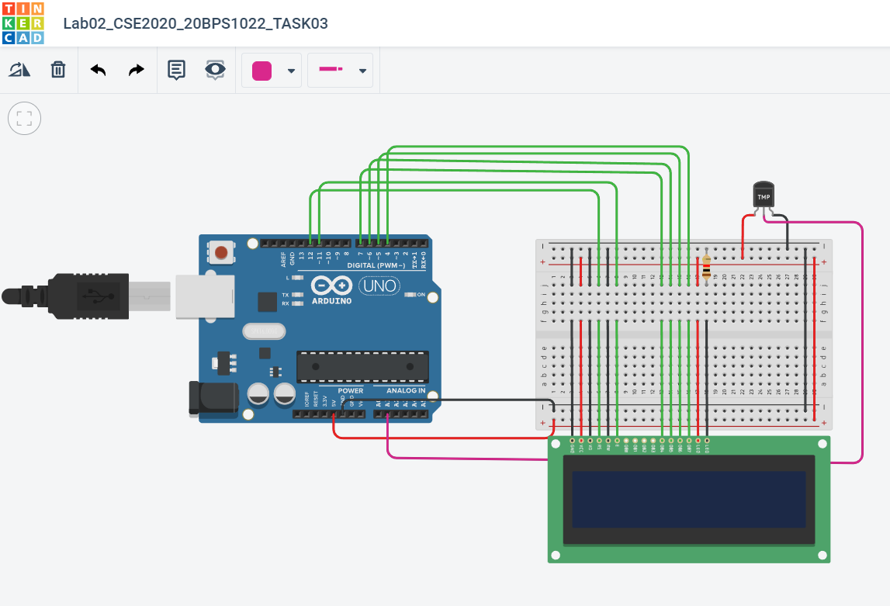

**Code:**

#include<LiquidCrystal.h>

LiquidCrystal lcd(12, 11, 7, 6,5,4);

float celsius;

int temp = A1;

void setup(){

pinMode(temp,INPUT);

}

void loop(){

celsius = analogRead(temp)*0.004882814;

celsius = (celsius - 0.5) * 100.0;

lcd.setCursor(0,1);

lcd.print("Temp: ");

lcd.print(celsius);

lcd.print(" C");

delay(1000);

lcd.clear();

}

**Output:**

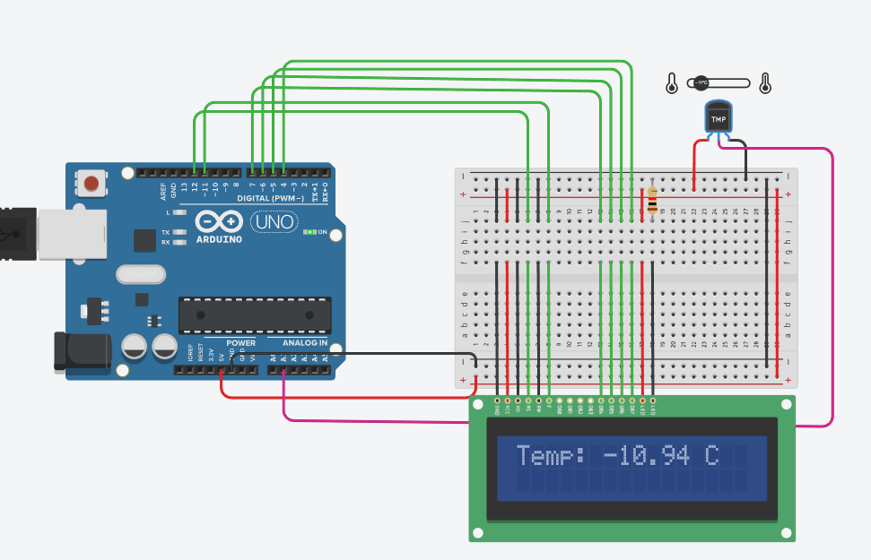 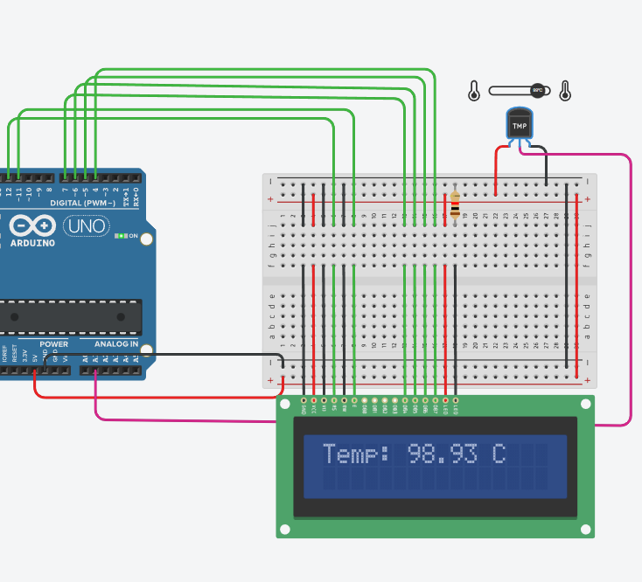

**Link:**

<https://www.tinkercad.com/things/ipgeSRCLnxD-lab02cse202020bps1022task03/editel>

**Task 4: Design a 4x4 keypad display in tinker cad and connect Arduino with 16x2 LCD display. When the user presses the values, it will display in the LCD display.**

**Circuit:**

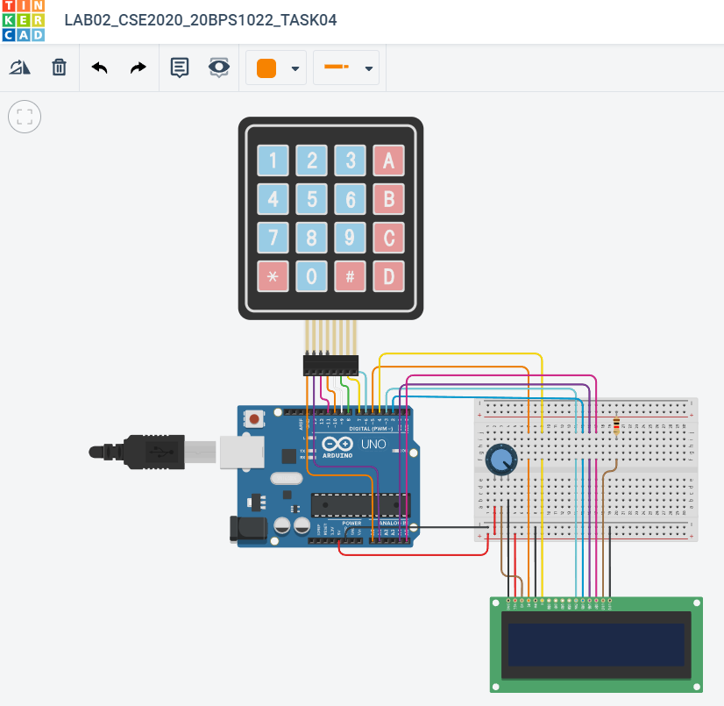

**Code:**

#include <Keypad.h>

#include <LiquidCrystal.h>

LiquidCrystal lcd(5, 4, 3, 2, A4, A5);

const byte ROWS = 4; //four rows

const byte COLS = 4; //three columns

char keys[ROWS][COLS] = {

{'1','2','3','A'},

{'4','5','6','B'},

{'7','8','9','C'},

{'*','0','#','D'}

};

byte rowPins[ROWS] = {A0, A1, 11, 10}; //connect to the row pinouts of the keypad

byte colPins[COLS] = {9, 8, 7, 6}; //connect to the column pinouts of the keypad

int LCDRow = 0;

Keypad keypad = Keypad( makeKeymap(keys), rowPins, colPins, ROWS, COLS );

void setup(){

Serial.begin(9600);

lcd.begin(16, 2);

lcd.setCursor(LCDRow, 0);

}

void loop(){

char key = keypad.getKey();

if (key){

Serial.println(key);

lcd.print(key);

lcd.setCursor (++LCDRow, 0);

}

}

**Output:**

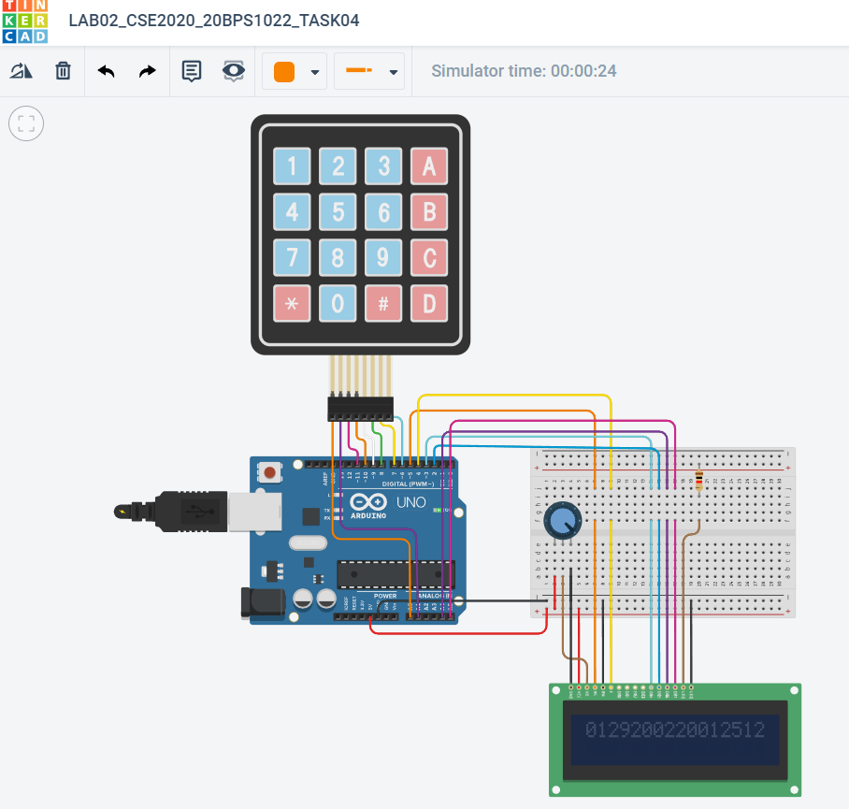

**Link:**

<https://www.tinkercad.com/things/h4243n8hVUS-lab02cse202020bps1022task04/editel>

**Result:** We have successfully accustomed and made a few circuits using sensors in Tinker CAD