**LAB-03**

**CSE2020**

**INTRODUCTION TO CPS LAB**

**Name: Preyash**

**Reg No.: 20BPS1022 Date: January 24, 2022**

**Task 1: Connect Arduino with ultrasonic sensor with LED. when object is detected near, RED LED will be ON and when the object is detected far, GREEN LED will be ON.**

**Circuit:**

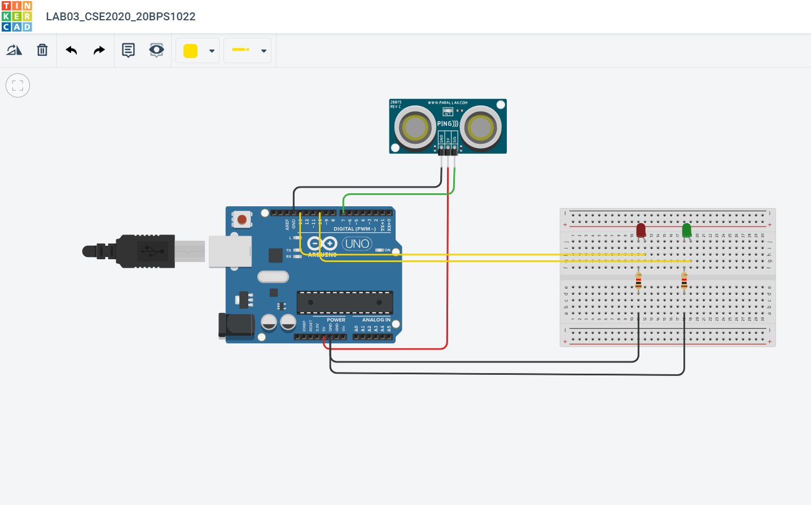

**Code:**

const int pingPin = 7; const int ledPin = 13;

const int ledPin2 = 10;

void setup() {

Serial.begin(9600);

pinMode(ledPin, OUTPUT);

pinMode(ledPin, OUTPUT);

}

void loop() {

long duration, cm;

pinMode(pingPin, OUTPUT);

digitalWrite(pingPin, LOW);

delayMicroseconds(2);

digitalWrite(pingPin, HIGH);

delayMicroseconds(5);

digitalWrite(pingPin, LOW);

pinMode(pingPin, INPUT);

duration = pulseIn(pingPin, HIGH);

cm = microsecondsToCentimeters(duration);

Serial.print("Distance: ");

Serial.print(cm);

Serial.print("cm");

Serial.println();

if(cm < 30) { digitalWrite(ledPin, HIGH);

}

else {

digitalWrite(ledPin2, HIGH);

}

delay(100);

}

long microsecondsToCentimeters(long microseconds) {

return microseconds / 29 / 2;

}

**Output:**

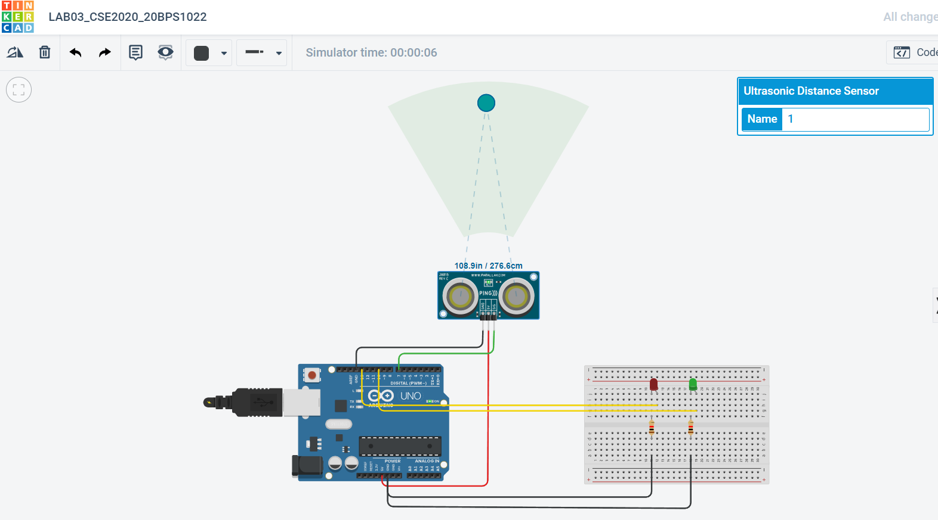

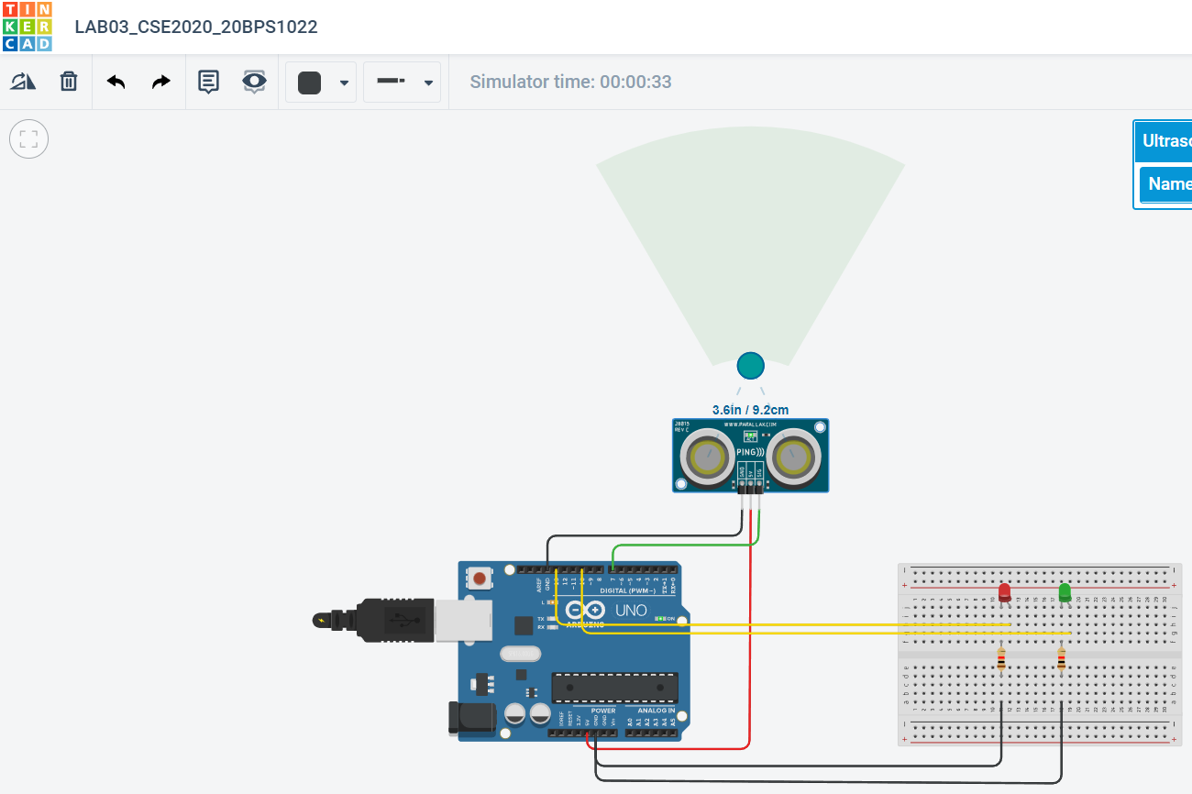

**Task 2: Connect Arduino with ultrasonic sensor, LED and buzzer. when object is detected near, RED LED will be ON with buzzer giving alert and when the object is detected far, GREEN LED will be ON and buzzer will be OFF.**

**Circuit:**

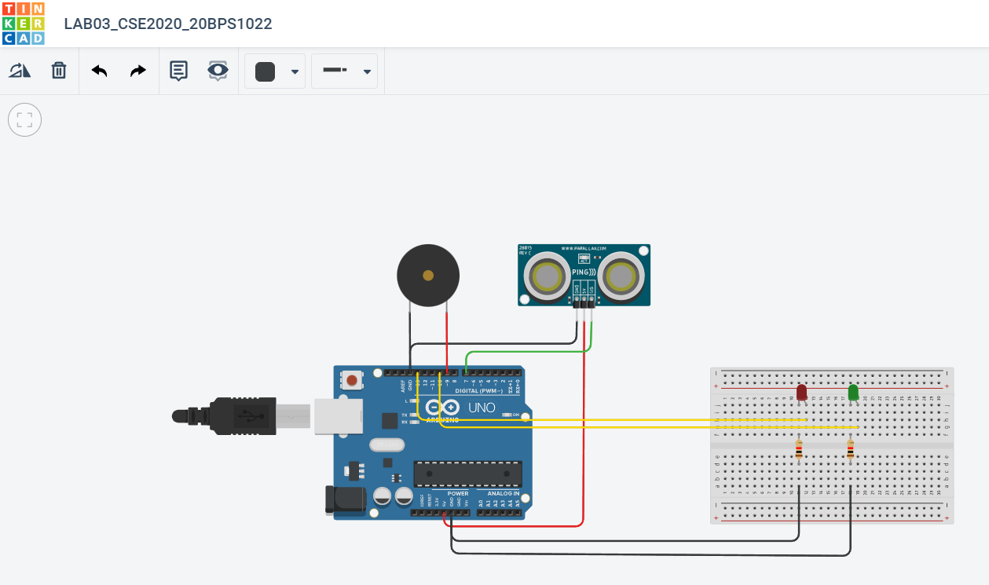

**Code:**

const int pingPin = 7;

const int ledPin = 13;

const int ledPin2 = 10;

int distanceThreshold = 0;

int cm = 0;

const int BuzzerPin = 9;

int inches = 0;

long readUltrasonicDistance(int triggerPin, int echoPin)

{

pinMode(triggerPin, OUTPUT);

digitalWrite(triggerPin, LOW);

delayMicroseconds(2);

digitalWrite(triggerPin, HIGH);

delayMicroseconds(10);

digitalWrite(triggerPin, LOW);

pinMode(echoPin, INPUT);

return pulseIn(echoPin, HIGH);

}

void setup() {

Serial.begin(9600);

pinMode(ledPin, OUTPUT);

pinMode(ledPin, OUTPUT);

pinMode(BuzzerPin, OUTPUT);

pinMode(2, OUTPUT);

pinMode(3, OUTPUT);

}

void loop() {

long duration, cm;

pinMode(pingPin, OUTPUT);

digitalWrite(pingPin, LOW);

delayMicroseconds(2);

digitalWrite(pingPin, HIGH);

delayMicroseconds(5);

digitalWrite(pingPin, LOW);

pinMode(pingPin, INPUT);

duration = pulseIn(pingPin, HIGH);

cm = microsecondsToCentimeters(duration);

Serial.print("Distance: ");

Serial.print(cm);

Serial.print("cm");

Serial.println();

if(cm < 30) { digitalWrite(ledPin, HIGH);

}

else {

digitalWrite(ledPin2, HIGH);

}

//buzzer

distanceThreshold = 50;

cm = 0.01723 * readUltrasonicDistance(7, 7);

inches = (cm / 2.54);

Serial.print(cm); Serial.print("cm, ");

Serial.print(inches);

Serial.println("in");

if (cm > distanceThreshold) {

digitalWrite(2, LOW);

digitalWrite(3, HIGH);

digitalWrite(BuzzerPin, LOW);

}

else {

digitalWrite(2,HIGH);

digitalWrite(3,LOW);

digitalWrite(BuzzerPin,HIGH);

}

delay(100);

}

long microsecondsToCentimeters(long microseconds) {

return microseconds / 29 / 2;

}

**Output:**

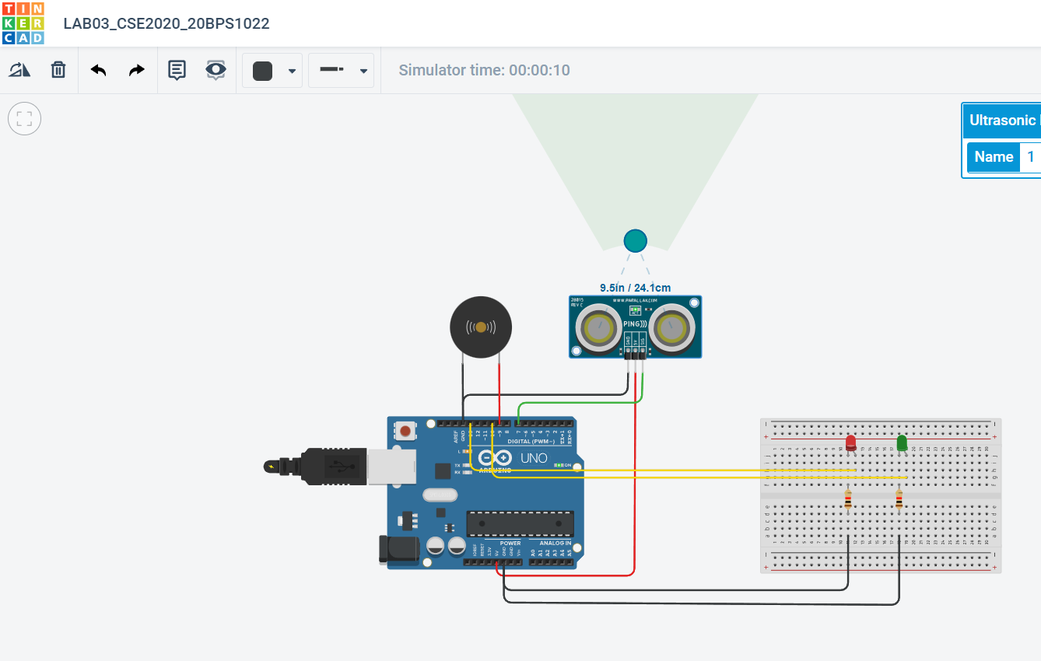

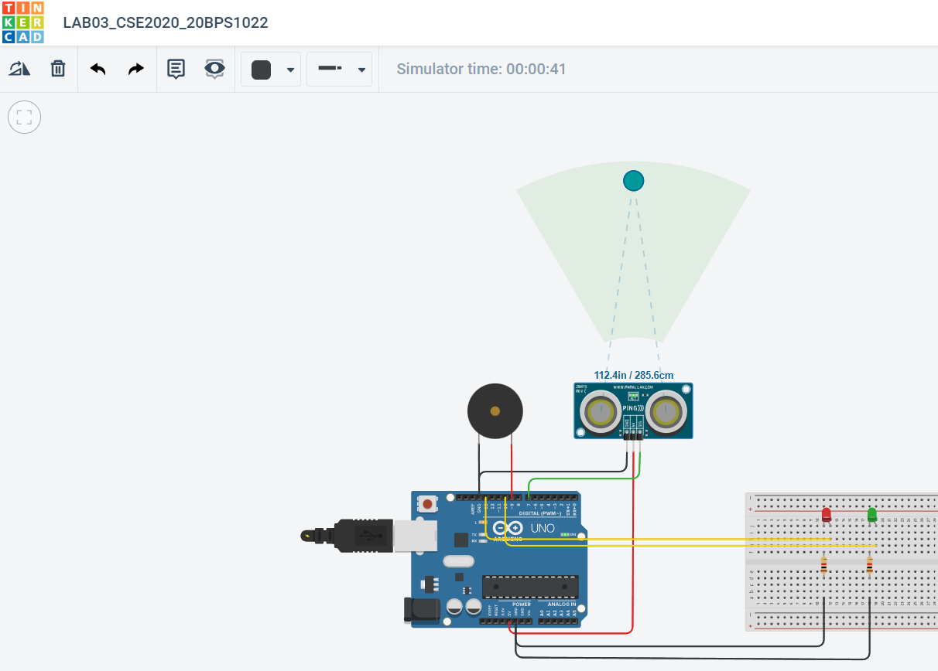

**Task 3:** **Connect Arduino with ultrasonic sensor, LED, buzzer and LCD for SMART door system. When object is detected, LED will turn ON with buzzer sound and door open will be displayed in the LCD. When object is detected far, LED will turn OFF with no buzzer sound and door closed will be displayed in the LCD.**

**Circuit:**

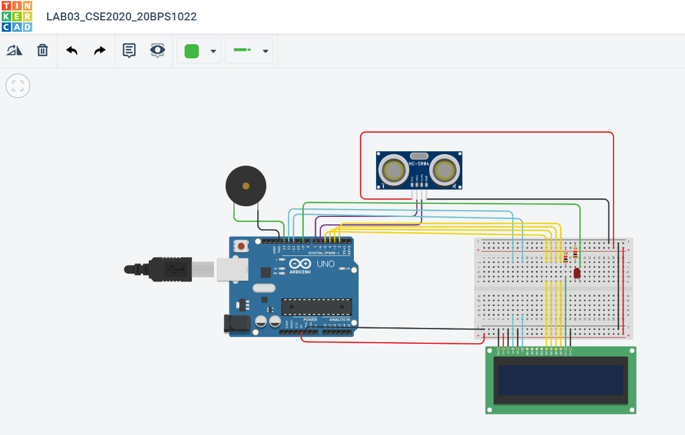

**Code:**

#include <LiquidCrystal.h>

LiquidCrystal lcd(12, 11, 5, 4, 3, 2);

int trigger=7;

int echo=6;

float duration;

float distance;

int threshold=100;

void setup() {

lcd.begin(16, 2);

pinMode(9, OUTPUT);

pinMode(13, OUTPUT);

pinMode(echo, INPUT);

pinMode(trigger, OUTPUT);

}

void loop() {

digitalWrite(trigger, HIGH);

delay(5);

digitalWrite(trigger, LOW);

duration = pulseIn(echo, HIGH);

distance = 0.017 * duration;

if(distance<threshold)

{

digitalWrite(9,HIGH);

digitalWrite(13,HIGH);

lcd.print("DOOR OPEN");

}

else{ digitalWrite(9,LOW);

digitalWrite(13,LOW);

lcd.print("DOOR CLOSED");

}

lcd.clear();

}

**Output:**

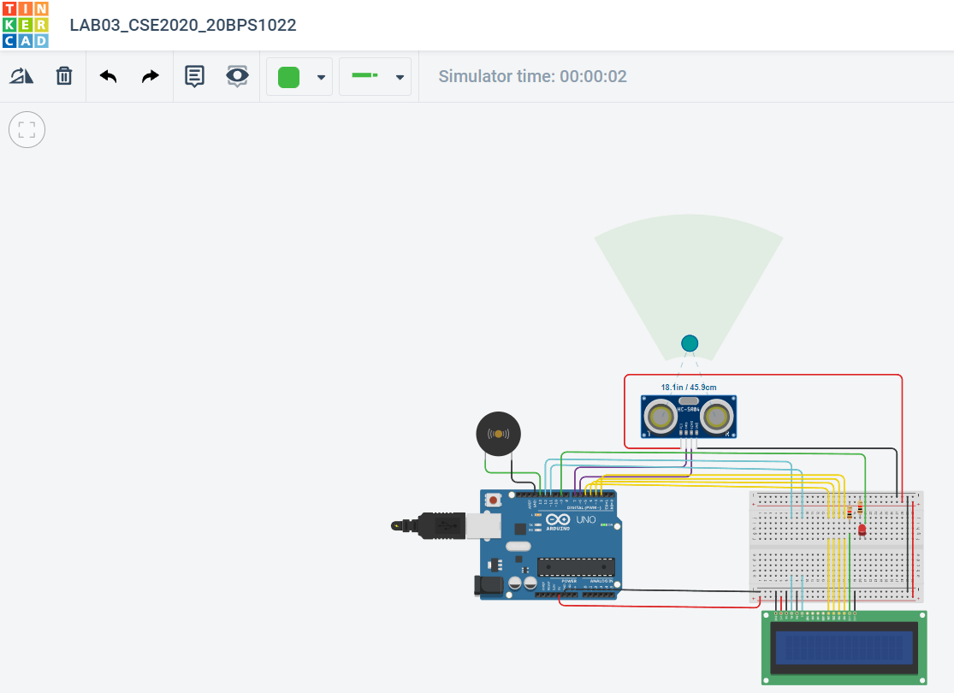

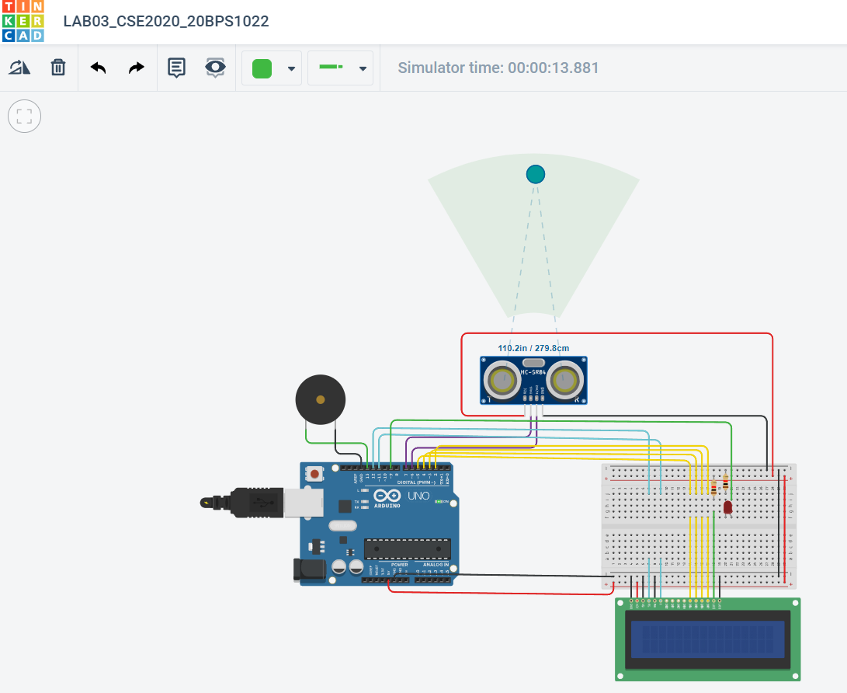

**Task 4: Continue the part. 3 experiments with slide switch. When slide switch is ON and all above criteria happens, enable the corresponding features.**

**Circuit:**

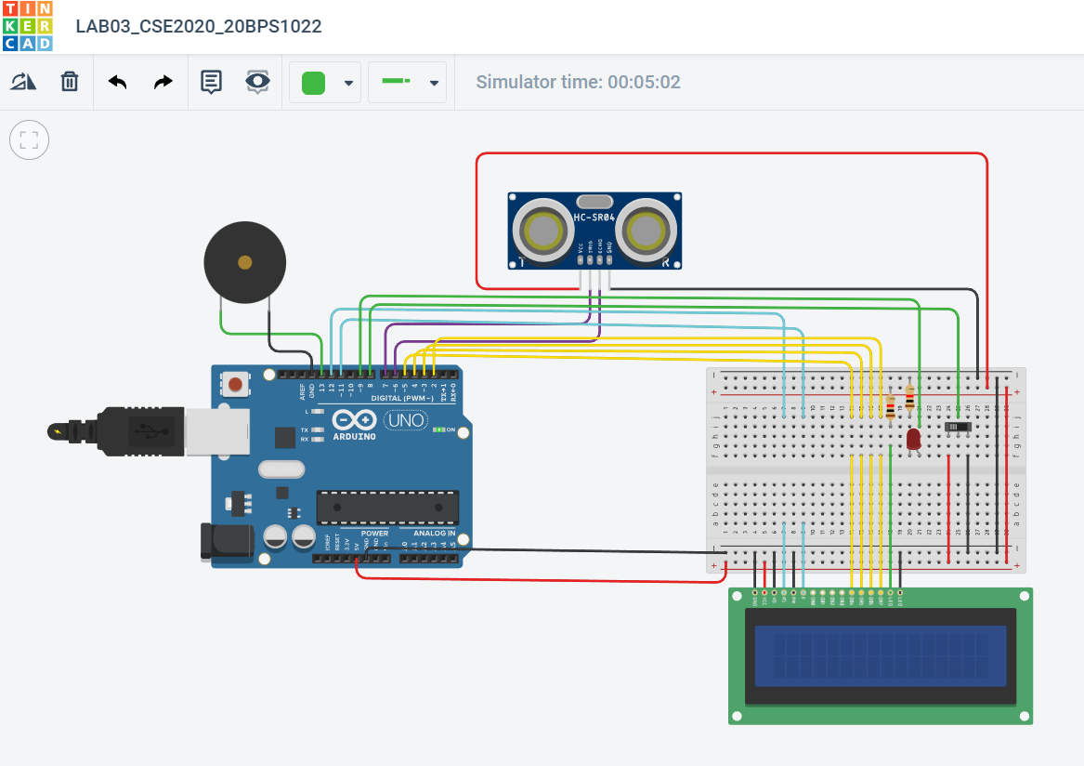

**Code:**

#include <LiquidCrystal.h>

LiquidCrystal lcd(12, 11, 5, 4, 3, 2);

int trigger=7;

int echo=6;

float duration;

float distance;

int threshold=100;

int sswitch;

void setup() {

lcd.begin(16, 2);

pinMode(9, OUTPUT);

pinMode(13, OUTPUT);

pinMode(echo,INPUT);

pinMode(trigger,OUTPUT);

}

void loop() {

sswitch=digitalRead(8);

if(sswitch==HIGH){

digitalWrite(trigger,HIGH);

delay(5);

digitalWrite(trigger,LOW);

duration=pulseIn(echo,HIGH);

distance=0.017*duration;

if(distance<threshold){

digitalWrite(9,HIGH);

digitalWrite(13,HIGH);

lcd.print("DOOR OPEN");

delay(100);

}

else{

digitalWrite(9,LOW);

digitalWrite(13,LOW);

lcd.print("DOOR CLOSED");

delay(100);

}

delay(1000);

}

}

**Output:**

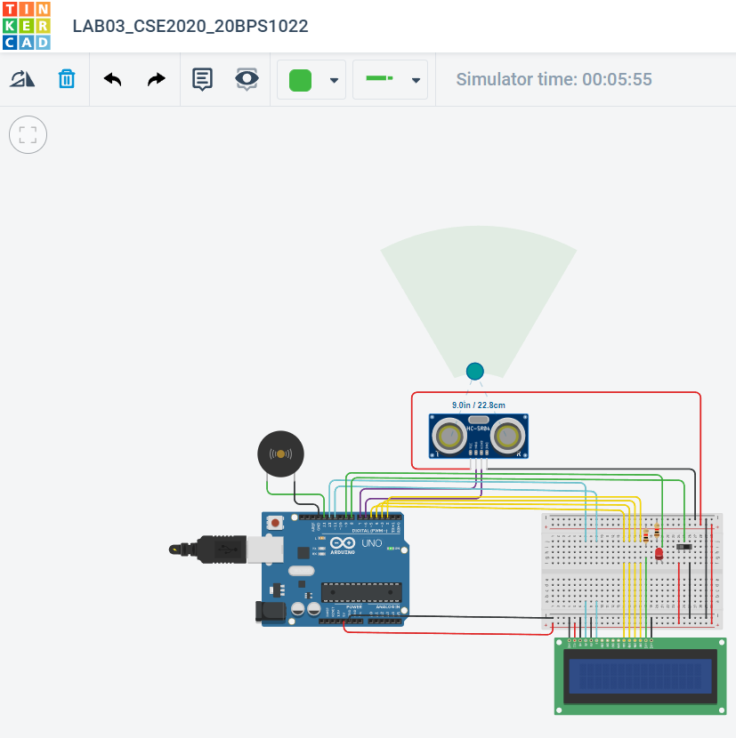

Switch ON and close

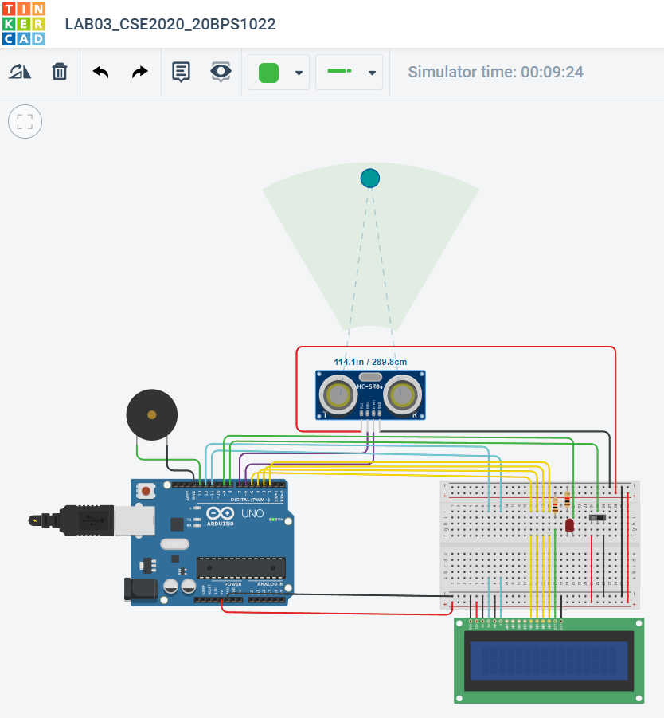

Switch ON and far

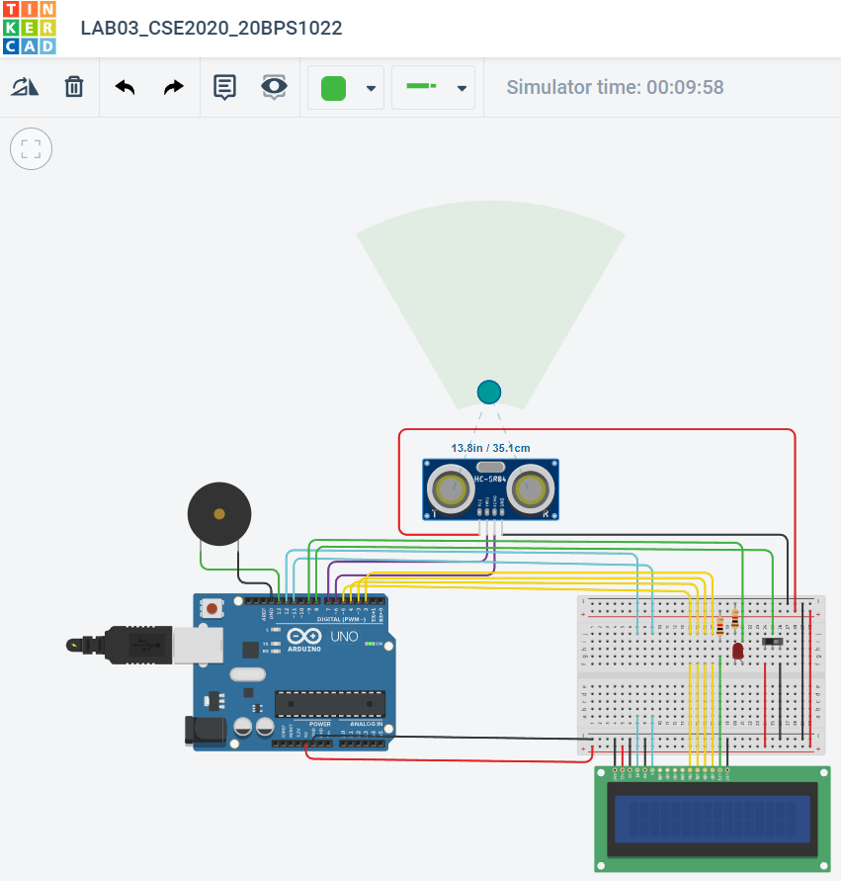

**Switch OFF and close**

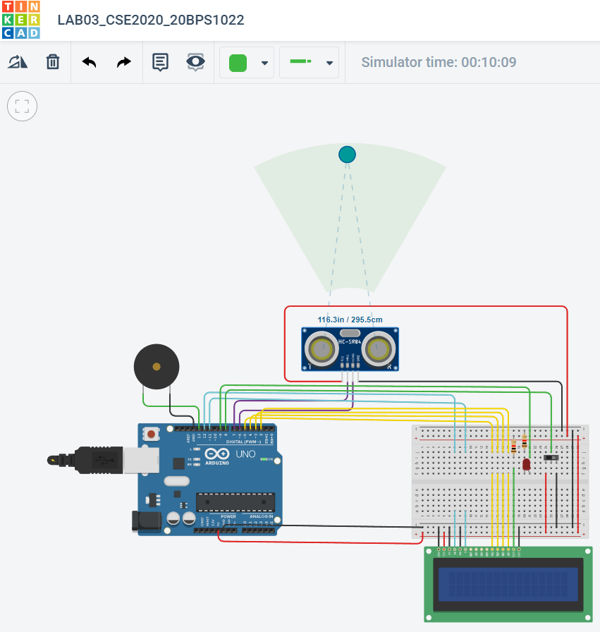

**Switch OFF and far**

**Result:**

We have successfully designed a SMART door system.

[link of the circuit](https://www.tinkercad.com/things/93Kr0MZ5ETR-lab03cse202020bps1022/editel)