**LAB-04**

**CSE2020**

**INTRODUCTION TO CPS LAB**

**Name: Preyash**

**Reg No.: 20BPS1022 Date: January 31, 2022**

**Task 1: Connect Arduino with PIR, Piezo Electric and an LED. When there is change in angle, the sensor and LED turn ON.**

**Circuit:**

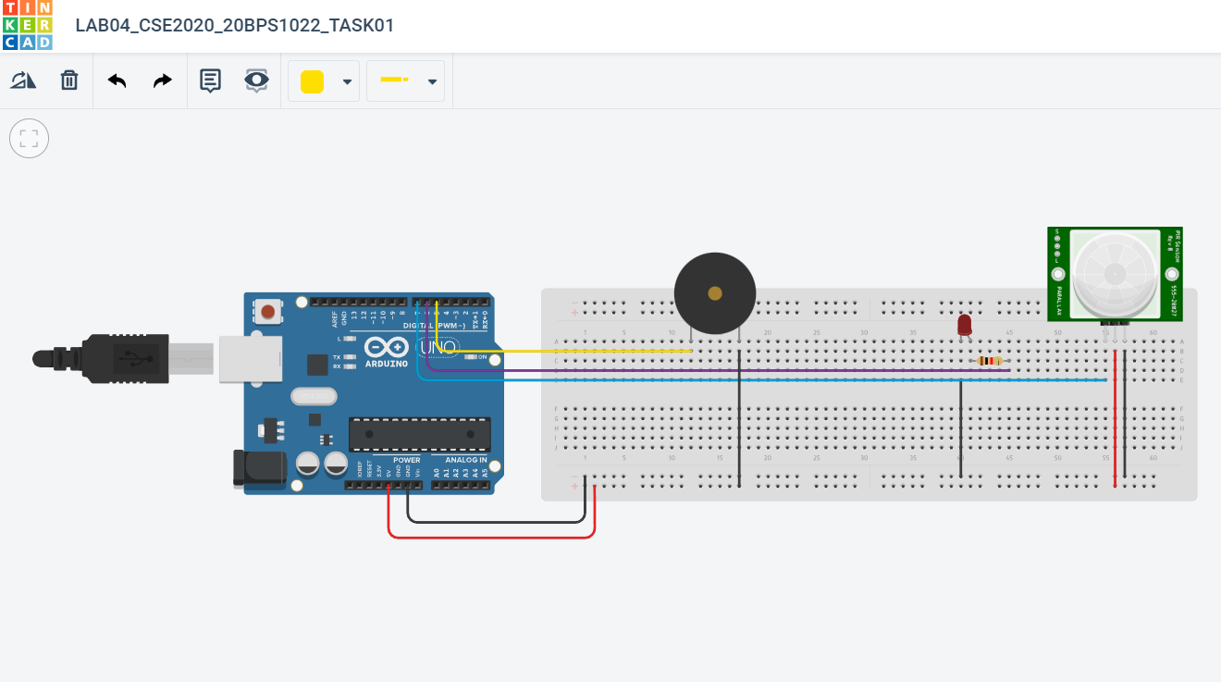

**Code:**

const int buzzerPin=5;

const int ledPin=6;

const int motionPin=7;

boolean buzzer_mode=false;

int ledState= LOW;

long previousMillis=0;

long interval=100;

void setup(){

pinMode(ledPin, OUTPUT);

pinMode(buzzerPin, OUTPUT);

pinMode(motionPin, INPUT);

delay(1000);

}

void loop()

{

if(digitalRead(motionPin)){

buzzer_mode=true;

}

if(buzzer_mode){

unsigned long currentMillis=millis();

if(currentMillis-previousMillis>interval){

previousMillis=currentMillis;

if(ledState==LOW)

ledState=HIGH;

else

ledState=LOW;

digitalWrite(ledPin,ledState);

}

tone(buzzerPin,1000);

}

if(buzzer_mode==false)

{

noTone(buzzerPin);

digitalWrite(ledPin, LOW);

}

else{

buzzer_mode=false;

}

}

**Output:**

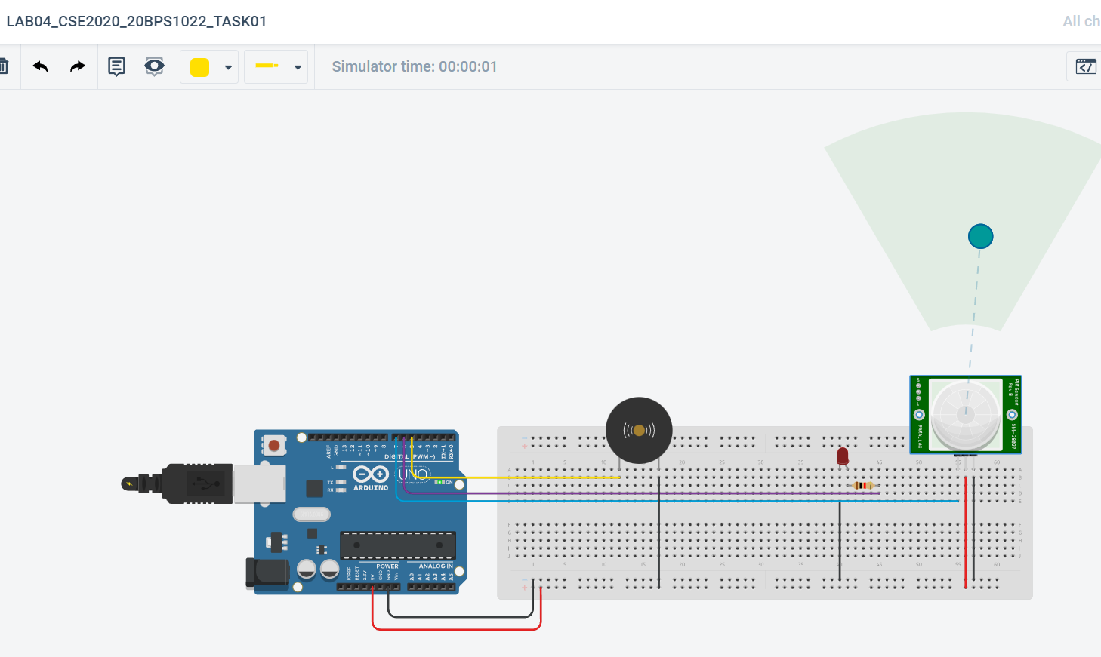

*Object at some angle*

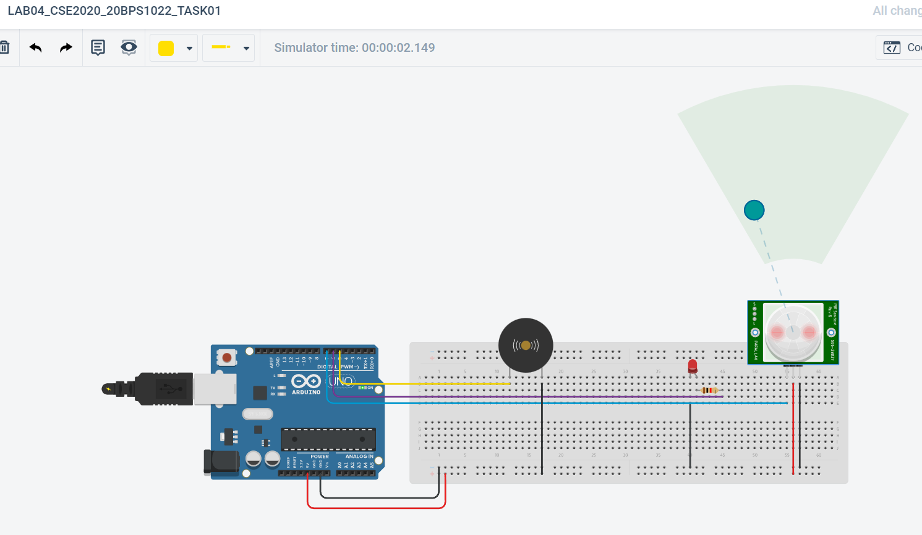

*Angle changed; motion detected. LED glows*

**Link:** [**https://www.tinkercad.com/things/eHr56u2C1v7-lab04cse202020bps1022task01/editel?sharecode=LC81AxSxLVpaa3iIPYP-hs-RXQZV0Om5yQtQv6xebow**](https://www.tinkercad.com/things/eHr56u2C1v7-lab04cse202020bps1022task01/editel?sharecode=LC81AxSxLVpaa3iIPYP-hs-RXQZV0Om5yQtQv6xebow)

**Task 2:** **Connect Arduino with IR Sensor and using a remote control it and show hexadecimal readings in the serial monitor, piezo.**

**Circuit:**

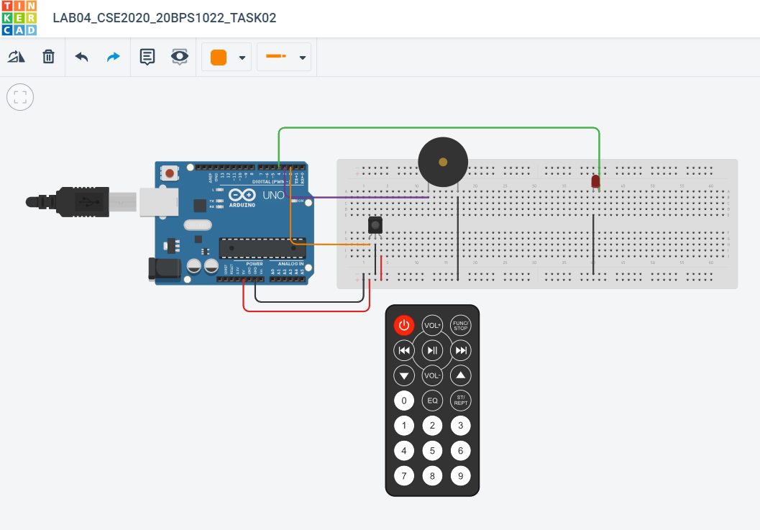

**Code:**

#include<IRremote.h>

int RECV_PIN=2;

IRrecv irrecv(RECV_PIN);

decode_results results;

int piezo=3;

int led=4;

void setup()

{

Serial.begin(9600);

irrecv.enableIRIn();

pinMode(piezo,OUTPUT);

pinMode(led,OUTPUT);

}

void loop(){

if (irrecv.decode(&results)){

long int decCode = results.value;

Serial.println(results.value);

digitalWrite(piezo,HIGH);

digitalWrite(led,HIGH);

delay(500);

irrecv.resume();

}

digitalWrite(piezo,LOW);

digitalWrite(led,LOW);

}

**Output:**

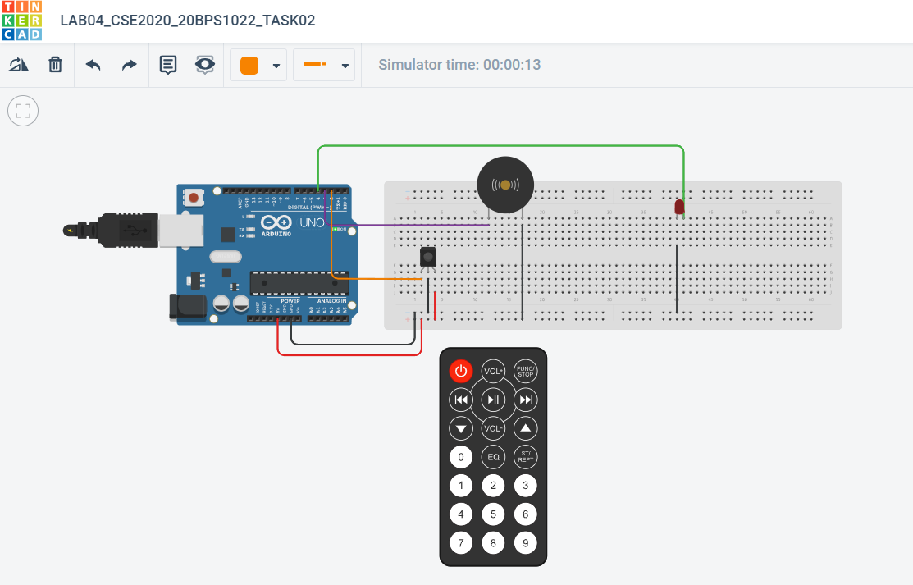

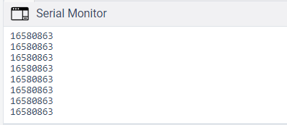

**Link:**

[**https://www.tinkercad.com/things/d73O6aq62n5-lab04cse202020bps1022task02/editel?sharecode=bcV9ghZhB56uBA1vG9YccHxovw0E0iAd3ei3ZGT9SxM**](https://www.tinkercad.com/things/d73O6aq62n5-lab04cse202020bps1022task02/editel?sharecode=bcV9ghZhB56uBA1vG9YccHxovw0E0iAd3ei3ZGT9SxM)

**Task 3:**

**Circuit:**

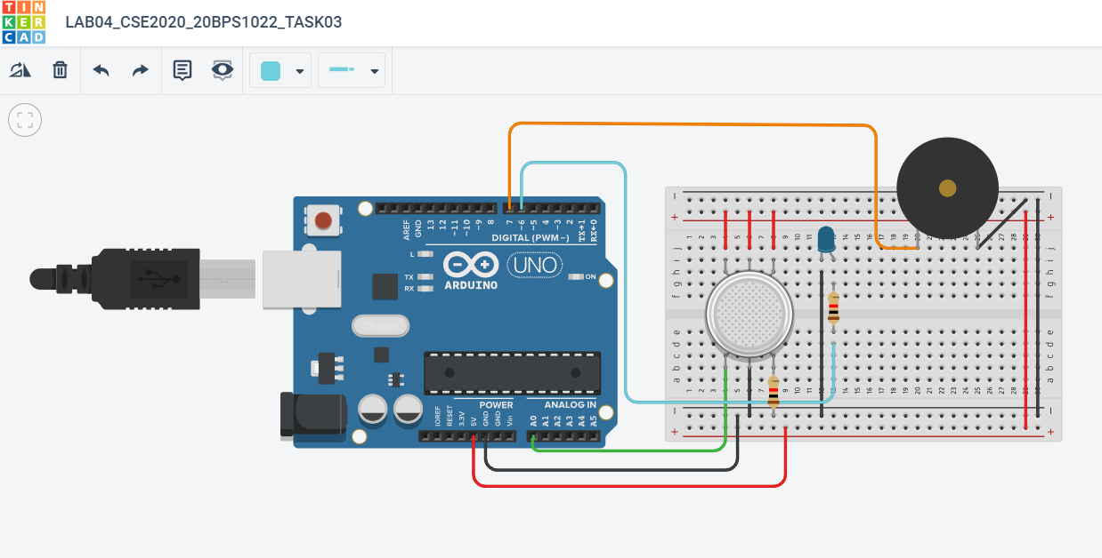

**Code:**

int led=6;

int buzzer=7;

int sensor=A0;

int sensorValue=0;

void setup()

{

pinMode(led, OUTPUT);

pinMode(buzzer, OUTPUT);

pinMode(sensor, INPUT);

Serial.begin(9600);

}

void loop()

{

int sensorValue=analogRead(sensor);

Serial.println(sensorValue);

if(sensorValue>300){

digitalWrite(led, HIGH);

digitalWrite(buzzer, HIGH);

}

else{

digitalWrite(led, LOW);

digitalWrite(buzzer, LOW);

}

}

**Output:**

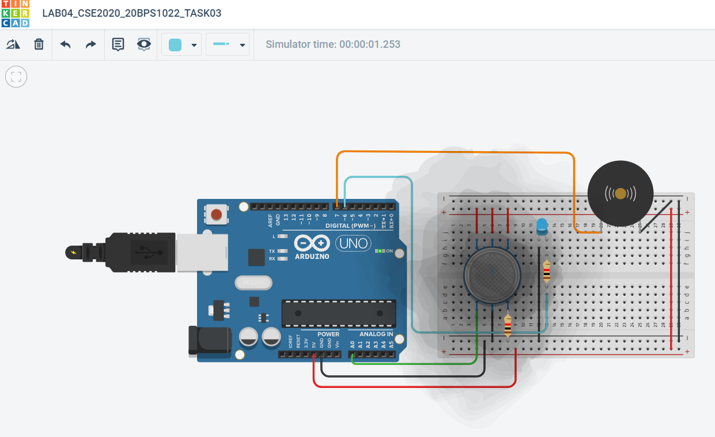

**Link:** [**https://www.tinkercad.com/things/5KpXDA0URaO-lab04cse202020bps1022task03/editel?sharecode=BTnOX16Tuip-PJA3En2sZJMIEgcA6wJvMF5WpMkMqvg**](https://www.tinkercad.com/things/5KpXDA0URaO-lab04cse202020bps1022task03/editel?sharecode=BTnOX16Tuip-PJA3En2sZJMIEgcA6wJvMF5WpMkMqvg)

**Task 4:**

**Implement a home automation project in tinker cad.**

**The following actions are being performed:**

1. **Control fan**
2. **Home door locking system**
3. **If there is any movement in the room, the light (LED) will immediately turn on.**

**Circuit:**

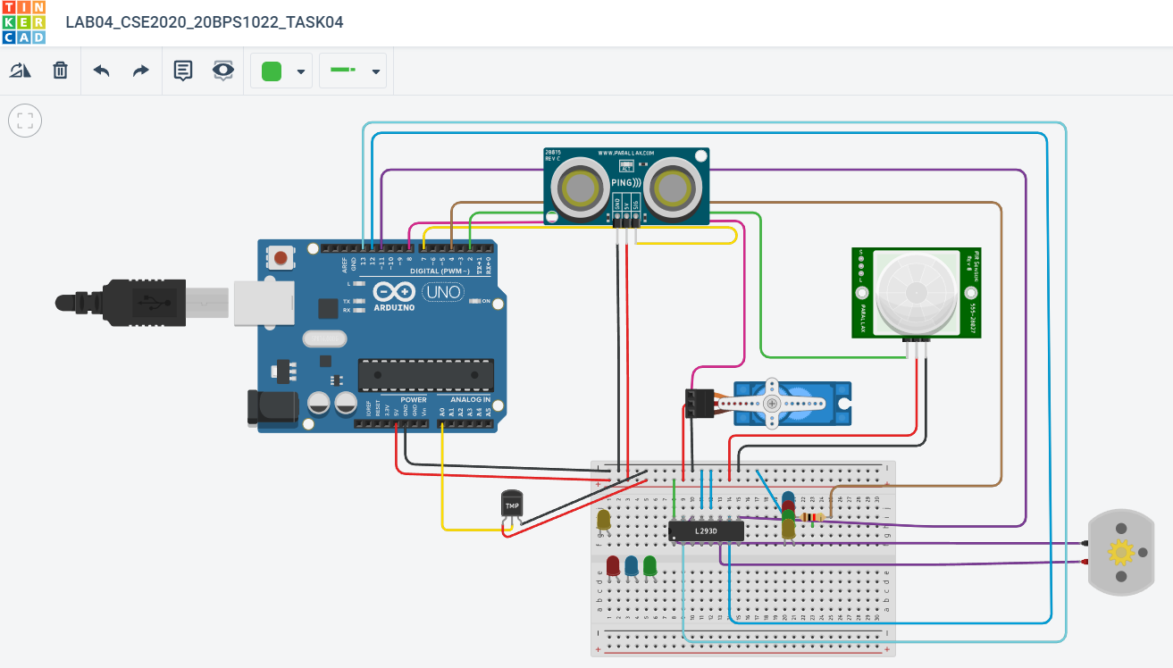

**Code:**

#include<Servo.h>

const int pingPin = 7;

int servoPin = 8;

Servo servo1;

void setup() {

// initialize serial communication:

Serial.begin(9600);

servo1.attach(servoPin);

pinMode(2,INPUT);

pinMode(4,OUTPUT);

pinMode(11,OUTPUT);

pinMode(12,OUTPUT);

pinMode(13,OUTPUT);

pinMode(A0,INPUT);

digitalWrite(2,LOW);

digitalWrite(11,HIGH);

}

void loop() {

long duration, inches, cm;

pinMode(pingPin, OUTPUT);

digitalWrite(pingPin, LOW);

delayMicroseconds(2);

digitalWrite(pingPin, HIGH);

delayMicroseconds(5);

digitalWrite(pingPin, LOW);

// The same pin is used to read the signal from the PING))): a HIGH pulse

// whose duration is the time (in microseconds) from the sending of the ping

// to the reception of its echo off of an object.

pinMode(pingPin, INPUT);

duration = pulseIn(pingPin, HIGH);

// convert the time into a distance

inches = microsecondsToInches(duration);

cm = microsecondsToCentimeters(duration);

//Serial.print(inches);

//Serial.print("in, ");

//Serial.print(cm);

//Serial.print("cm");

//Serial.println();

//delay(100);

servo1.write(0);

if(cm < 40)

{

servo1.write(90);

delay(2000);

}

else

{

servo1.write(0);

}

// PIR with LED starts

int pir = digitalRead(2);

if(pir == HIGH)

{

digitalWrite(4,HIGH);

delay(1000);

}

else if(pir == LOW)

{

digitalWrite(4,LOW);

}

//temp with fan

float value=analogRead(A0);

float temperature=value*0.48;

Serial.println("temperature");

Serial.println(temperature);

if(temperature > 20)

{

digitalWrite(12,HIGH);

digitalWrite(13,LOW);

}

else

{

digitalWrite(12,LOW);

digitalWrite(13,LOW);

}

}

long microsecondsToInches(long microseconds) {

return microseconds / 74 / 2;

}

long microsecondsToCentimeters(long microseconds) {

return microseconds / 29 / 2;

}

**Output:**

**Opening/Closing Door:**

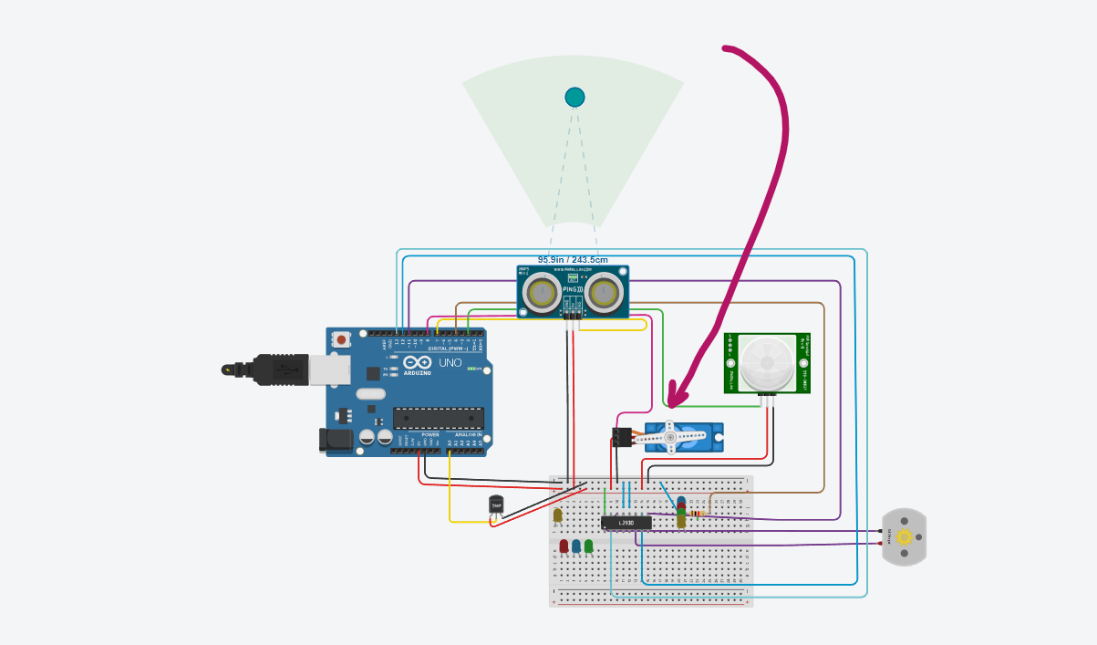

***Door is closed***

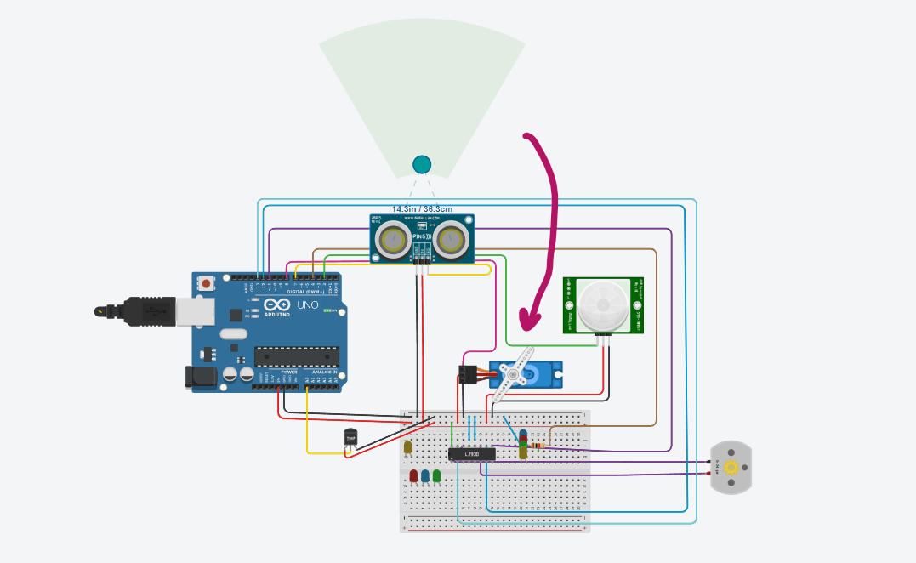

***Door is opening***

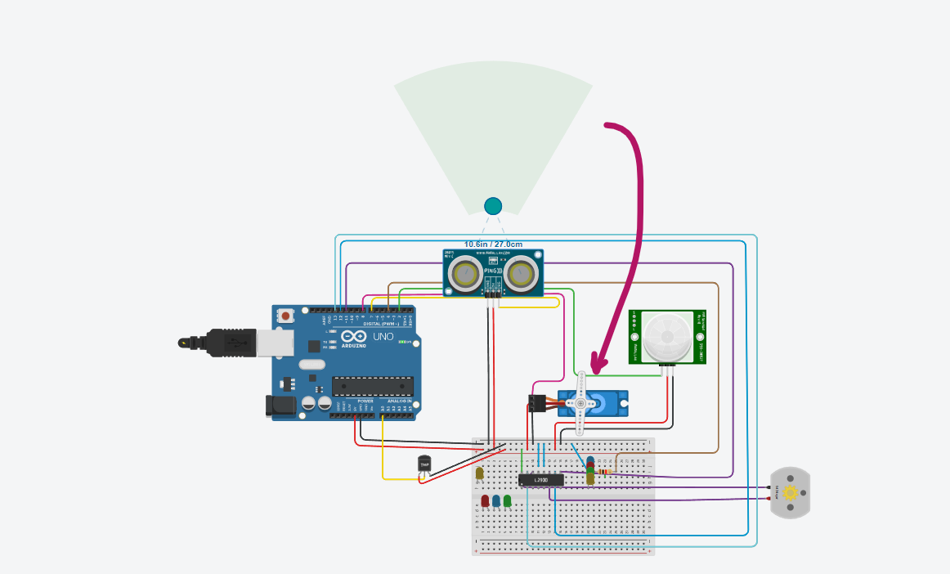

***Door is open***

**Turning FAN ON/OFF:**

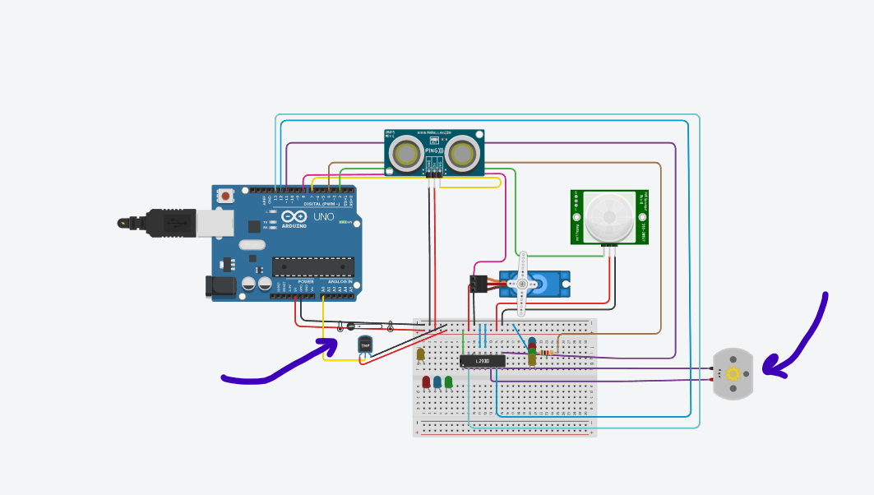

***Low temperature so Fan OFF***

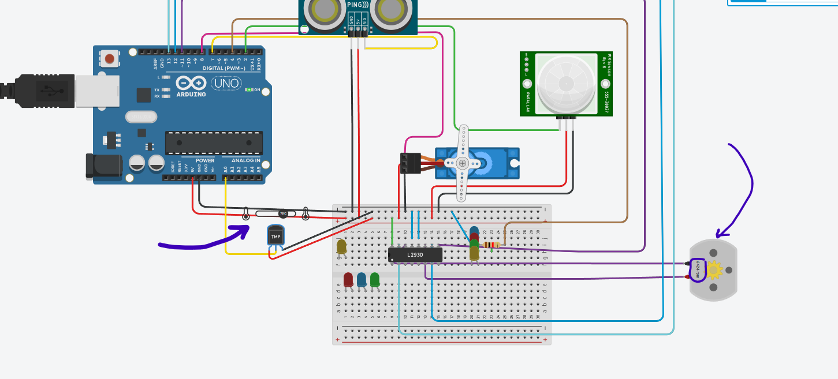

***Temperature rose FAN turned ON***

**Automatic Lights:**

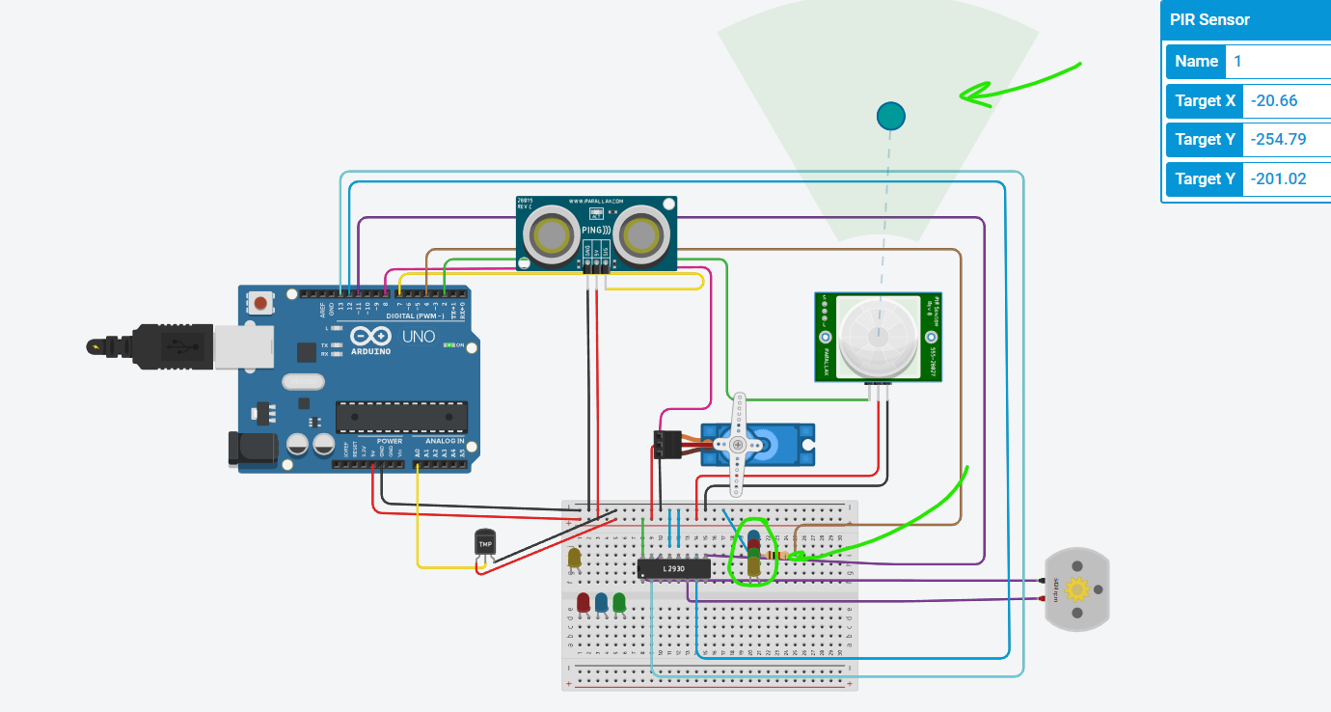

***No motion in room, so lights OFF***

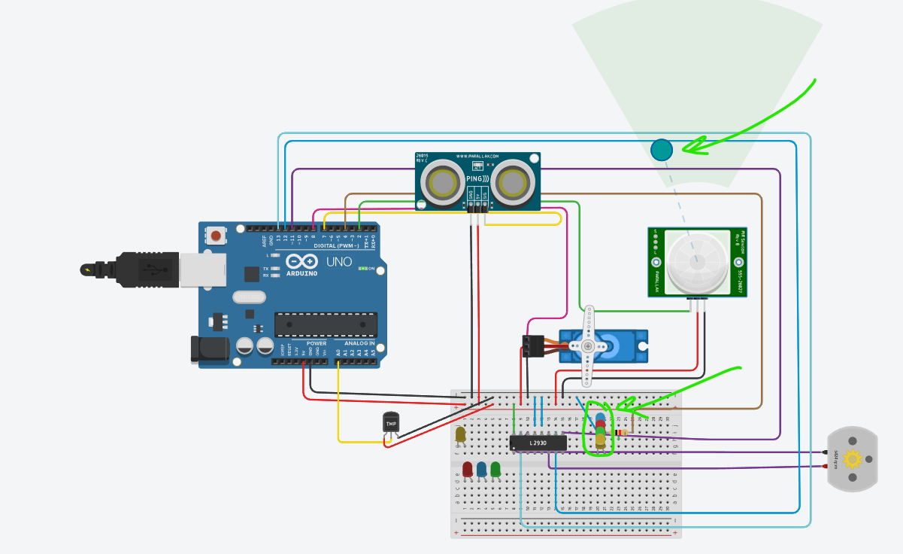

***Motion in room, lights turned ON***

**Link:**

[**https://www.tinkercad.com/things/hkK8ynEAE4J-lab04cse202020bps1022task04/editel?sharecode=vAndfCBFow5lOQeFygbYHtRNKCAvJ8LoBVN0bA_npR0**](https://www.tinkercad.com/things/hkK8ynEAE4J-lab04cse202020bps1022task04/editel?sharecode=vAndfCBFow5lOQeFygbYHtRNKCAvJ8LoBVN0bA_npR0)

**Result:**

All the circuits were successfully built as required.