**LAB-06**

**CSE2020**

**INTRODUCTION TO CPS LAB**

**Name: Preyash**

**Reg No.: 20BPS1022 Date: February 21, 2022**

**Aim:** To introduce ourselves to Node-Red.

**Tools Used:** Node-Red.

**Task 1:** Installing Node-Red.

**Screenshot:**

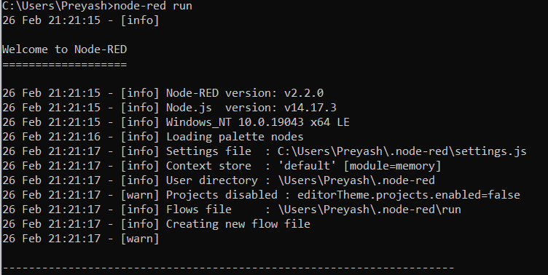

**Task 2:** Hello World Printing.

**Flow:**

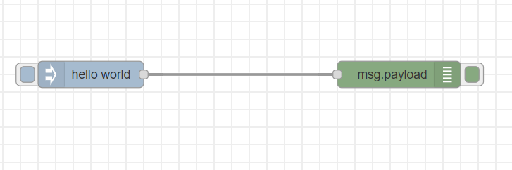

**Debug window:**

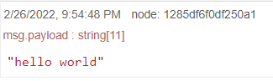

**Task 3:** Add a timestamp to the given string input.

**Flow:**

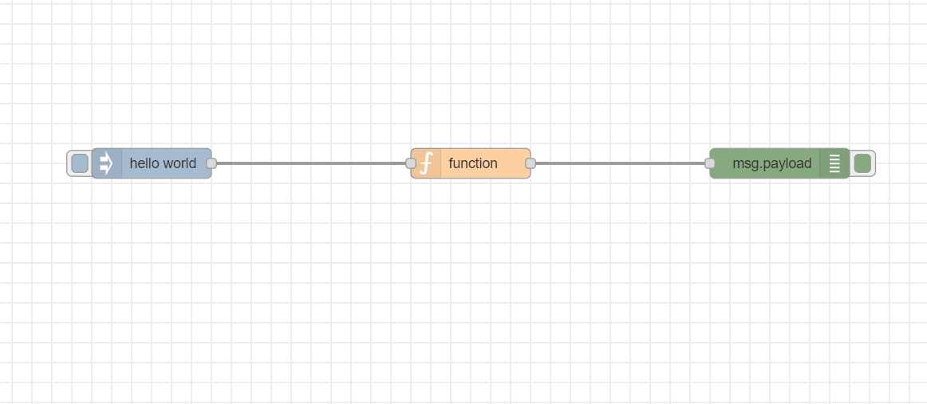

**Debug window:**

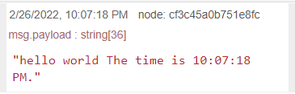

**Code:**

var dateNow = new Date();

var timeAsString = dateNow.toLocaleTimeString();

msg.payload = msg.payload + ' The time is ' + timeAsString + '.';

return msg;

**Task 4:** Write a program for String Count: counting number of words and number of characters in the following format:

**Flow:**

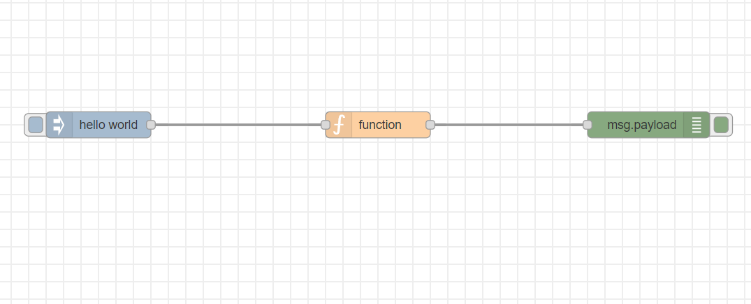

**Debug window:**

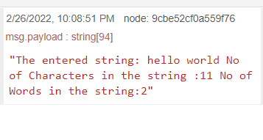

**Code:**

var ip = msg.payload;

var wordCount = ip.match(/(\w+)/g).length;

var letterCount=ip.length;

msg.payload = 'The entered string: '+msg.payload + ' No of Characters in the string :' +

letterCount + ' No of Words in the string:'+wordCount;

return msg;

**Task 5:** Write a Program to convert the temperature given as Degrees to Fahrenheit using the formula in Node-RED (T°C × 9/5) + 32 = X°F

**Flow:**

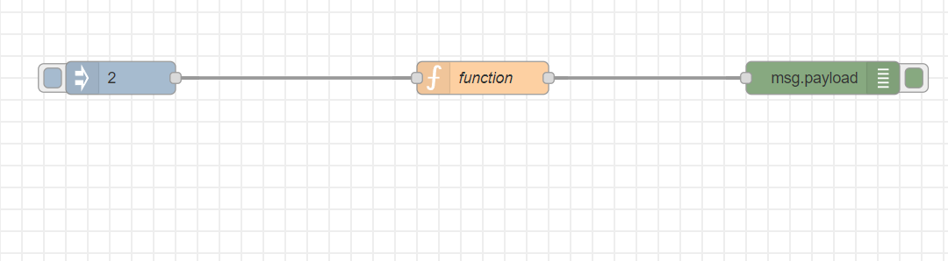

**Debug window:**

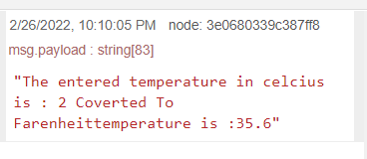

**Code:**

var ip = msg.payload;

var op= (ip*(9/5))+32;

msg.payload = 'The entered temperature in celcius is : '+ip+ ' Coverted To Farenheittemperature is :' + op;

return msg;

**Result:**

We have tested out the basics of Node-Red.