**LAB-07**

**CSE2020**

**INTRODUCTION TO CPS LAB**

**Name: Preyash**

**Reg No.: 20BPS1022 Date: February 28, 2022**

**Aim:** To explore Node-Red.

**Tools Used:** Node-Red.

**Practice 1:** Compare two inputs and give a separate output.

**Flow:**

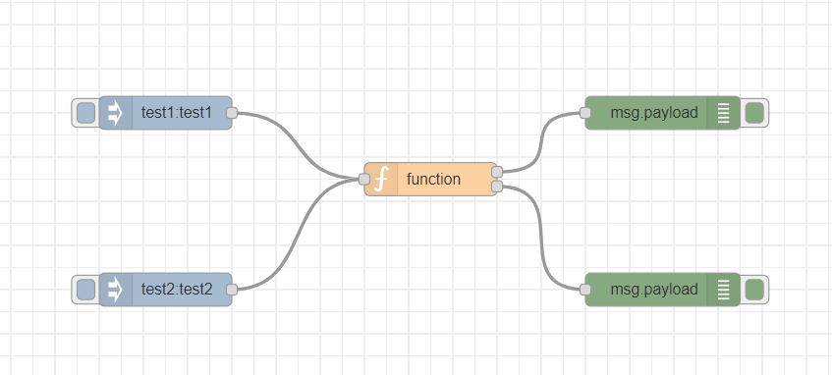

**Code:**

var topic = msg.topic;

if(topic == "test1")

return [msg, null];

if(topic == "test2")

return [null, msg];

**Debug window:**

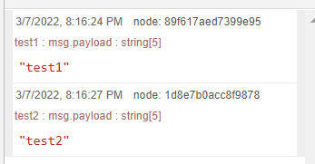

**Exercise 1:**  Simulate there are two sensors controlling the operation of two objects in two different rooms. the first sensor will operate the operation of AC and second sensor will control the operation of Light. Simulate the Node-Red Code for injecting two sensors that will display four different outputs.

**Flow:**

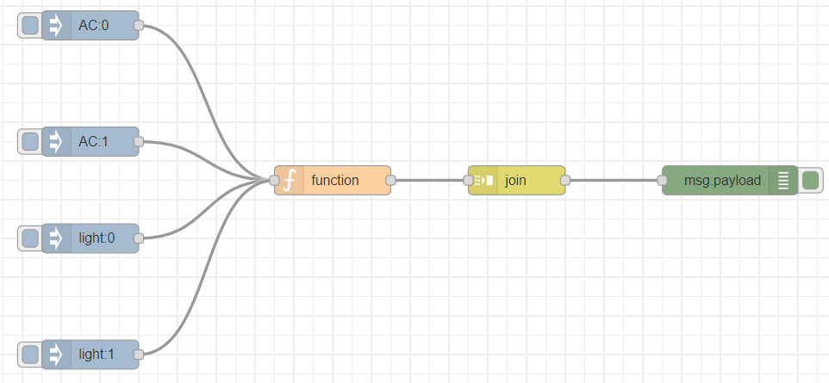

**Code:**

var topic=msg.topic;

if (msg.topic=="AC")

{

if(msg.payload==1)

{

msg.payload="AC ON,";

}

else

{

msg.payload="AC OFF";

}

}

else

{

if(msg.payload==1)

{

msg.payload="light ON,";

}

else

{

msg.payload="light OFF";

}

}

return msg;

**Debug window:**

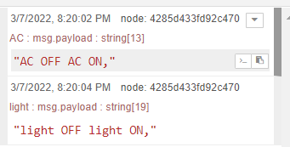

**Practice 2:** Using Switch & Change Nodes.

**Flow:**

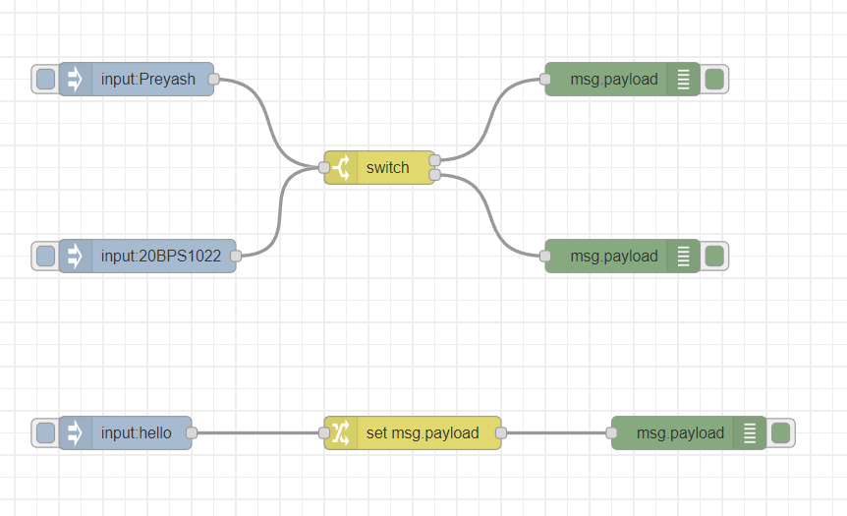

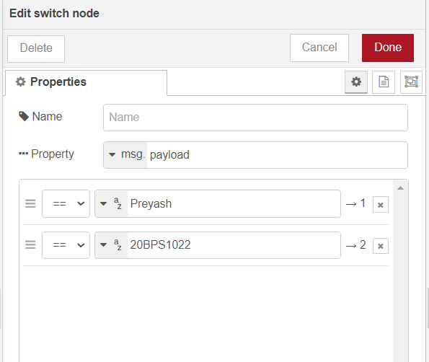

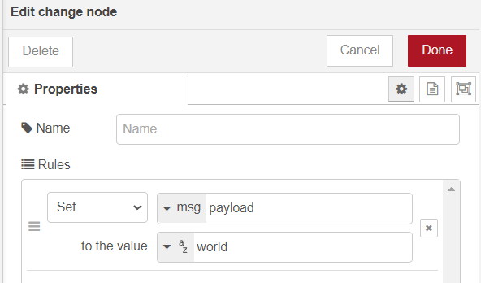

**Debug window:**

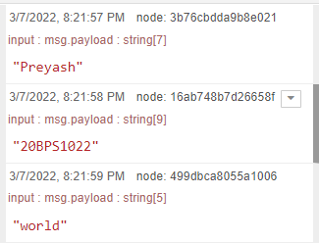

**Practice 3:** Use the join Node.

**Flow:**

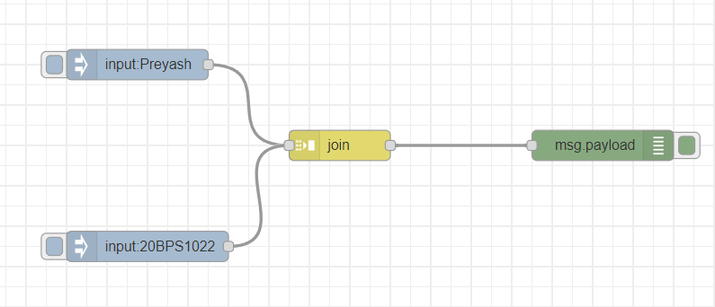

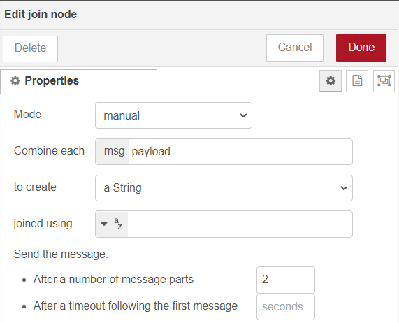

**Debug window:**

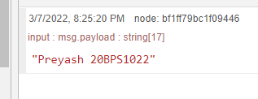

**Task 2 and 3:**

* Make a calculator program by injecting the two numbers and the operation to be performed.
* Make a calculator with only two inputs and provide output to all the arithmetic operations as a single output.

**Flow:**

**Task 2:**

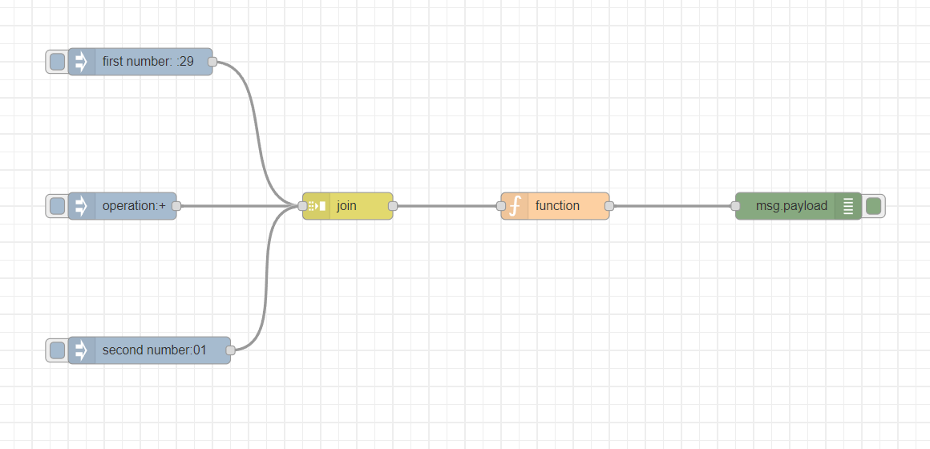

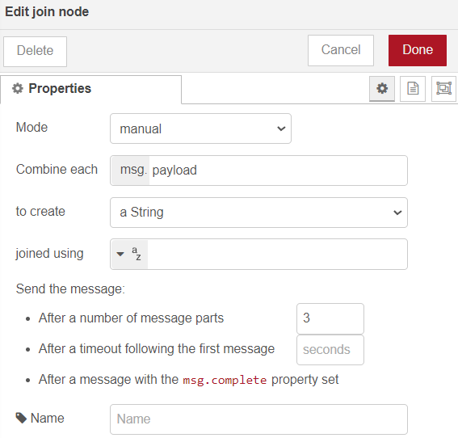

**Task 3:**

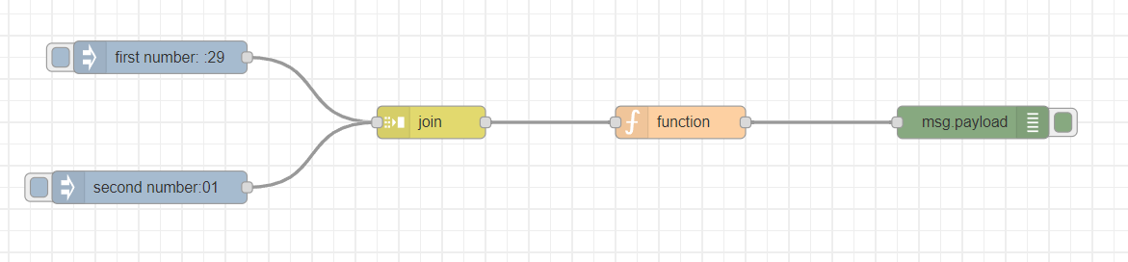

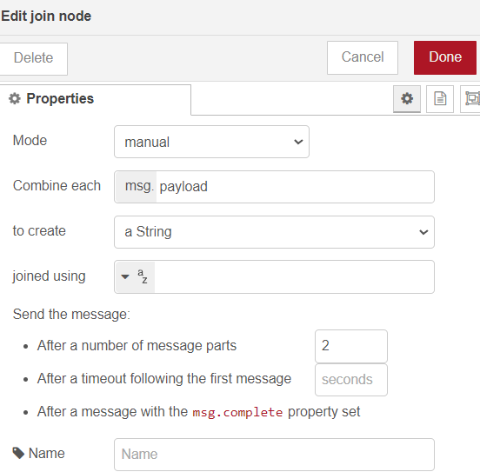

**Code:**

**Task 2:**

op=msg.payload

msg.payload=eval(msg.payload)

return msg;

**Task 3:**

op=msg.payload

no1=op[0]

no2=op[1]

sum=no1+no2

diff=no1-no2

prod=no1*no2

Q=no1/no2

msg.payload='Sum ='+sum+' Difference ='+diff+' Product ='+prod+' Quotient ='+Q;

return msg;

**Debug window:**

**Task 2:**

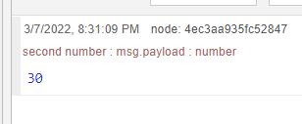

**Task 3:**

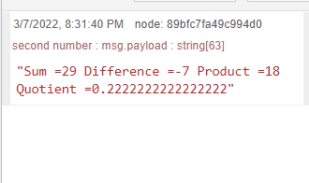

**Result**: We have tested out the conditional statements in Node Red.