**LAB-08**

**CSE2020**

**INTRODUCTION TO CPS LAB**

**Name: Preyash**

**Reg No.: 20BPS1022 Date: March 21, 2022**

**Aim:** To use APIs and Email services using NODE-RED.

**Tools Used:** Node-Red, Open-Weather.

**Task: Sending weather Information via e-mail.**

**Flow:**

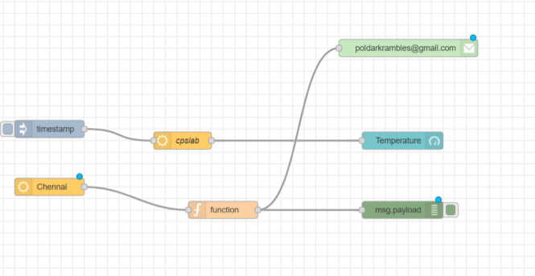

**Debug window:**

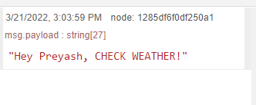 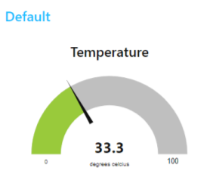

**Output:**

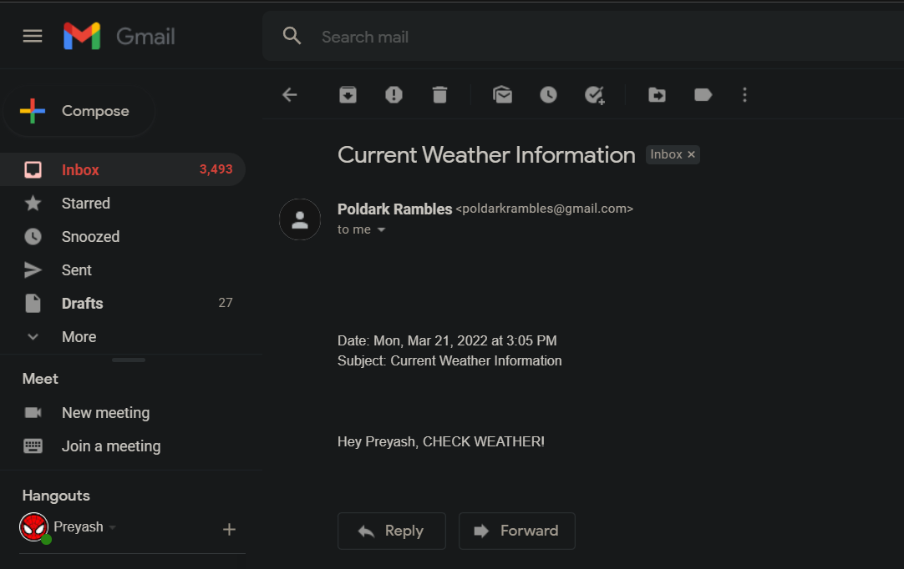

**Result**: Weather Information was successfully visually represented and Sent via Mail­­­­