Name: Preyash

Registration Number: 20BPS1022 DATE: 18-04-2022

**Introduction to Cyber Physical Systems**

**L31 & L32 SLOT**

**MID TERM LAB**

SET 5

1. Create and return multiple messages in a function node using node red.

**Flow:**

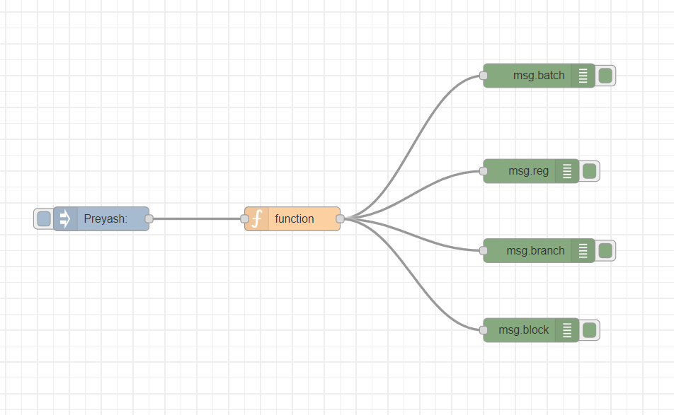

**Inject Node:**

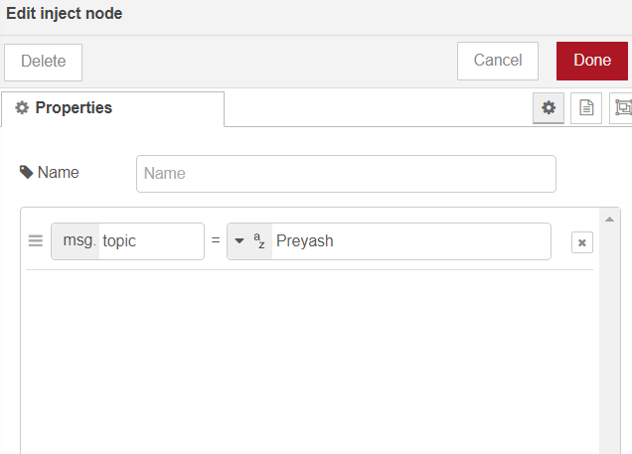

**Function Node:**

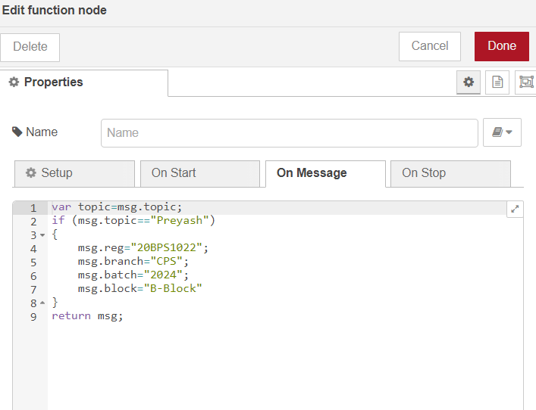

**Debug nodes:**

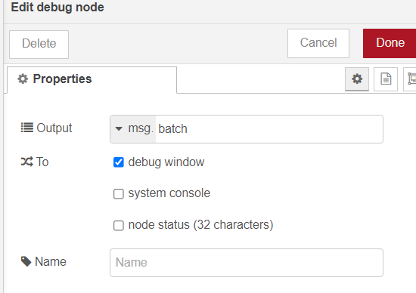

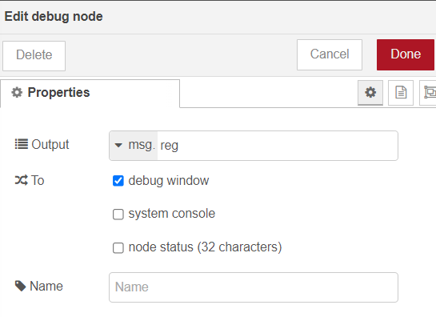

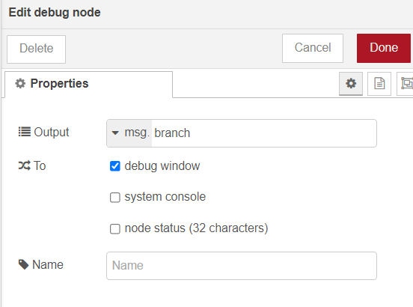

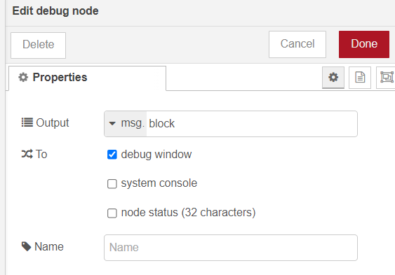

**Debug Window:**

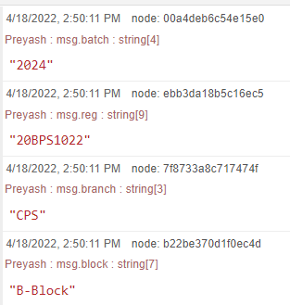

2. Design a program using tinker cad to display the temperature value from the sensor in the LCD and serial monitor.

**Circuit Diagram:**

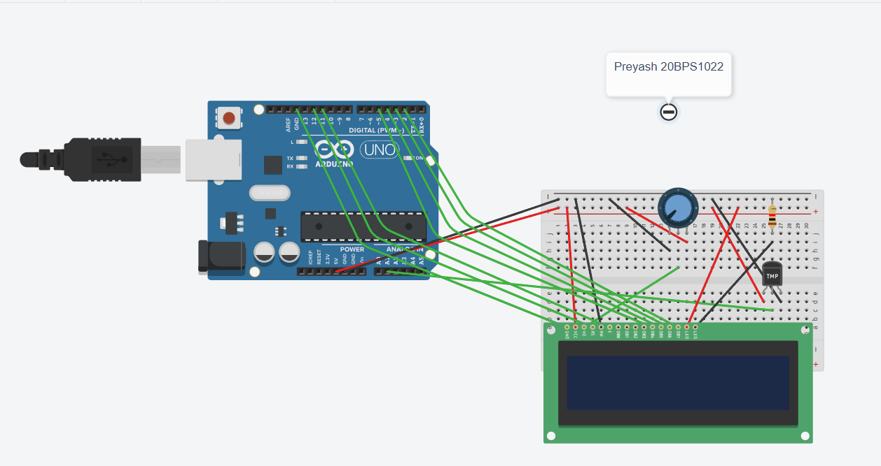

**Code:**

#include<LiquidCrystal.h>

LiquidCrystal lcd(12,11,5,4,3,2);

float value;

int tmp = A1;

void setup(){

pinMode(tmp,INPUT);

Serial.begin(9600);

}

void loop(){

value = analogRead(tmp)*0.004882814;

value = (value - 0.5) * 100.0;

lcd.setCursor(0,1);

lcd.print("Tmp:");

lcd.print(value);

Serial.println(value);

delay(1000);

lcd.clear();

}

**Output:**

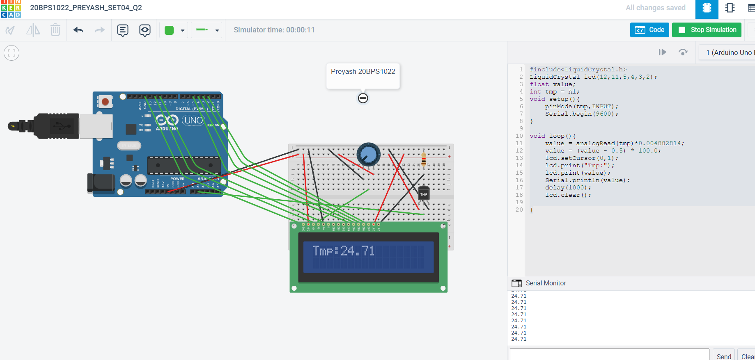

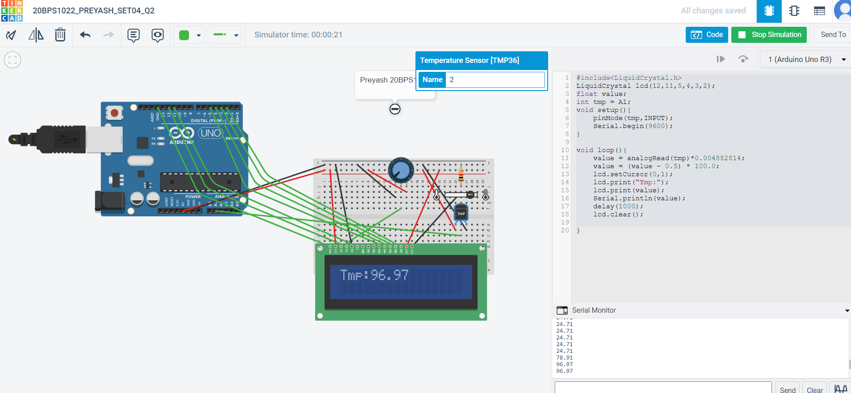

Link: <https://www.tinkercad.com/things/aGI1RnEpwUl-20bps1022preyashset04q2/editel?sharecode=yBFFQMbJHLrTL1cTNKOeveNO9MIzFOpJSCnZ-cQGTgk>