Name: Preyash

Registration Number: 20BPS1022 Date: January 13, 2022

**LAB-01**

**CSE2021**

**DISTRIBUTED REAL-TIME SYSTEMS**

**Task 1:** **Connect Arduino with 16x2 LCD display and a button option.**

**Circuit:**

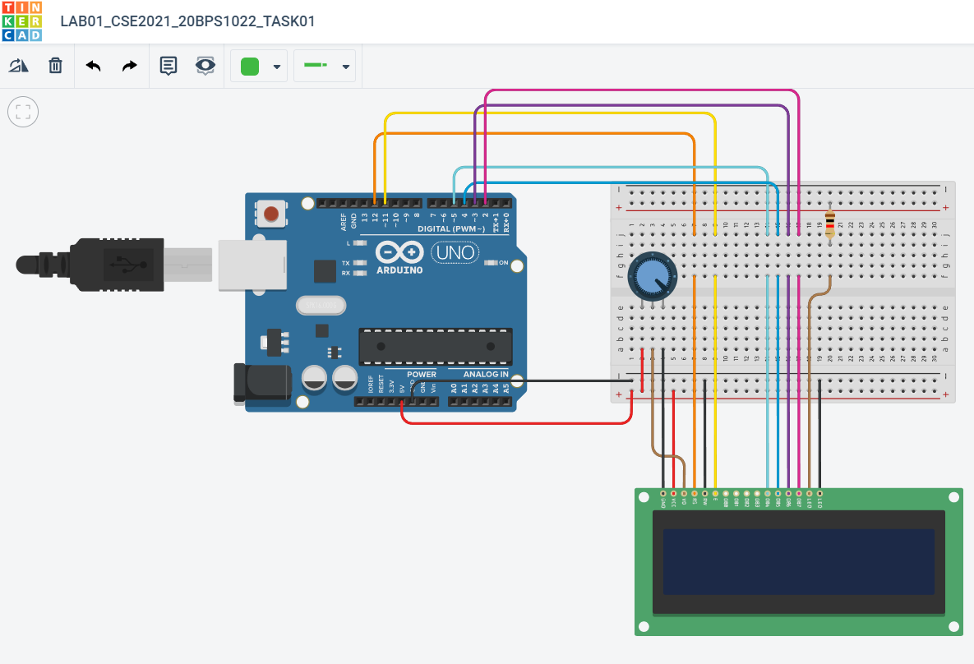

**Code:**

#include <LiquidCrystal.h>

LiquidCrystal lcd(12, 11, 5, 4, 3, 2);

void setup() {

lcd.begin(16, 2);

}

void loop() {

lcd.setCursor(0, 0);

lcd.print("Hello!,Preyash");

delay(5000);

lcd.clear();

lcd.print("Welcome to");

delay(5000);

lcd.clear();

lcd.print("DRTS Lab");

delay(5000);

lcd.clear();

}

**Output:**

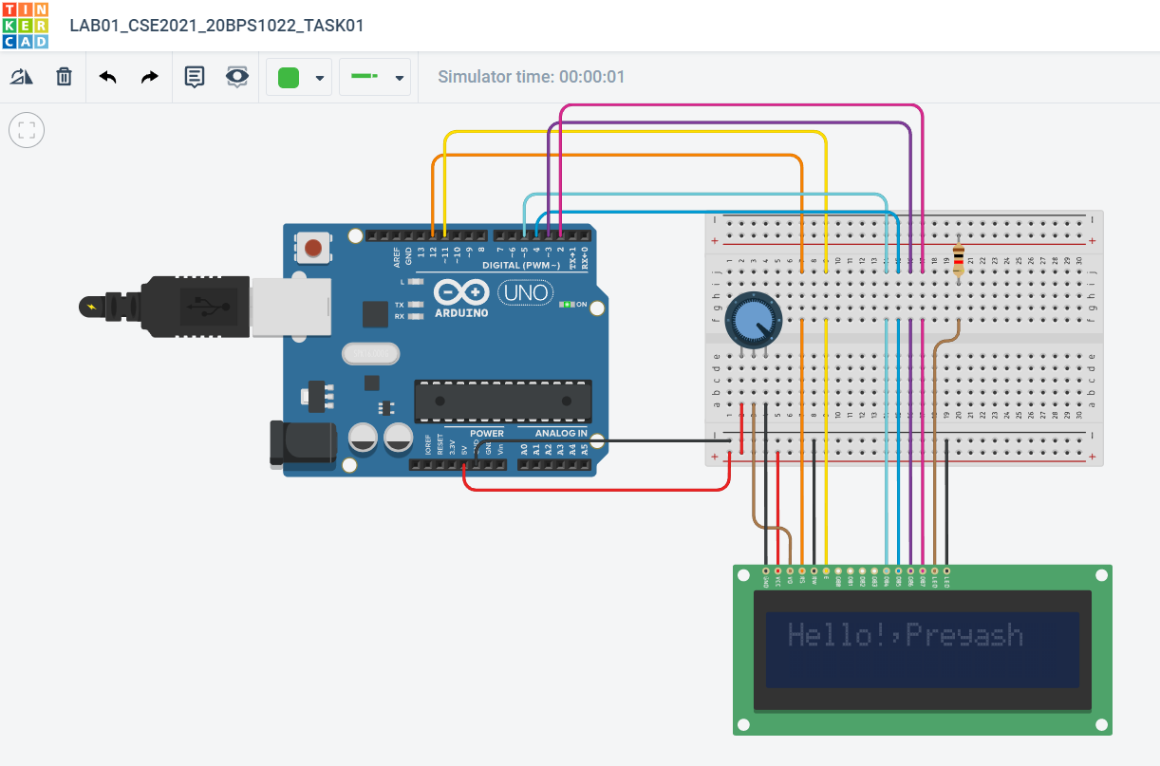

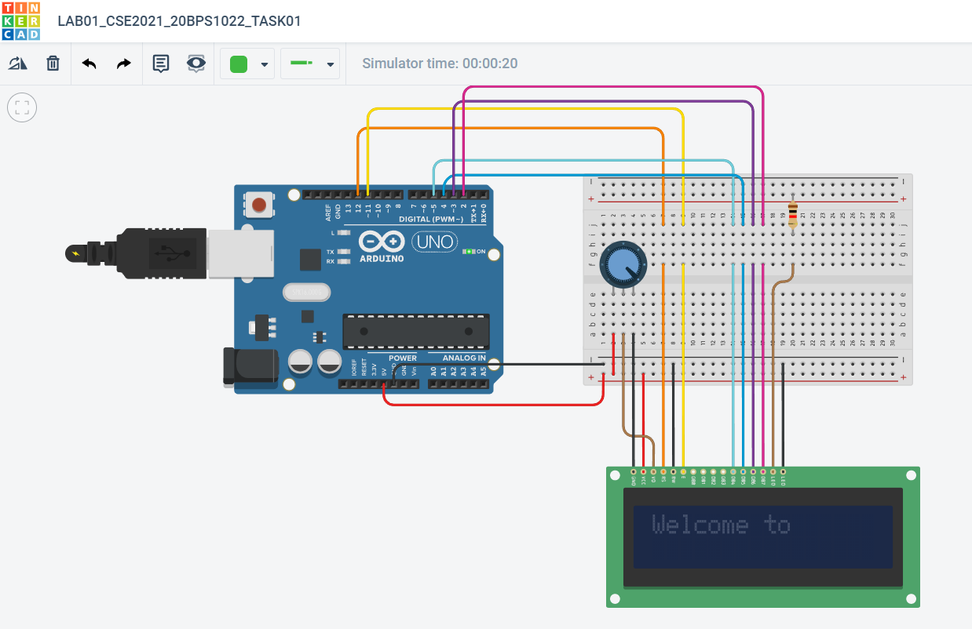

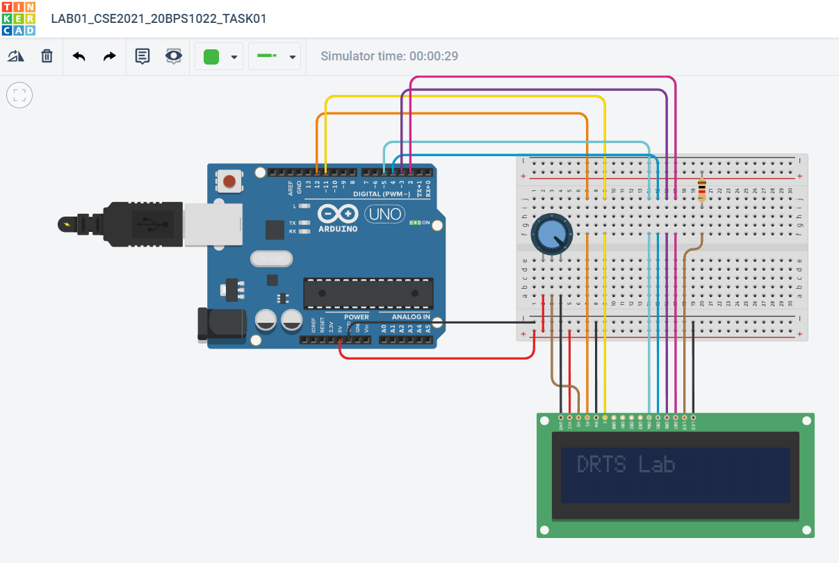

**Link:**

<https://www.tinkercad.com/things/611AROmFpRh-lab01cse202120bps1022task01/editel>

**Task 2:** **Connect Arduino with a LCD display and connect a temperature sensor. The temperature reading must be displayed in the LCD and serial monitor.**

**Circuit:**

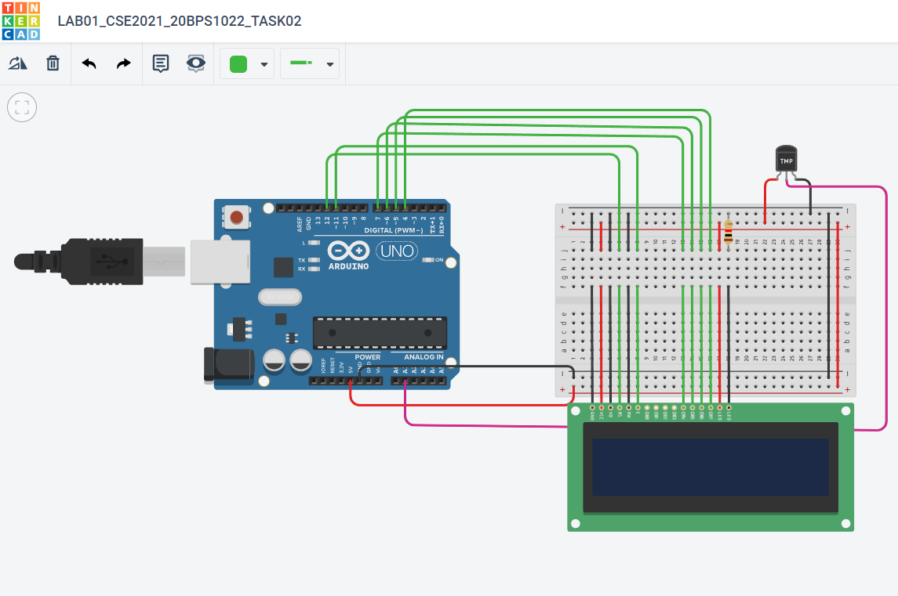

**Code:**

#include<LiquidCrystal.h>

LiquidCrystal lcd(12, 11, 7, 6,5,4);

float celsius;

int temp = A1;

void setup(){

pinMode(temp,INPUT);

}

void loop(){

celsius = analogRead(temp)*0.004882814;

celsius = (celsius - 0.5) * 100.0;

lcd.setCursor(0,1);

lcd.print("Temp: ");

lcd.print(celsius);

lcd.print(" C");

delay(1000);

lcd.clear();

}

**Output:**

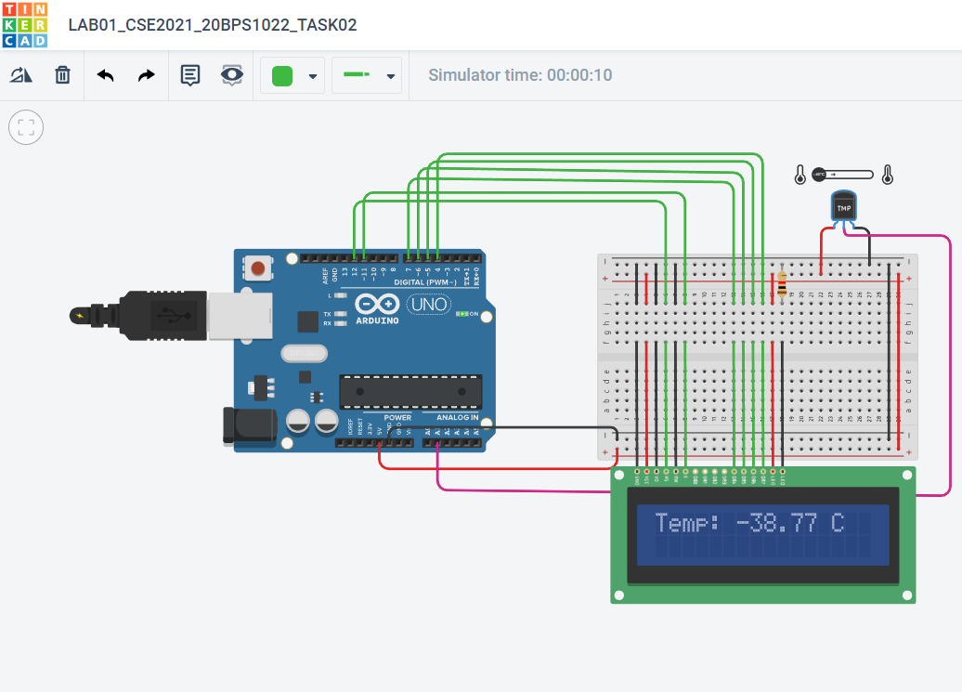

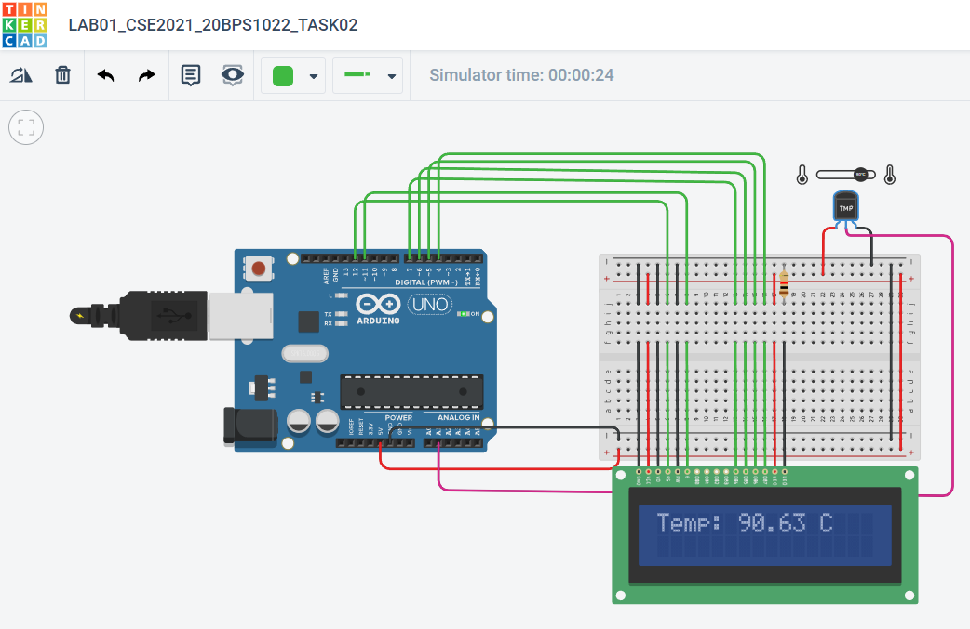

**Link:**

<https://www.tinkercad.com/things/iWnexWWiFeh-lab01cse202120bps1022task02/editel>