Name: Preyash

Registration Number: 20BPS1022 Date: January 20, 2022

**LAB-02**

**CSE2021**

**DISTRIBUTED REAL-TIME SYSTEMS**

**Tools Used: Ptolemy**

**Task: Design a model of a thermostat with hysteresis using FSM**

**Circuit:**

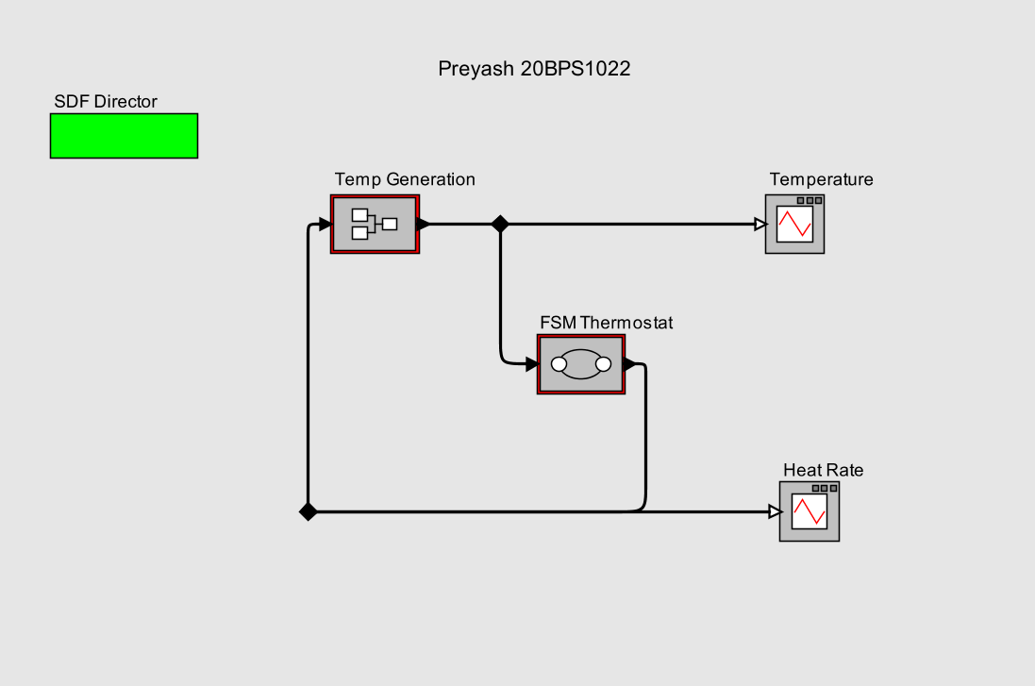

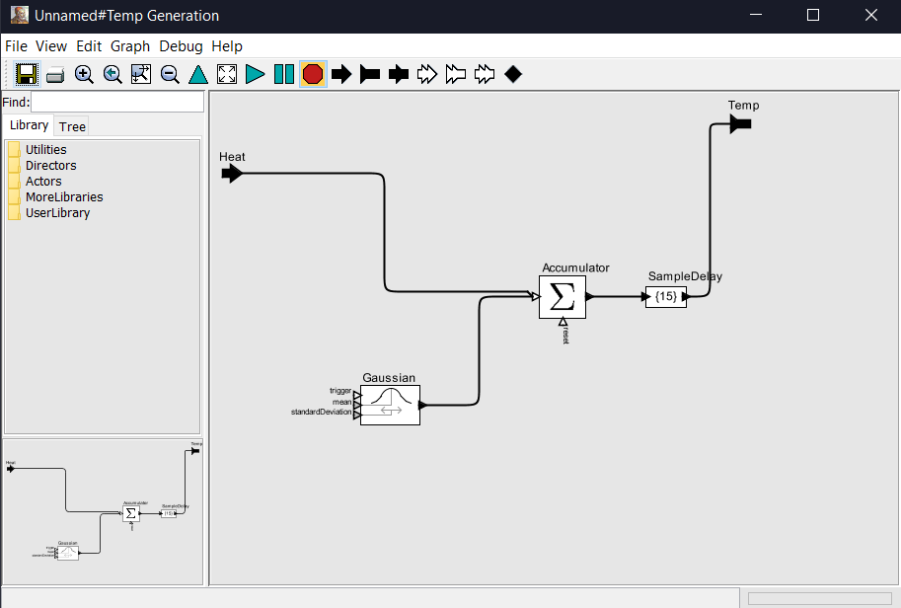

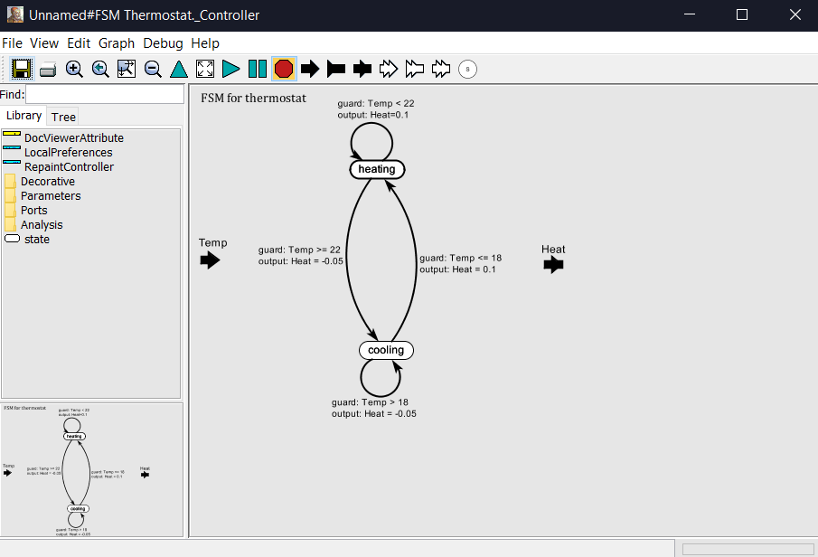

**Output:**

